Mountains | Vertical Zonation
Andes –  Sierra Madres – | Different elevations in the mountains have ______________________________________________  Different types of food can be grown at ________________________________________________
Bodies of Water
Atlantic _____

Pacific _________

Caribbean ____________

Amazon River –

Orinoco River –

Panama Canal – connects the ______________________
________________________________________________________

Archipelagoes | Climate
Groups of islands  The Greater Antilles –  The Lesser Antilles - | Tropical climates cover most of the area  Tropical Wet -  Tropical Wet and Dry -
Pampas | Deserts
Pampas is a grassland in _____________________________  Gauchos are ___________________________________________  Llanos are grasslands in ______________________________ | Most of Mexico is _____________________________________  Atacama Desert -
Natural Hazards | Seasons
Part of this area is on the ___________________________  There are many active and __________________________  _________________________________________________________ | The seasons are reversed _____________________________  ___________________________________________________________  When it is summer in Newport News it is __________________ in Argentina!  Near the ______________________ there are only wet and dry seasons
Wildlife Migrations
Many animals migrate to ____________________ when it turns to winter in the U.S.

Monarch butterflies migrate to ___________________

Many birds migrate to Mexico and Central America
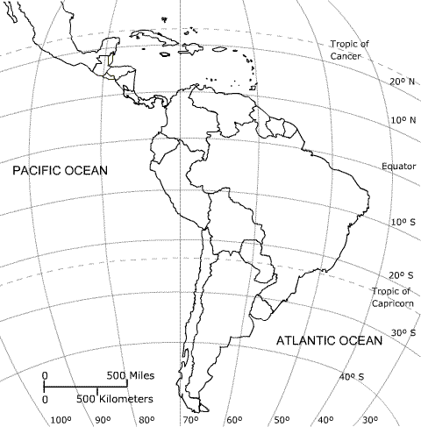 |  | Label:  Llanos  Pampas  Andes  Atacama  Amazon  Greater Antilles  Lesser Antilles  Panama Canal  Low latitudes  Ring of Fire  Mexico  Brazil  Argentina

