Ride The Reading Wave!
The showcase I liked the best was ride the reading wave book talks! This was one of Stuart Pepper Middle Schools showcases. There showcase was based on the 6-8th grade Kentucky bluegrass nominees! The names of the nominees are:
- All the Broken Pieces by Anne E. Burg
- Faith, Hope, and Ivy June by Phyllis Reynolds Naylor
- Flawed Dogs: The Shocking Raid On Westminster by Berkley Breathed
- Jane in Bloom by Deborah Lytton
- Leviathion by Scott Westerfeld
- Slob by Ellen Potter
- The Storm in the Barn by Matt Phelan
- Woods Runner by Gary Paulsen

This year’s showcase was Erica K, Taylor M, Allie M, Kayla C, Cheyenne K, and Leah O. I liked their showcase because they had excellent resources and information on their topic. They used poster boards, videos, books, and play away to relay their information to their audience.
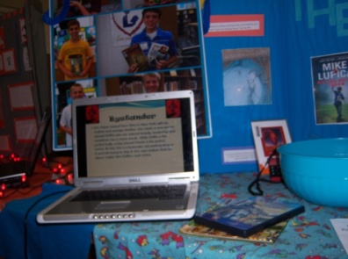
The PowerPoint presentation and the book

They gave credit to their librarian Janet saying “We could not have been had all of our information without her help”. They show her gratitude because without her they wouldn’t have access to the books that came from the library.
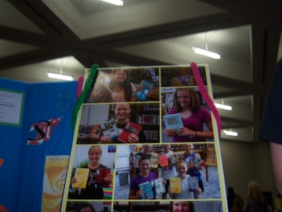
Poster boards showing the students with the books

They also thanked their STLP coordinator Jane Slinger by saying “We couldn’t have done it without Jane”. I am in the middle of Jane in Bloom and it is a book that I never want to put down! This showcase affected me because it encouraged me to read books that I normally wouldn’t choose myself. I plan on reading as many of the books as I can!

By Kelsie S.

