Welcome to Study Skills!!
Teacher: Ginger Smith

Goals: The goal of this class is to get you ready for high school.
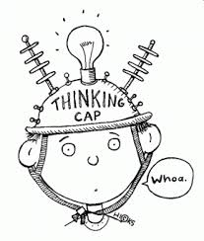
- Reading better will not only raise your grade but make ALL classes easier to get through in your high school career. Everybody wants things to be easier, right?
- Writing better will also help every class’s grade. People who think well will write well, so we’re not only working on writing, but thinking as well.
- Who wants to do better on your EOC? You have another EOC in 11th grade, so we want to get better.
Teacher Expectations:
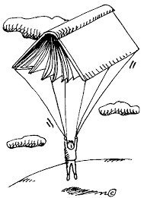
- That you will focus on class. This is not the time for playing—save that for lunchroom.
- You will not disrupt our SRA practice. If you do, our program makes us repeat whatever we are working on. You will only be making your classmates work harder if you act up. Repeatedly doing this will result in a write up. Everyone must participate.
- We are all here to help each other. Making fun of people/bullying is not allowed in any fashion.
- I expect you to have a good attitude about 90% of the time. You’d be surprised what you can do just by TRYING. Those successful people you want to be like…they are not successful because they are lucky, they are successful because they TRY and WORK HARD.
Behavior Policy:
- No talking when the teachers are talking.
- Treat others with respect and courtesy. Be polite. Help others in our room when you are able.
- Use time wisely. No playing. There is no time for off task behavior. If you have extra time, you should read a book!
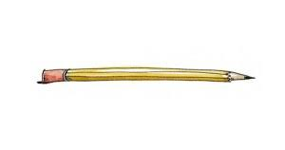
___________________________________

Supplies:
- Pens (blue or black ink)
- Pencils
- Paper and Notebook (preferably one with a few sections.)
- Highlighters

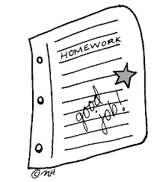
Grading:
40% Writing projects and tests (Writescore benchmark or teacher made.)
25% homework and classwork
15% quizzes and participation

Extra Help Policy:
I am always here to help you before or after school and at lunch if you need extra help. I consider that a teacher’s job.
BUT if you goof off all year then want me to give you extra credit in December, you may end up disappointed. Don’t wait too late.

