RAZ KIDS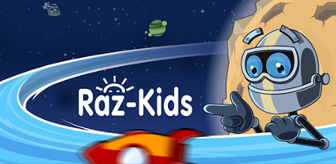

Dear Parent or Guardian:

Your child has access to award-winning digital resources through Kids A-Z, Learning A-Z's website created for students. After
your child logs in, each website your child's teacher has subscribed to is shown. Your child can work on assignments or select other resources for reading and writing practice.

Website Resources for Your Student
Thousands of leveled books and resources in printable and digital formats (In English and Spanish)*

* Access resources on mobile devices by downloading the Kids A-Z app from the app store. Data rates may apply.
Kids A-Z Login Instructions

Step 1: Go to www.kidsa-z.com
Step 2: Enter or choose the teacher's username, dphillips61
Step 3: Your child finds his or her username on the class chart.
Step 4: Your child enters his or her password, which is his/her classroom number. If your child is number 1-9 you will need to enter a zero as the first digit. For example: 01, 02, 03, etc.

