Mrs. Daniel’s Newsletter
February 15-19, 2021
Grammar (adverbs that tell when and where) and
Reading Skills (plot and theme) Tests: Friday
Vocabulary and Spelling (compound words) Tests: Friday
Story:  “The Night the Moon Fell”  retold by Pat Mora  Phonics/Fluency:  compound words  Text-Based Comprehension:  plot and theme; visualizing  Grammar:  adverbs that tell  when and where |  | Selection Vocabulary Words (Students will be tested on these):  - coral – an underwater stony substance made by marine life  - rattle – made sharp knocking sounds as a result of being shaken  - sliver – a small, thin piece of something that has been split off  - balance – footing; even placement of weight that lets someone stand upright  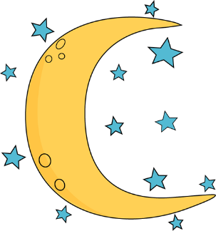  - sway – move back and forth or side to side  - canyons – deep valley with steep sides  - whisper – make a soft sound  Amazing Words  adjust, unexpected, tease, accent,  landmark, quiver, foreign, forlorn
Math: Topic 10  Place Value to Thousands  This week in Math we will be discussing place value. We will look at the value of digits in the ones, tens, and hundreds. Please look for homework to practice these skills in this week’s homework packet. |  |  | Social Studies/Science  Our study this week is people who have made important contributions to our country’s  history. We will learn about individuals,  events, documents, and symbols that  represent the United States. We will also  discuss the importance of the Statue of  Liberty and look at other symbols including  the Liberty Bell and World War II Memorial.
Spelling Words:
- downstairs  - football  - cowboy | - houseboat  - railroad  - rainbow |  |  | - boyhood  - oatmeal  - soybean | - roadway  - outplay  - daydream

