HOW TO PREPARE FOR PRE-K
- Establish schedules and routines in nap time and meal times and bed times at home. (Pre-K classes have a scheduled nap time each day).
- Provide your child with social experiences around other children where they are required to share (daycare, church, family gatherings, play dates, etc…).
- Play games where your child can sometimes win and sometimes not win and help him/her work through the results.
- Help your child understand that cleaning up his/her own mess is an expectation. Have him/her participate in chores around your home.
- Practice, practice, practice! Learning how to get ready each morning for the trip to school takes time and practice. It's helpful to practice this before the actual first day. Pretend it's a school day, and go through the steps of getting up, dressed, fed, and out the door.
- Rehearse self-help skills such as dressing, undressing, and hand-washing. Your child will feel more confident when she's asked to do these things at school.
Teach your child toileting skills for independence (fastening and unfastening clothing/belts, wiping, washing hands, discarding toilet tissue versus other trash). Boys need exposure to urinals.
Teach your child how to fasten and unfasten his/her own jacket (turn right side out).
Teach your child how to put on his/her own shoes.
Teach your child to use eating utensils.
Teach your child learn how to open snack packaging (chips, juices, ketchup and others).

- Visit the school or classroom before the first day (Meet and Greet). Take a few trips to the school to see the building and the playground.
- Read good books about starting school. Literature is a great way to prompt a discussion about going off to school.
- Talk to your child about his feelings about school, friends, teachers, and new activities.
- Make a family photo. You can't stay with your child all year, but your photos can! The process of making a small photo album together is a bonding and comforting project. Use a small, soft plastic album (available at most dollar stores) that can be easily washed, carried, and kissed!
- Teach your child how and when to ask for help.
- Ask your child what kind of snack she wants to bring. Shop together for the ingredients and engage her in the making and packing of the snack.
- Go school shopping. Back-to-school clothes and items are popular with little guys as well as big. It's not too early to start the ritual of shopping for special school outfits or a backpack. It doesn't have to be something expensive. Even a "new-to-you" item will have meaning when it is designated especially for back to school.
- Write student names on everything in permanent marker. Make it clearly visible on book bags and lunchboxes.
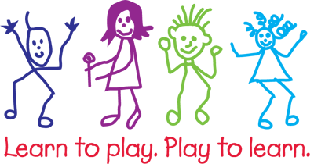
ON THE FIRST DAY OF PRE-K
- Wake up early enough so that you and your child don’t have to rush to get to preschool.
- Make breakfast for your child and, if possible, sit down to eat together—or at least talk with him/her as she eats and you get ready.
- Review the day’s routine (what preschool will be like, how your child will get to school/come home).
- Pack your child’s backpack together. If your child is bringing lunch, select foods that you know are favorites. Having some familiarity on his/her first day is helpful as he adjusts to so many changes.
- Let your child choose two towels to bring to school for warmth and comfort. Send your child with two family photos as well (one to post on the wall and one to keep close). These familiar objects can help if he/she feels lonely during the day.
- Keep your tone positive and upbeat. Children pick up on the reactions of the trusted adults in their lives. So try not to look worried or sad, and don’t linger too long.
- When you see that your child is comfortable, it is time to leave. If he/she is having a harder time getting engaged, you may want to ask your child’s teacher to stay with your child as you say good-bye so that when you leave, he/she can turn to another caring adult for support. Say a quick, upbeat good-bye and reassure your child that all will be well. Give him/her a quick hug, tell your child how much you love him/her, and leave him/her in the hands of the capable teacher. Even if your child is crying hysterically, he/she will likely only cry for a few minutes once you’re out of sight. If you linger, the crying will probably last longer.
- Think about creating a special good-bye routine. For example, you can give your child a kiss on the palm to “hold” all day long. Or, the two of you can sing a special song together before you leave. Good-bye routines are comforting to children and help them understand and prepare for what will happen next.
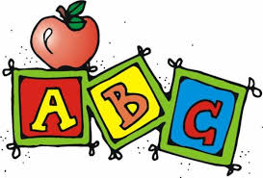
- Resist the Rescue. Try not to run back in the classroom if you hear your child crying, as upsetting as this can be. This is a big change and your child may, quite understandably, feel sad and a little scared. But if you run back in, it sends the message that he/she is only okay if you are there and it is likely to prolong your child’s distress and make it harder for him/her to adapt. Rest assured, teachers have many years of experience with helping families make the shift to preschool. Instead, you can wait outside the classroom for a few minutes to ensure that all is well, or call the school later in the morning to check in.

