Today your child had a guidance lesson on being helpful and kind. Children discover that occasional disagreements with friends, neighbors, and classmates are a fact of life. With time and experience, by trial and error, and guided by positive role models, children become increasingly skillful at resolving everyday conflicts for themselves without the need of adult supervision.

The first book we read was “What does it mean to be kind?” We discussed ways we can be kind to others using the book’s prompting questions or ideas. Students were introduced to the concept of being mean and hurtful rather than helpful and kind through the book, “The Recess Queen”. Jean is bullying all the students on the playground every day at recess. One day a new student comes to Jean’s class. The new girl shows Jean how to be a friend to others rather bullying them.

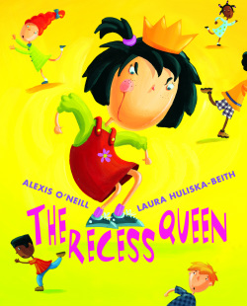
Thank you,

Annabeth Greene
PreK-2 Counselor

