AUTAUGAVILLE SCHOOL 2021-2022 REGISTRATION:
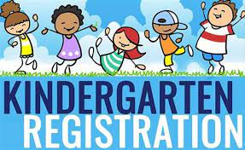
Registration will be April 19th – 23rd in the Media Center/Library. The times will be 10:00 - 2:00, except on Thursday we will have extended hours from 10:00 - 5:00.
All registration is now done online. We will have electronic devices here at the time of registration for your convenience. No paper packets will be handed out this year. You can go ahead and register online, but we do need for you to come to registration April 19th-23rd to complete the process.

Please bring the following with you to registration:
Your child’s birth certificate
Child’s Immunization record
Your Photo ID
2 Forms of Residency (Pick two from the following):
Current Signed Lease
Current W2
Current Tax Property Statement (Autauga County Tax Office)
We do not accept mortgage statements
Property Deed
Warranty Deed
One Utility (Water, Power or Gas only)
No phone or internet bills are accepted.

It is required that you have an email address to register, please make sure you have one or have created one before you try to register.

