SECTION 3
CELLS: CELL CYCLE, CELL DIVISION, AND REPRODUCTION

Important Relationship:
Cell Cycle leads to Cell Division

BIO. 1 E. 1-2/ 3A. 1-3

Cell Division
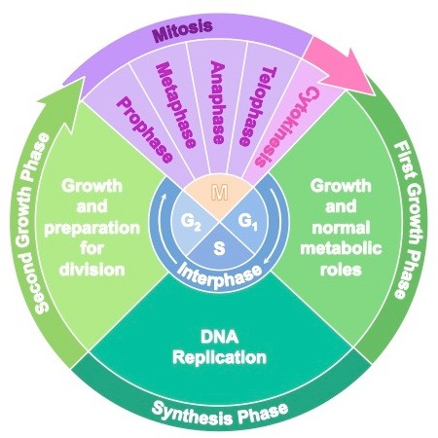

CELL CYCLE

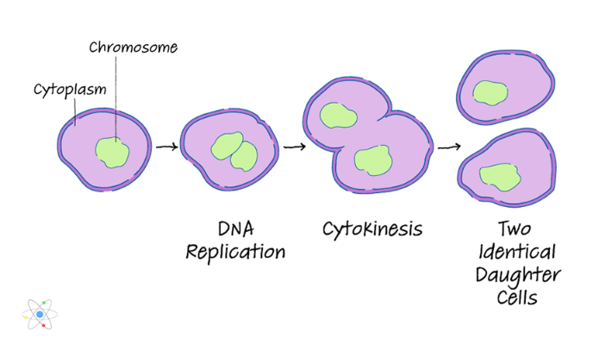
BINARY FISSION
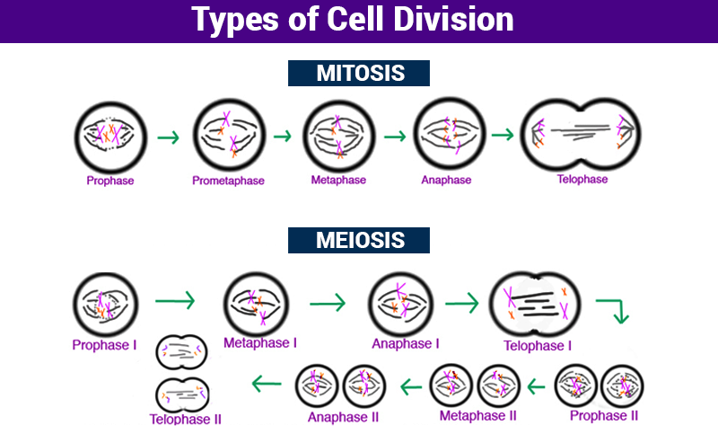
EXPLAINS BOTH

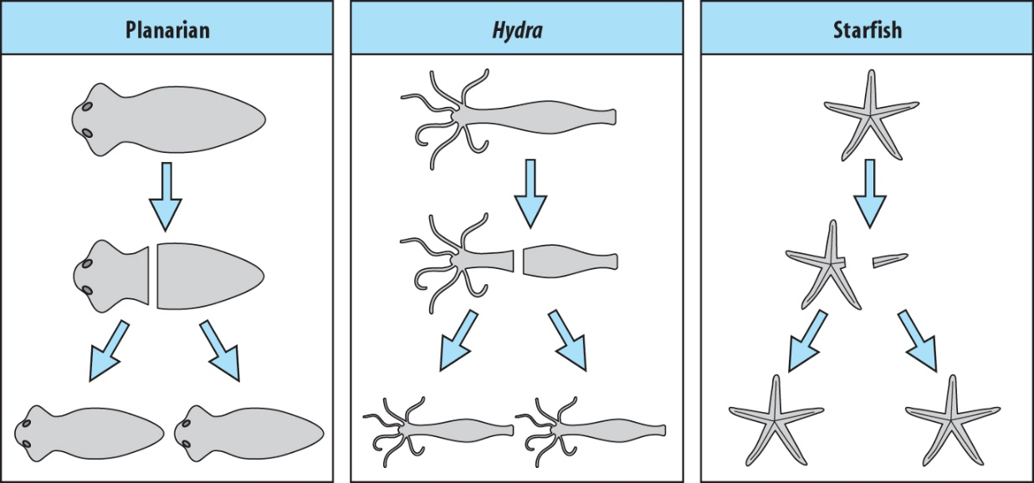
REGENEARTION

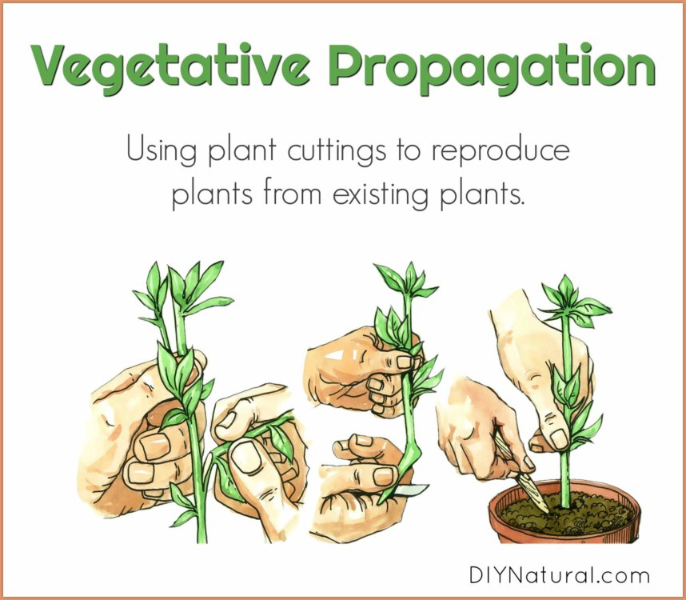

KEY CONCEPTS ABOUT CELLS: CELL CYCLE, CELL DIVISION, AND REPRODUCTION
MS-CCR Standard(s):
Bio. 1E. Students will relate the diversity of organelles to a variety of specialized cellular functions.
BIO. 1E. 1. Construct models to explain how the processes of cell division and cell differentiation produce and maintain complex multicellular organisms.
BIO. 1E. 2. Identify the describe the changes that occur in a cell during replication. Explore problems that might occur if the cell does not progress through the cycle correctly (cancer).
BIO. 1E. 3. Relate the processes of cellular reproduction to asexual reproduction in simple organisms (i.e., budding, vegetative propagation, regeneration, binary fission. Explain why the DNA of the daughter cells is the same as the parent cell.
BIO 1E. 4. Enrichment: Use an engineering design process to investigate the role of the stem cells in regeneration and asexual reproduction, then develop application of stem cell research to solve human medical conditions.
BIO. 3A. Students will develop and use models to explain the role of meiosis in the production of haploid gametes required for sexual reproduction.
BIO. 3A. 1. Model sex cell formation (meiosis) and combination (fertilization) to demonstrate the maintenance of chromosome number through each generation in sexually reproducing populations. Explain why the DNA of the daughter cells is different from the DNA of the parent cell.
BIO. 3A. 2. Compare and contrast mitosis and meiosis in terms of reproduction.

Important: Types of Cell Division based on reproduction to study
Type of Cell Division | Asexual Reproduction | Sexual Reproduction | What are the offspring called?
Mitosis |  |  | Daughter cells
Meiosis |  |  | Daughter cells
Binary Fission |  |  | Daughter cells
Vegetative Propagation |  |  | Uniform Offspring
Regeneration |  |  | Uniform Offspring
Budding |  |  | Uniform Offspring

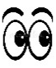
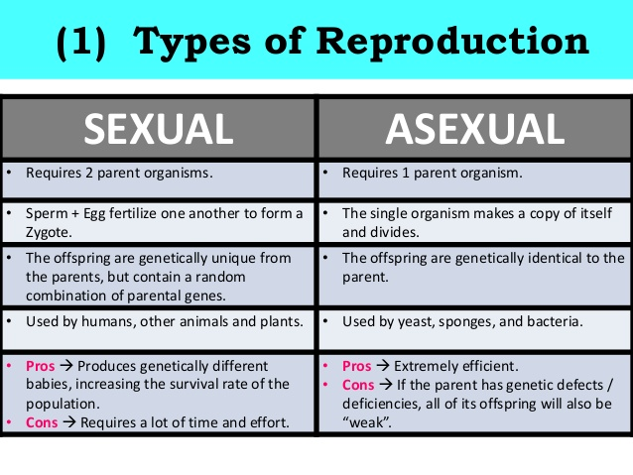
Key Information:
- End of Mitosis ends with 2 daughter cells
- Miosis= somatic or body cells

Adeeper look
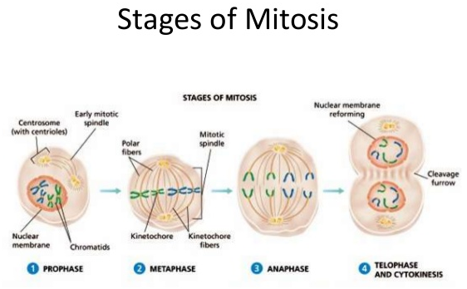

Clues
Prophase- chromosomes are bunch up/about to divide
Metaphase- chromatids line up in the middle
Anaphase- separate/ move to opposite sides of the cells
Telophase- 2 new nuclear membrane starts to form.

.

.
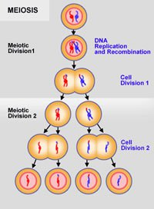

Remember
-During cross over below, genetic variation increases

--

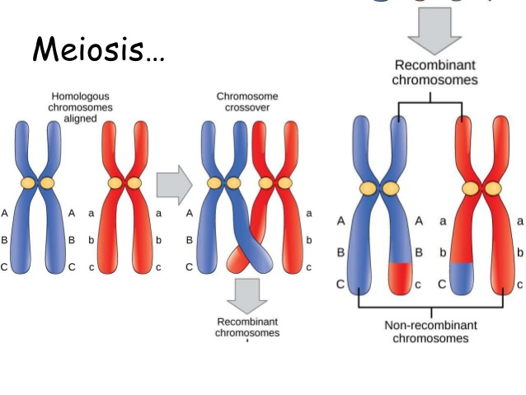
Key Information:
- Meiosis makes the sex cells called gametes (sperm=male & egg=female)
- At the end of Meiosis 4 gametes. 4 sperm survive and 1 out of the 4 eggs survives
- Meiosis- zygotes ends up with half of the parent’s chromosome.

BINARY FISSION

Key Information:
- DNA of bacterium uncoils and duplicates.
- DNA is pulled to separate poles of the bacterium.
- a growing (new) cell wall begins to separate the bacterium.
- the complete development of the cell wall results in the. split of the bacterium.
- the daughter cells have tightly coiled DNA rods, ribosomes, and. plastids.

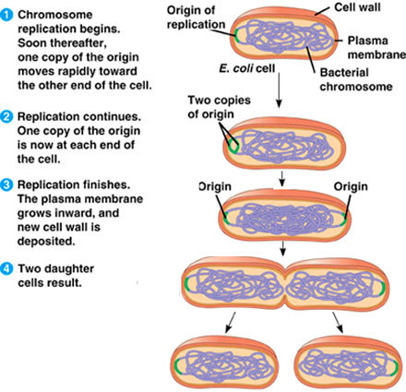

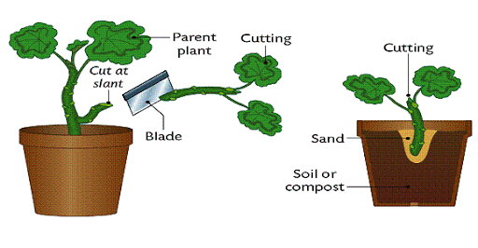
Key Information:
- DNA of bacterium uncoils and duplicates.
- DNA is pulled to separate poles of the bacterium.
- a growing (new) cell wall begins to separate the bacterium.
- the complete development of the cell wall results in the. split of the bacterium.
- the daughter cells have tightly coiled DNA rods, ribosomes, and. plastids.
VEGATATIVE PROPAGATION

Remember
-During regenartion, a piece cut off, comes back as the exact length and copy of the original

--
REGENERATION

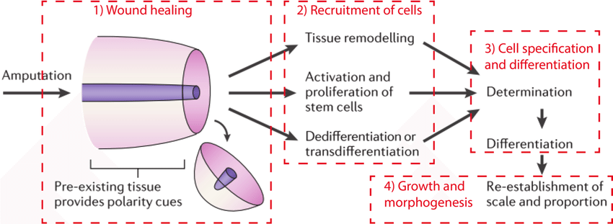

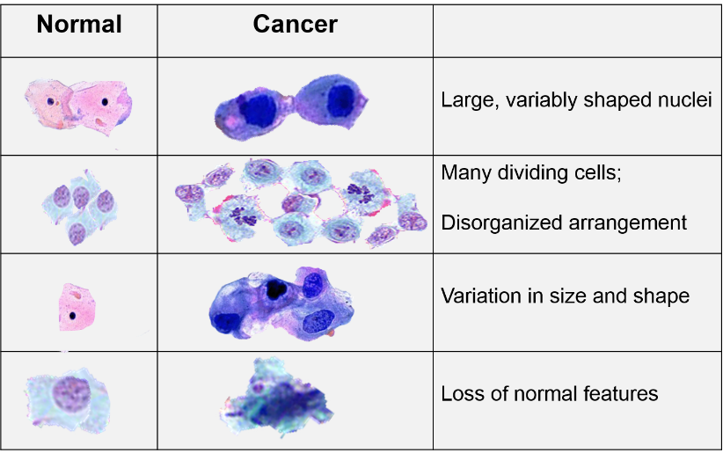
Problems within cell division can lead to cancer….

KEY VOCABULARY CELLS: CELL CYCLE, CELL DIVISION, AND REPRODUCTION
MS-CCR Standard(s):
Bio. 1E. Students will relate the diversity of organelles to a variety of specialized cellular functions.
BIO. 1E. 1. Construct models to explain how the processes of cell division and cell differentiation produce and maintain complex multicellular organisms.
BIO. 1E. 2. Identify the describe the changes that occur in a cell during replication. Explore problems that might occur if the cell does not progress through the cycle correctly (cancer).
BIO. 1E. 3. Relate the processes of cellular reproduction to asexual reproduction in simple organisms (i.e., budding, vegetative propagation, regeneration, binary fission. Explain why the DNA of the daughter cells is the same as the parent cell.
BIO 1E. 4. Enrichment: Use an engineering design process to investigate the role of the stem cells in regeneration and asexual reproduction, then develop application of stem cell research to solve human medical conditions.
BIO. 3A. Students will develop and use models to explain the role of meiosis in the production of haploid gametes required for sexual reproduction.
BIO. 3A. 1. Model sex cell formation (meiosis) and combination (fertilization) to demonstrate the maintenance of chromosome number through each generation in sexually reproducing populations. Explain why the DNA of the daughter cells is different from the DNA of the parent cell.
BIO. 3A. 2. Compare and contrast mitosis and meiosis in terms of reproduction.

KEY TERMS | KEY IMAGE | CLUES TO REMEMBER
Cell division | 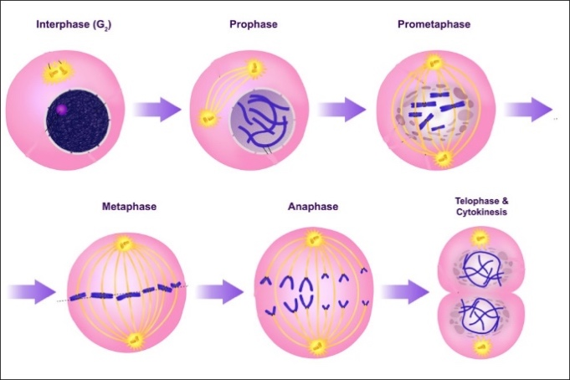 | - Two main types (mitosis/meiosis)  - Result of the Cell cycle
Asexual Reproduction | 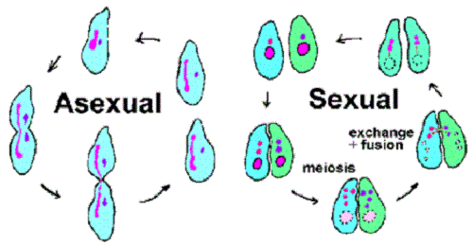 | - Produces identical offspring from ONE single parent cell
Sexual Reproduction |  | - Produces genetically different offspring from TWO parent cells
Budding | 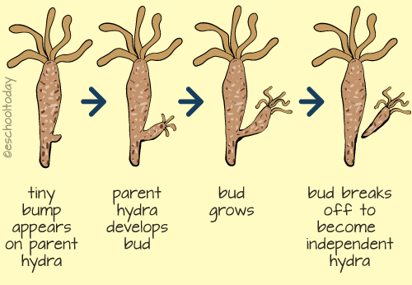 | - Type of asexual reproduction  - Results in an exact copy of the parent cell
Vegetative Propagation | 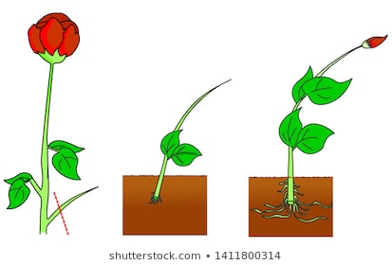 | - Type of asexual reproduction  - Results in an exact copy of the parent cell
Regeneration | 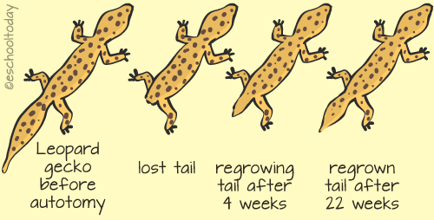 | - Type of asexual reproduction  - Results in an exact copy of the parent cell
Binary Fission | 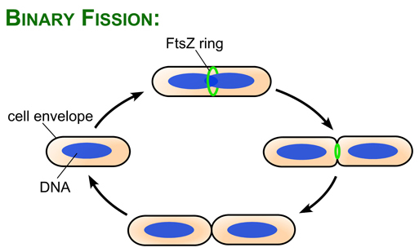 | - Type of asexual reproduction  - Results in an exact copy of the parent cell
Chromosome | 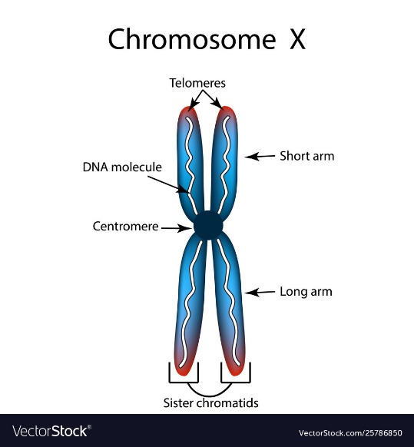 | - In cell division, the chromosome replicates in the nucleus
Chromatin | 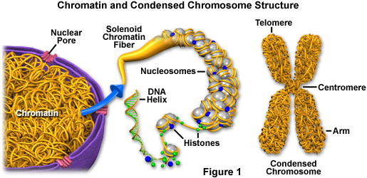 | - Composed of DNA & proteins that condense (shrink) to form chromosomes in cell division.
Chromatid | 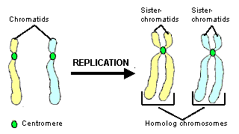 | - One side of the chromosome
Centriole | 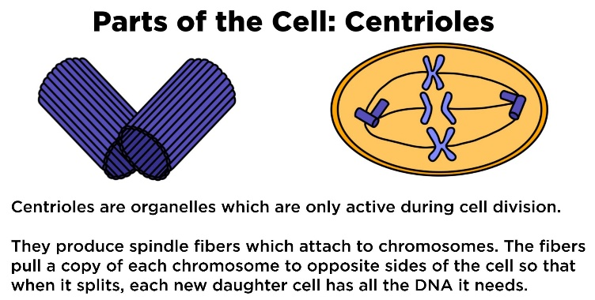 | - Helps form the spindle fibers that are used to separate the chromosomes
Spindle Fibers | 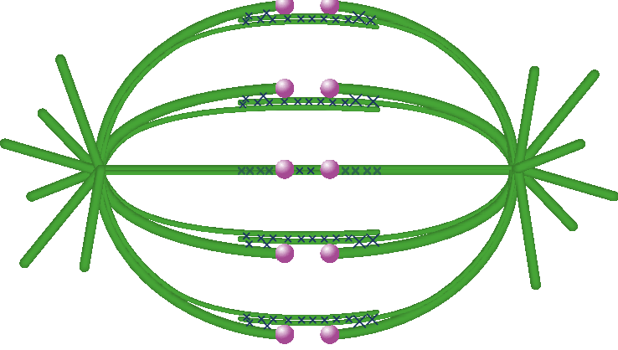 | - Separate the chromosomes during Anaphase of Cell division
Somatic Cells | 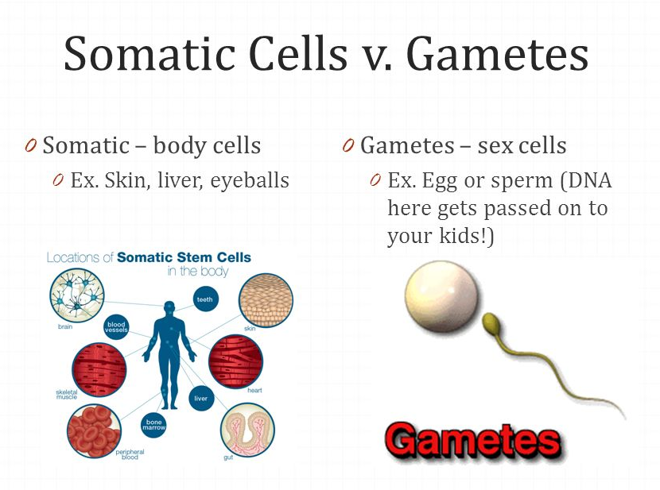 | - Body cell (none sex cells)
Cell Cycle | 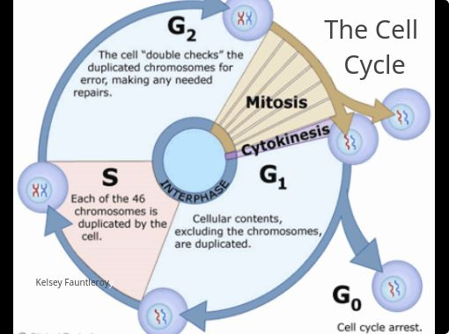 | - Process used to reproduce cells resulting in two daughter cells
Interphase | 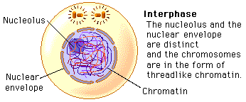 | - Cell mostly stays in this phase and copies its DNA waiting to divide
Mitosis | 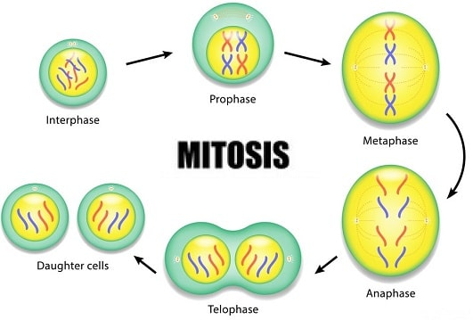 | - a part of the cell cycle when replicated chromosomes are separated into two new nuclei
Gap 1 Phase | 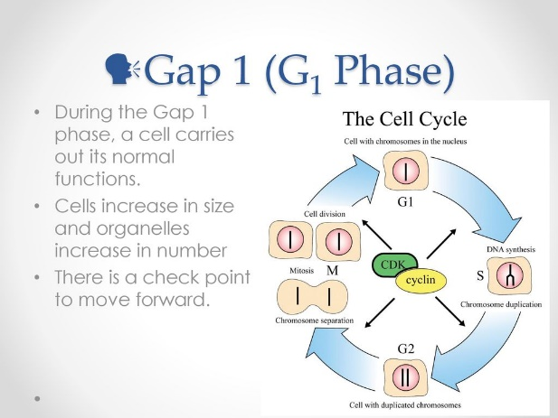 | - the first of four phases of the cell cycle, the cell synthesizes mRNA and proteins in preparation for subsequent steps leading to mitosis
Gap 2 Phase | 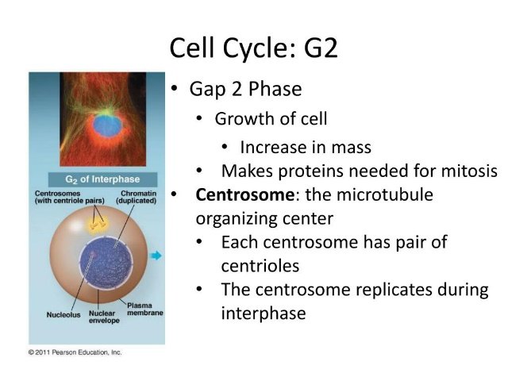 | - the third subphase of interphase in the cell cycle directly preceding mitosis, the cell’s DNA is replicated
Synthesis Phase | 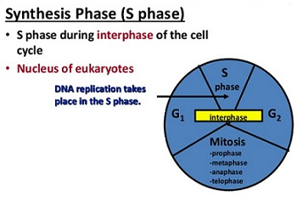 | - DNA is packaged into chromosomes and replicated. This event is an essential aspect of the cell cycle because replication allows for each cell created by cell division to have the same genetic make-up.
Cytokinesis | 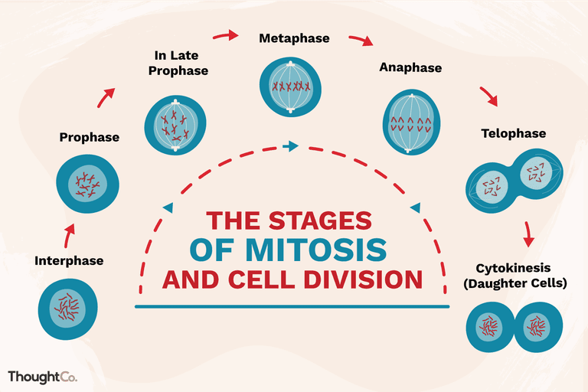 | - the cytoplasm of a single eukaryotic cell divides into two daughter cells
Prophase |  | - first stage of cell division, Beginning after interphase, condensation of the chromatin and the disappearance of the nucleolus
Metaphase |  | - chromosomes are at their second-most condensed and coiled stage, align in the equator of the cell before being separated into each of the two daughter cells
Anaphase |  | - after the process of metaphase, replicated chromosomes are split and the newly copied chromosomes are moved to opposite poles of the cell
Telophase |  | - the final stage in both meiosis and mitosis, the effects of prophase
Daughter Cell |  | - are genetically identical to the parent cell because they contain the same number and type of chromosomes
Cancer | 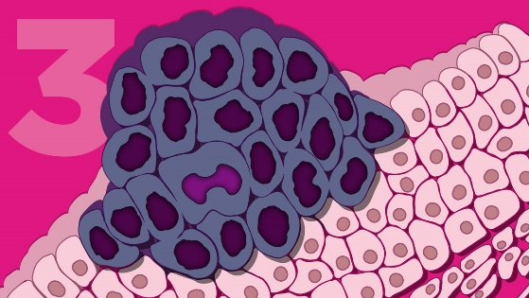 | - Uncontrolled cell growth causing tumors to form
Tumor | 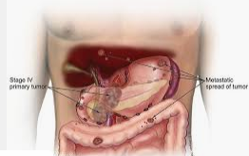 | - mass of tissue that's formed by an accumulation of abnormal cells
Metastasis | 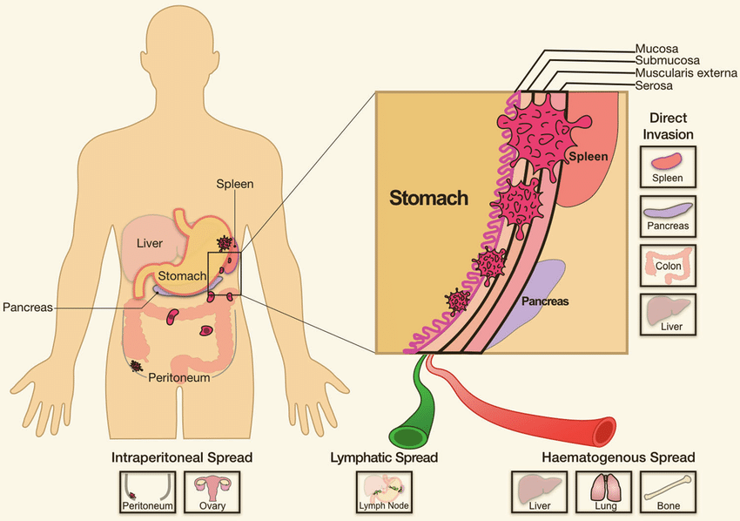 | - pathogenic agent's spread from an initial or primary site to a different or secondary site within the host's body
Growth Factor | 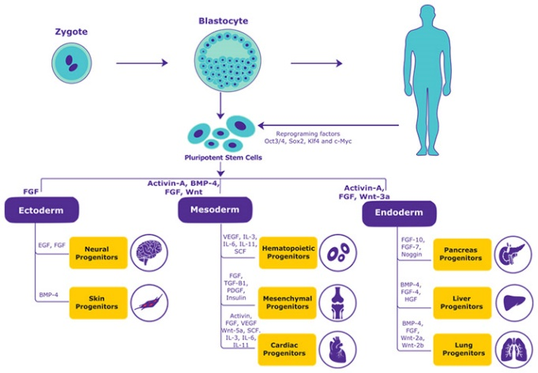 | - naturally occurring substance capable of stimulating cellular growth
Stem Cell | 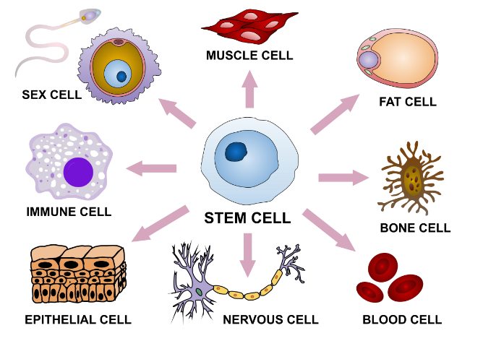 | - Unspecialized cells that can form differentiated cells
Embryo | 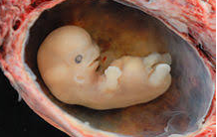 | - an early stage of development of a multicellular organism

CONCEPT REVIEW
- The growth phase of the cell cycle is called _____________________________.

- The 3 substages of interphase are: _______, _______, & ________.

- During the _______ stage, DNA is replicated

- Mitosis occurs in _____________________________or body cells

- The end result of mitosis is _____________________________ daughter cells with the

_____________________________ number of chromosomes.

- Daughter cells are _____________________________ or 2n

- In _____________________________ the chromatids pair up. In _____________________________

the chromatids line up and down the equator of the cell. In _____________________________ the

chromatids pull apart. In _____________________________ 2 cells are made.

- Identify the following stages of mitosis.

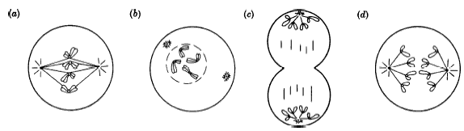
a)______________ b) ______________ c) ______________ d) ______________

- _________________________ Disorder in which some of the body’s own cells cannot stop dividing; they have lost the ability to control the cell cycle.

- _________________________ Mass of growing tissue that may form when a cell or group of cells begins to grow and divide uncontrollably.

- Examples of asexual reproduction include:

a.

b.

c.

d.

- Meiosis produces ________________________ cells or gametes.

- The two types of gametes are ________________________ and ________________________

- Meiosis produces #_________ gametes that are ________________________(n).

- Meiosis 1 involves the separation of ________________________ ________________________, while Meiosis 2 involves the separation of ________________________ ________________________

- Crossing over occurs in ________________________

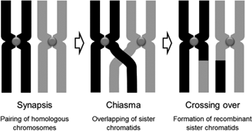

- _______________________ reduces the number of chromosomes.

- If a gamete of an organism has 6 chromosomes, the body cells have ________ chromosomes.

- If a liver cell of an organism has 32 chromosomes, a muscle cell of the same organism will have _______ chromosomes and a gamete will have _______ chromosomes.

- Complete the chart below by checking off which cell division has which characteristics.

Description | Mitosis | Meiosis | neither
Cell division in body cells
Cell division in gametes
Eukaryotic cells
Produces haploid cells
Produces diploid cells
Produces 2 cells
Produces 4 cells
Used by bacteria to divide

MAAP TEST PREP
1)
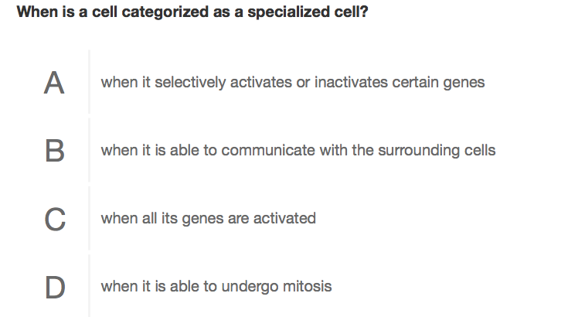

- Define the following terms from the question above:

Specialized

- Rewrite the question in your own words. What are they really asking?

- What is the correct answer and WHY? (you will not get credit without an explanation)

2)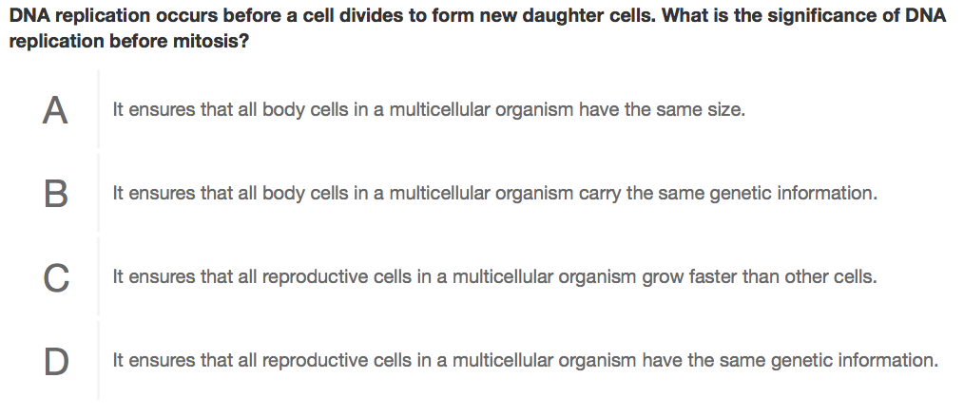

- Define the following terms from the question above:

Significance

- Rewrite the question in your own words. What are they really asking?

- What is the correct answer and WHY? (you will not get credit without an explanation)

3)
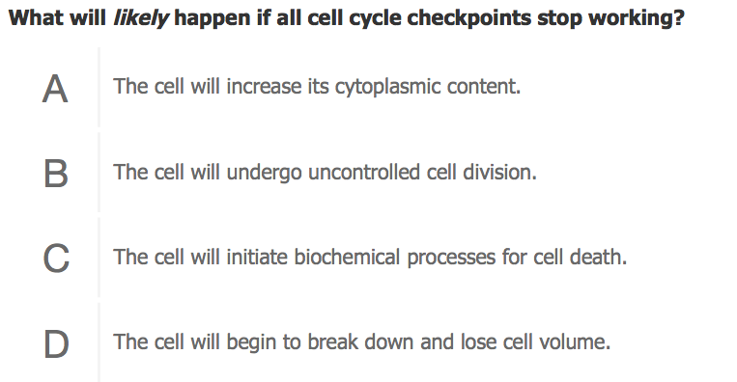
- When are the cell cycle checkpoints?

- Rewrite the question in your own words. What are they really asking?

- What is the correct answer and WHY? (you will not get credit without an explanation)

4)
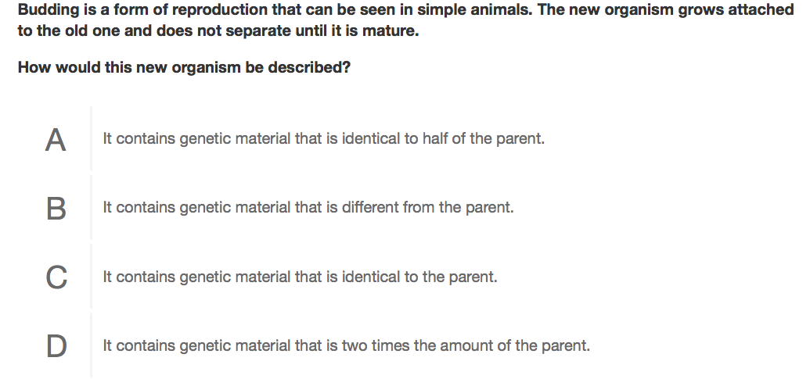

- Define the following terms from the question above:

Budding

- Rewrite the question in your own words. What are they really asking?

What is the correct answer and WHY? (you will not get credit without an explanation)

1)
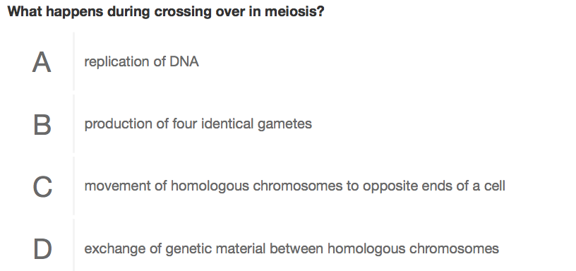

- Define the following terms from the question above:

Crossing over

DNA replication

Homologous chromosomes

- Rewrite the question in your own words. What are they really asking?

- What is the correct answer and WHY? (you will not get credit without an explanation)

2)
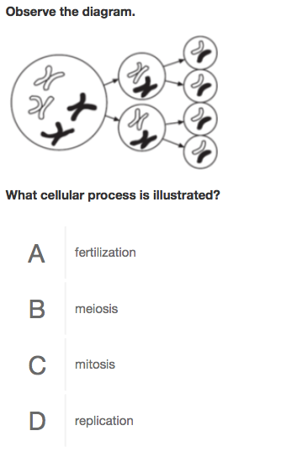
- What are the products of mitosis?

- What are the products of meiosis?

- Rewrite the question in your own words. What are they really asking?

- What is the correct answer and WHY? (you will not get credit without an explanation)

