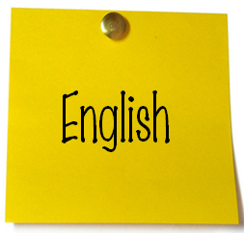
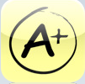
Miss Spell
Free
Check to see whether the word lists are spelled correctly or not.
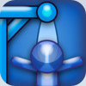
Super Hangman LE & Global High Scores
Free
Fairly standard Hangman app, with good graphics
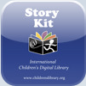
Story Kit
Free
Create an electronic story book by writing text, and either drawing on the screen or using your own photos. Record sound effects too!
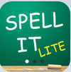
Spell It Lite
Free
Basic spelling app where you can select different levels. You can hear audio, get hints etc
Stanza
Free
This app gives you the ability to read e-books, including over 50,000 free titles.
iSign Lite
Free
A Sign Language app that teaches basic signs using animations. We will be using this when our Grade 1 students investigate communication.

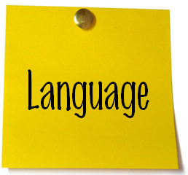
KT-Dict CE
Free
Chinese-English dictionary. See here for more details on how we use it at school.
Finger Lite
Free
Turn your iPod Touch into a wireless Chinese writing tablet.
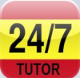
Spanish Tutor
Free
Puzzles, writing, flashcards – this free Spanish app has it all.

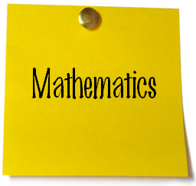
Number Line
Free
Excellent little app for ordering decimals, percentages and fractions. Would suit middle to upper primary.
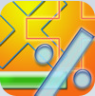
Basic Math
Free
Choose from the 4 operations (addition, subtraction, multiplication & division) and complete multiple choice questions on them.
iChoose
Free
App which allows you to select from coin toss, yes/no, dice roll, card choice, rock/paper/scissors and many other options. Great for probability and statistics.
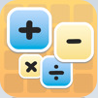
Match Lite
Free
Match the tiles on the screen, e.g. 9 and 7 + 2. Great for reinforcing basic skills. It also times you completing each board.
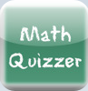
Math Quizzer
Free
Choose from addition, subtraction, multiplication & division (or a combination of these) and then complete the questions. Multi-choice answers are provided below.
Brain Blaze Divide
Free
This is ok… You go through the sets of division problems, unlocking a new set each time you correctly answer each set. Only thing is, it allows you to work with one set at a time (e.g. division by 1, division by 2 etc), rather than mix them up. Still, it’s a good starting place.
Tanzen Lite
Free
A neat little app that allows you to complete tangram puzzles (set to very zen-like music). A well thought through application.
Tape Measure
Free
Basic ruler in inches or centimetres.
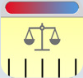
Units
Free
Excellent little app which will quickly show you any unit (area, temperature, length and weight, to name a few) in most other units, e.g. for Length it shows you Miles, Nautical Miles, Yard, Foot, Inch, Kilometre & Metre. The perfect app to illustrate why we should think about whether we need to spend time teaching our kids this stuff when it does it for us so quickly…
Geared
$0.99
App which our Grade 5′s will be using to reinforce understanding of simple machines. This game gets progressively harder as you solve more challenging problems.
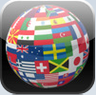
World Wiki
Free
As it implies, gives you access to demographic info on most countries in the world.
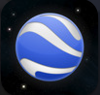
Google Earth
Free
Excellent iPod Touch version of the desktop programme created by Google. Absolutely awesome.
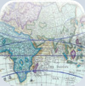
History: Maps of the world
Free
View historical maps of the world.
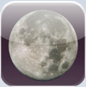
iEphemeris Lite
Free
Astronomical app showing moon phases, the surface of the moon, the distance between the earth and the moon… You get the idea!
Weather Bug
Free
Live local weather forecasts, 7 day forecasts, maps and (in certain areas) video footage of weather conditions.
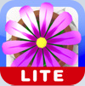
Flower Garden Lite
Free
Neat little app where you plant, water and grow flowers and send bouquets via email.
Epicurious
Free
Great app for recipes, complete with photos, clear instructions and the ability to create shopping lists.
iFirst Aid
Free
Great basic first aid information for all. Once you have registered, you can access info on CPR, bleeding, burns, choking & poisons. I was pleased to see for the CPR section, you can choose between Adult, Child 1-8 years and Baby. There are visuals which aid instructions.
Step Trak Lite
Free
Neat app which acts as a pedometer. Simple to use, really effective. You can upload your results to MapMyWalk.
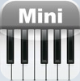
Mini Piano
Free
A one octave piano keyboard. Works beautifully.
Pocket Shaker
Free
Select a percussion instrument from an extensive list, then play it!
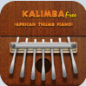
Kalimba Free
Free
A realistic looking kalimba, in the key of C or G.
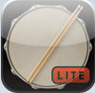
Drum Kit Lite
Free
Decent drum kit with some good audio output! Our music teacher plans to use it with the class to play rhythms en masse!
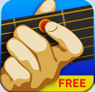
Touch Chords
Free
Takes you through some easy, medium and advanced chords, and also ‘Little Hands’ chords (where you don’t play all the strings). Nice introduction.

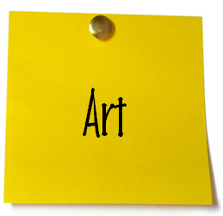
Art
$0.99
Great list of historical artists, their lives, their art, and so much more. If $0.99 seems a little much, why not try the lite version, which is free.
Doodle Kids
Free
Neat little app created by a 9 year old Singaporean boy. We’ve used it for fine motor skills, creativity etc. You can take screen shots of your creations and email them later.
Make a Face
Free
This app lets you make crazy faces using various noses, mouths, face shapes etc.
Comic Touch Lite
Free
Add captions and speech bubbles to photos. A bit like Comic Life on a Mac.
Whiteboard Collaborative Drawing
Free
Neat little app that allows you to connect more two iPod Touches together. Great for communication!
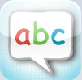
abc Pocket Phonics
$0.99
I think this is a great little app for the early years. You learn to form letters, hear the sounds of each letter, then blend sounds to make words at the end. The Lite version has the first sounds only, but the full version has sound blends as well. Give it a go! See here for more details on how we used with with K2.
Early Reader
$0.99
Another great little app for beginning readers. It covers the basic sight words, phonics, etc and is easy to use. You can turn the voice on or off.
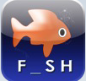
Word Magic
$0.99
This app has missing letters which the kids need to select from a list to complete the word. There are a range of settings you can customize, including lowercase or uppercase letters, the missing letters at the beginning, middle or end of the word, and the length of the word (to name but a few).
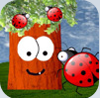
Ladybug Tree
$0.99
This is a good app for developing touch-pad skills. You catch ladybugs (the Kiwi in me wants to say ‘Ladybirds’, but I’ll let it go!) and put them in a jar, and see how many you can catch in the time given.
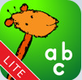
iWrite Words
Free
Trace the letters on screen. It’s ok, but not the writing format we usually teach. Good for fun though.
Tozzle Lite
Free
Great little puzzle for developing touch-pad skills. Tap and drag the pictures into the correct places. My 2 year old loves this one.
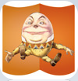
Classic Nursery Rhymes Lite
Free
This version only has Humpty Dumpty on it, however it is nice the way you can listen to the nursery rhyme and then put Humpty Dumpty back together again.

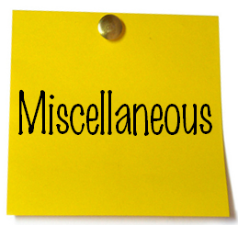
Skype
Free
Fabulous communication tool you will all know and love, I’m sure.
TED
Free
Link straight to the amazing TED website where you can access all of the fabulous videos for Technology, Entertainment & Design.
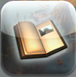
Myst
$4.99
This computer game has been reconfigured for the iPod Touch. I hope to use it later in the year as a stimulus for creative writing. The visuals are really great, and it is a critical thinking sort of game (which I like). There is also Myst Free for you to check out first, if you’re put off by the price tag.
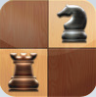
Chess Free
Free
App that allows you to play chess. Simple and to the point.
Learn Chess
Free
Nice and simple way to learn to play chess. Good mix of visuals and instructional text.
Phew! That’s it for now! I am always on the look out for new apps, so if you have some great ones to share, why not leave a comment?
Photo Credit: Peteris B

