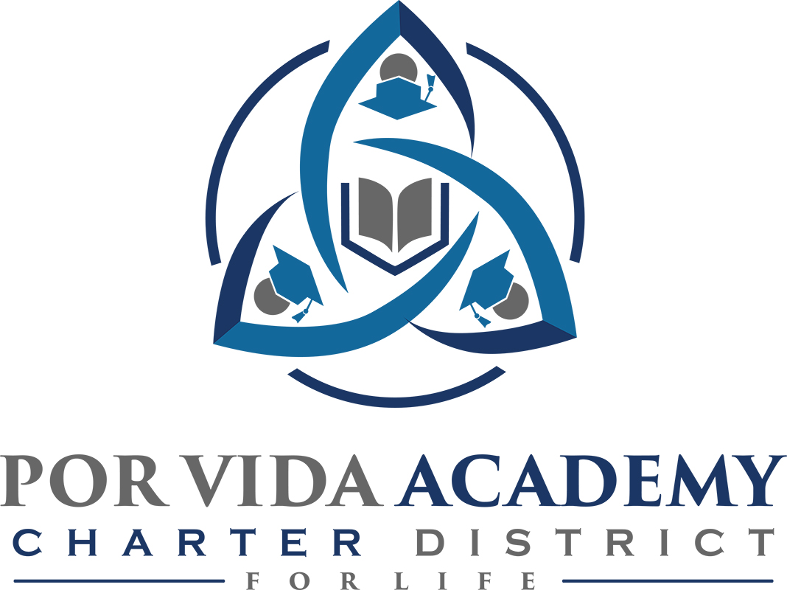

Thursday, January 10, 2019 at 12:00pm 1135 Mission Road, SA TX 78210

Agenda of Regular Called Board Meeting

- Call to Order and Establishment of Quorum
  - Roll Call & Recording of Board Members Present - Declaration of Quorum Present
  - Recording of the Executive Director/Superintendent and Staff Members Present.

- Closed Session: None

- Pledge of Allegiance

- Salute to the Texas Flag- “Honor the Texas Flag; I pledge allegiance to thee, Texas, one state under God, one and indivisible.”

- Public Testimony

- Approval of Minutes: October 19, 2018 & August 24, 2019

- Superintendent Items:
- Claudette Yarbrough discussion on sustainability
- Financial Management Report
- Charter FIRST
- School reports

- Financials
  - Current

- Board Items: None

- Adjournment

