PSAT I Writing—Mrs. Stevens
April 20-24

You will find class resources (notes and PowerPoints/presentations) for me each week in the PSAT 2020 General Section. At the top, click Files>Class Materials>Week 5 folder for me. I'll try to post any PowerPoint documents in PDF form as well just in case the actual PPT doesn't cooperate with your device. See pic below of this week's directions.

This week, I am going to have you work on something a little bit different. We will read a short book together in the upcoming weeks called Of Mice and Men (it’s such a short book that it’s actually called a novella). Everyone who had me for Gifted English 10 already had their parents sign a permission slip to read this book; however, if you HAVEN’T had me for sophomore English, I will need your assistance with this next step before you move on. This book was published in 1937 and has mature content, including violence, swearing, and racism. It’s set in the American West during the Great Depression. John Steinbeck, the author of this book, won the Nobel Prize for Literature in 1962. This book’s topics can be controversial, but its content provides value in examining prejudice and the welfare of others, along with our ideas of the American Dream. I do not personally condone cursing, racism, or violence, in books or in real life, but I also see there is importance in the lessons shared from this book. If you didn’t have me for English class, I need you to write on a sheet of paper “My child has permission to read Of Mice and Men.” Have a parent sign that statement and date it, then take a picture of it and send it to me through Remind or Teams Chat. If you are not allowed to read this book and discuss along with us, then have your parent do the same thing with date and signature stating, “My child does not have permission to read Of Mice and Men. I’d like an alternate assignment.” Whatever happens, you will do some reading and writing in the upcoming weeks.

Why are we reading this little book when this is the Writing section of the PSAT? Sometimes I have students read fiction and respond, and other times I have students read nonfiction and respond. This book is easily accessible for free online. I hope to see your writing skills IN ACTION when you respond to what you’ve read, so I can help you with actual sentences you’re constructing and the decisions you’re making in the writing process.

Therefore, you are utilizing all of the grammar lessons we’ve learned SO FAR in your writing, which is the most relevant need for these lessons—for you to be a better writer/communicator!

For this week, if the permission part mentioned above has been completed, you will do the following:
- Read this informational text about The Migrant Experience: https://www.loc.gov/collections/todd-and-sonkin-migrant-workers-from-1940-to-1941/articles-and-essays/the-migrant-experience/
Write an objective summary after you read this passage. What’s an objective summary? See tips in below section.
- Read Ch. 1 of Of Mice and Men* (if you have the actual book for this, you will see that it’s divided into six sections and doesn’t have labeled chapters; however, the online source that you will use does have the chapters labeled 1-6). http://giove.isti.cnr.it/demo/eread/Libri/sad/OfMiceAndMen.pdf (I’d go ahead and save this link as a bookmark or to your phone/computer for easy access). * If you are desperate for a physical copy of this text, please let me know, and I’ll try to get you one.
Some of you may want to read ahead, but keep in mind that you will probably forget some of the specific things I will have you write about if you do that, but it’s really up to you. Also, DO NOT GIVE ANY SPOILERS TO CLASSMATES IF YOU READ AHEAD!!!!! (spoiling books is NOT something I take lightly, so be warned)
  - Write a summary of Ch. 1 in ONE paragraph. The summary paragraph must be written in the academic conventions you’ve been taught—to the best of your ability.
  - In a SEPARATE paragraph, write your reaction to Ch. 1. Your reaction can be anything you want to discuss or question or conclude.

To clarify, you should write an objective summary to The Migrant Experience passage. You should write a paragraph summary to Ch. 1, and you should write a reaction paragraph to Ch. 1. Your reaction paragraph can be written in 1st person/your opinion…after all, it’s YOUR reaction. Within your writing for ALL of this, I want to see you use at least 7 transitions and I need you to underline them.
You’ve been expected to study the transition list for multiple weeks now. Here is the link if you need a reminder: https://www.smart-words.org/linking-words/transition-words.html Read through this webpage’s tips for answering transition questions: https://blog.prepscholar.com/transition-questions-on-sat-writing

This will be turned in as one document or piece of writing—with three distinguishable sections. I prefer this to be typed, but if hand-written, please make sure you take clear photos with legible handwriting to submit.

TIPS for writing summaries:

OBJECTIVE summary (used more for informational texts)

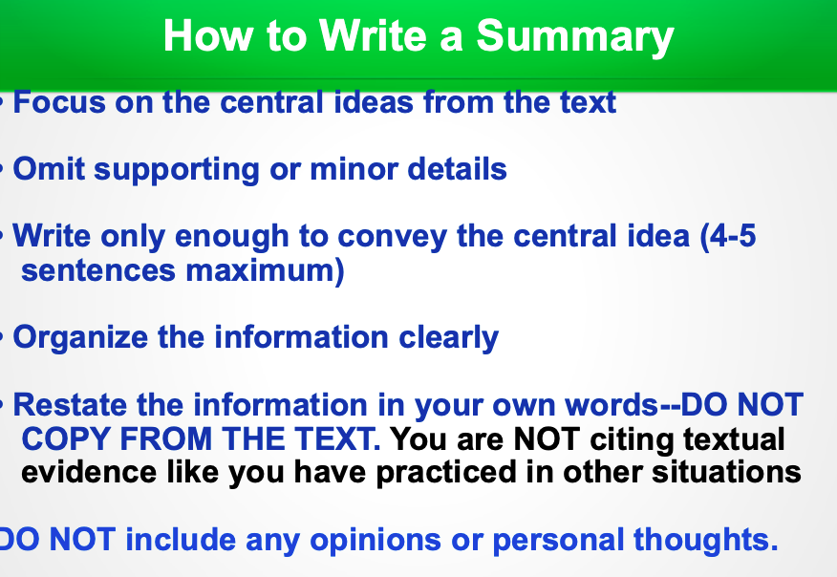
(depending on the LENGTH of the original, the entire summary can be longer than 4-5 sentences… a standard summary is around 25% in size of the original)

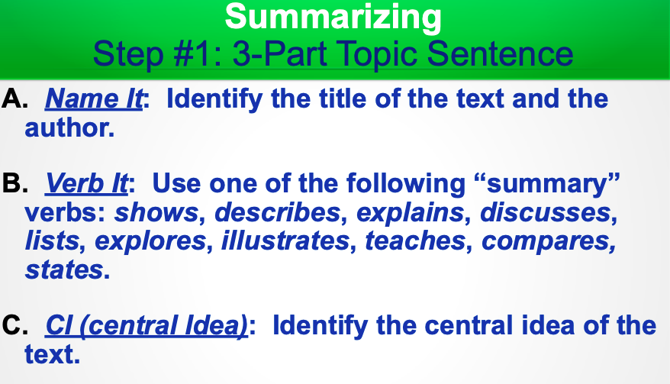

Ways to approach summaries for fictional texts:
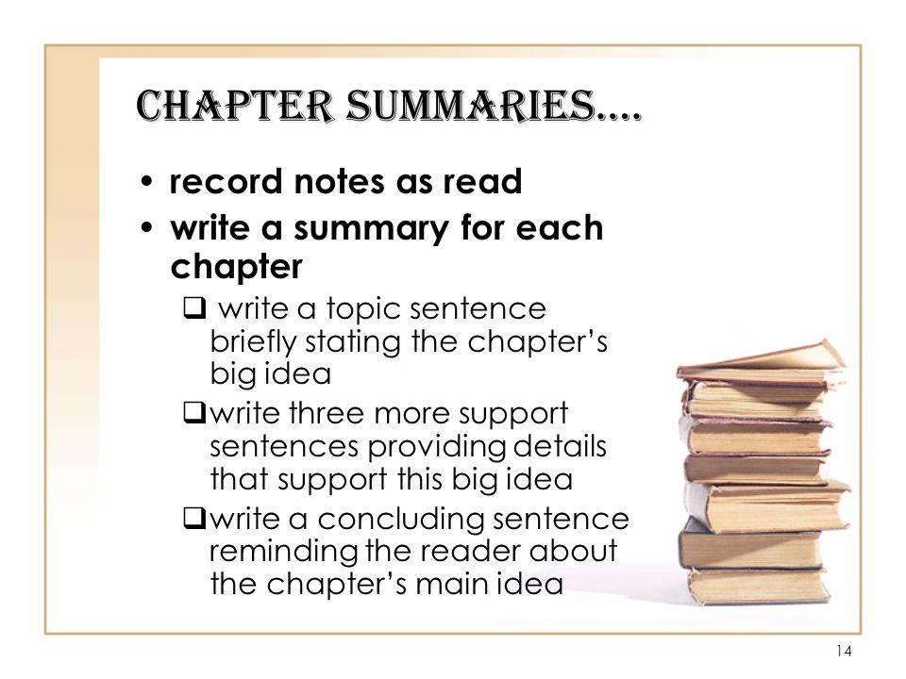
Typically answer WHO, WHAT, WHEN, WHERE, WHY, HOW questions.
Some people like to use the strategy “Someone, Wanted, But, So, Then” (see attached photo)
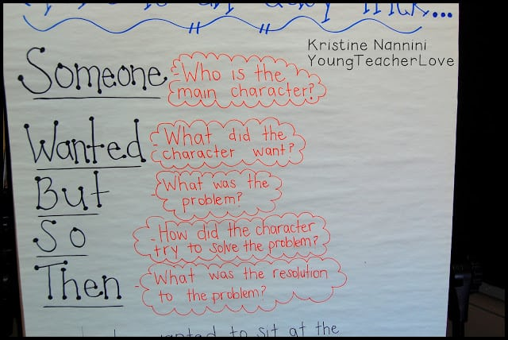

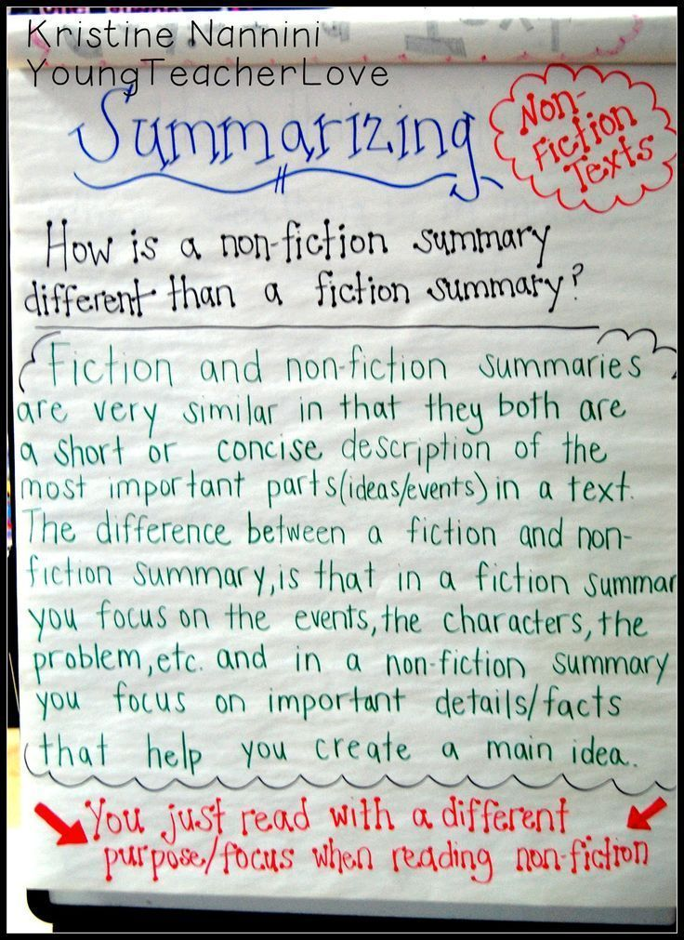

~~~~~~~~~~~~~~~~~~~~~~~~~~~~~~~~~~~~~~~~~~~~~~~~~~~~~~~~~~~~~~~~~~~~~~~~~~~~~~~~~~

OLD NEWS From previous weeks: Sign up for Flipgrid and respond to the two prompts already there. You should also respond to 3-5 other classmates’ videos (or more!) You can see the codes I sent in Remind earlier. Use your Microsoft school emails to sign up. Flip code for the class: stevens2993
There is a way you can participate/respond without always showing your face/surroundings. I’d prefer to see your face, though ;)

News: We have not got any other information to share with you about PSAT camp other than the goal is to still have it…we are hoping for more information in the coming weeks.

Most of you signed up for a PSAT practice test scheduled for April 15 (today). As of right now, I’m not sure if they will move that to early fall or just cancel it and refund your money. Hopefully, we will find out soon.

