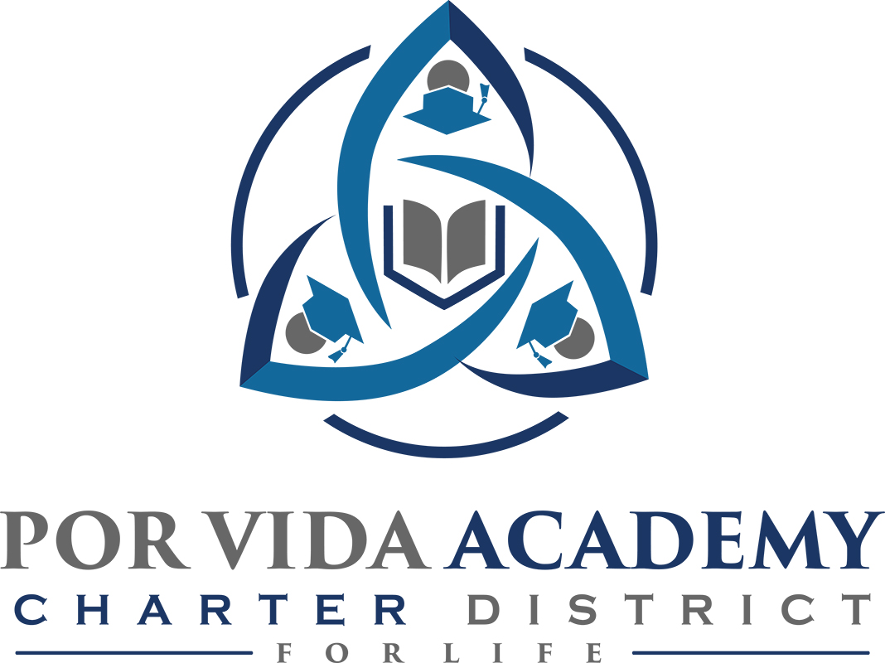

Wednesday, February 26, 2020 at 12:00pm 1135 Mission Road, SA TX 78210

Minutes of Regular Called Board Meeting

- Call to Order and Establishment of Quorum
  - Roll Call & Recording of Board Members Present - Declaration of Quorum Present. Sr. Odilia Korenek, Jose Gonzalez, Edie Cogdell
  - Recording of the Executive Director/Superintendent and Staff Members Present. Joseph G. Rendon, Stephanie Rodriguez, Sandra Valencia, Loren Franckowiak, Ashley Trevino
  - Others present: Dr. Lura Davidson

- Closed Session: None

- Pledge of Allegiance

- Salute to the Texas Flag- “Honor the Texas Flag; I pledge allegiance to thee, Texas, one state under God, one and indivisible.”

- Public Testimony

- Approval of Minutes: January 22, 2020 minutes. Sr. Odilia moves to approve, Jose Gonzales seconded. January minutes approved as presented.

- Superintendent Items:

  - Turnaround Plan. CEC submitted a turnaround plan in addition to target improvement plan and within turnaround plan it details the things that CEC intends to do long term in order to turn campus around and get accountability rating up. Plan consist of different things they would concentrate on with teachers, such as renewing lesson plans, the things in place right now such as look at data from the teachers and force them to use the data to drive their instruction, evaluations, professional development that they are offering, etc. Also working in conjunction with region 20 and Ms. Dill from TEA for review/feedback. Once submitted more feed back expected. Board needs to approve turnaround plan. School must make a selection and we chose the school improvement plan which is to improve foundational practices at the campus by working with a vetted improvement program and/or develop and internal capacity building. This is what we will be submitting to the state. Valencia: on training the teachers through the data disaggregation process, this plan details how they would continue that, details EEP, summer trainings, how they consult with Dr. Davidson and different instructional coaching such as Julie White, what they would do with new staff members. Turnaround plan is a long range plan of services we are able to offer as an organization. Joseph will email board members the plans. Valencia feels like they will pass they have worked so hard and feels like they are seeing results. Jose Gonzales, is there a plan b? There is no plan b, school will close. Edie moves to approve, Jose seconded. Turnaroud plan approved as presented.

  - Principal Reports CCCP: haven’t had any new changes from the last time, other than NHS members about to be inducted, our ENT program about to start working in the ambulance and helping patients medical responses.100% of seniors being accepted to a college or university. PVA: not much changes from last time. Exciting news, one of our students took the TSI and scored very high, those things help us for domain 3 for accountability. He had a high score in English and had the highest score on the essay portion that you can get. He also got an internship with Pablo he’s making $12 an hour in IT. The requirement is he needs to be enrolled in an IT program. He starts tomorrow. For the first time, we are going to have multiple distinguished grads.

  - Monitor Report. Dr. Davidson, yes they are working very diligently all three campuses, sees a difference in the way they are approaching using the data, asks questions. TEA and the direction they are moving, overall accountability. Recently they released the state scores, it isn’t just a rough score but they put them in the formula so the different content areas as you look at the them so they can support one another. They just recently put up the Christmas scale scores from the EOC and they filled it up a couple points, the other part in regards to that, right now they have 3 different areas that they are giving school districts/charters They have approach which the federal government clearly tells the state that is not acceptable. They said approaching is not what title one federal money is looking towards for all the states in the United States, so they are still looking at approaching with full knowledge within one year or two, anticipating that it will be at Leaps. They have 2 things that they are doing that will impact Por Vida Academy, we are using the data to help ask questions they continue to peel down and look at each individual student to see how they are doing. Por Vida doing very well rounding up students. Overall the district is moving towards a system, if one area falls short, an alert will go out, you come in and fix it. We are looking at all these different aspects . This year they are going very deep. They are making progress and is continuing to work with the governance and reports that. The committee has been formed to review but committee at TEA has not started.

  - Superintendent purchase of laptop: There is an old apple laptop 2015 that Joseph wants to buy. Pablo said a couple hundred bucks was fine. Jose moves to approve the laptop for Superintendent. Sr. Odilia seconded. Purchase of old laptop approved.

  - Termination of TDA agreement: Every year we enter to an agreement with Texas Department of Agriculture to run our National School Lunch program, we serve a reimbursable meal, and they reimburse us at a certain dollar amount. We make approximately $50,000 a year in reimbursable meals. We are on 3 year cycle for reviews, we just completed our review with the Texas Department of Agriculture and we have a whole boat load of issues we need to address. In a nutshell we would have to replace our current staff to be able to do the work that needs to be done that’s required. They do not have the skill set to run the National School Lunch program as the Dept of Agriculture requires it. They have gone to trainings and just can’t do it. We can do 2 things, we can fire them and hire new people who are qualifies to run the program, or the other option is to terminate the agreement and realize that we will lose the reimbursable meals revenue of about $50,000 a year, the positive to that is now all students can eat for free because we don’t have the requirement of free or reduced lunch. We keep the requirement of having students who qualify for free lunch, have to be given a free lunch that is a state requirement not a federal one. So if we terminate agreement with TDA the State of Texas says, if you have a local program then you are still required give kids who qualify for a free lunch a free lunch through TEA, if we terminate the agreement of course now every kid would be able to eat for free. The meals we change significantly. Attorneys and TDA say what they have seen in another programs, more kids eat. We no longer have to meet the requirements through TDA so meals will be less healthy. The other change is now the cafeteria can serve meals to the public, child development, etc. We are hoping we can offset some the costs of losing the revenue from the School lunch program. Attorneys are prepared to do a policy for a local defined program. This will be effective February 1, 2020. We will not be submitting February claims. We need to close out the review as of January 31, 2020. Jose Gonzalez moves to approve to terminate TDA agreement as proposed by Superintendent. Edie Cogdell seconded. TDA agreement termination approved as presented.

  - Disposition of surplus property: Joseph has had conversations with Attorneys about property/items since we moved one campus into the other campus. We have three full storage units from Corpus, see list. Attorneys said have board sign this resolution so we can dispose of them of how we see fit. Everything under $5,000, furniture, laptops, accessories, etc. We will keep some of the items but most of it will be sold. We have a bunch of stuff we want to open up to the staff, community, students, and public. So lawyers drew up this resolution. Edie has a couple of recommendations, this appears disposing of property right now, does not authorize you to sell property that’s deemed surplus in the future, can we modify it so that’s a standing resolution, something like any equipment designated as surplus in the future you won’t have to do another resolution. It also states that it is referring to stuff that was acquired with states funds. Joseph: all the federal money that we have is not capital outlay, so those federal grants that we have when they are under we already have permission to dispose of them. Edie: so you could modify this to include any other funds as well and you might want to define anything that wasn’t capitalized that was a unit cost of less than $5,000 just to be clear. How are you going to determine what you’re selling it for? Joseph, IT will come and wipe all the computers, they will also make recommendations of selling amounts on computers. Edie: recommends setting some kind of selling price, don’t want any issues between employees if not treated equally. If nobody takes equipment and make an offer then they can take it. Edie moves that they approve the resolution as amended. Jose seconded. Resolution is approved that we dispose of surplus property as per amended with Edie Cogdell suggestions and Jose and Sr. Odilia approval.

- Financials
  - Latest financials. Edie moves to approve, Sister Odilia seconded. February 25, 2020 financials approved as presented once amendments are made. Edie questioned the $55,000 in misc. revenue what that for (stipends for teacher trainings was a portion of it and E-rate was the other half) also Fund 240 needs to be amended. Will move misc revenue to bank savings. Edie also moves to approve January financials statements. Sr. Odilia second.

- Board Items: April meeting date

- Adjournment. Sr. Odilia Korenek adjourned the meeting at 1:20 p.m.

___________________________________ _________________________
Sr. Odilia Korenek Date Edith Cogdell Date
President Secretary

