Veterans High School
Spanish 1 Syllabus
Señor Vivas (Roberto.vivas@hcbe.net)

Bienvenidos estudiantes a la clase de Español 1.
Please review the following information to ensure you understand the class expectations and what you need to do to succeed in Spanish class this semester. Parents/guardians need to review this syllabus with students then sign and return the last page. If you have any questions or comments, please contact me by email at Roberto.vivas@hcbe.net . You can also call the school office and leave a message for me at 478-218-7537.

Course Description: The Level I language course focuses on the development of communicative competence in the target language and understanding of the culture(s) of the people who speak the language. Student’s main focus will be on communicating about their immediate world and daily life activities, read material on familiar topics, and write short, directed compositions.

Please visit the following web site for information on course standards:
https://www.georgiastandards.org/standards/pages/BrowseStandards/MLLStandards9-12.aspx

Textbook – Santillana Español level 1. Student must replace book if lost.

Materials: Please be prepared for each class meeting with the following materials:
- Textbook, three-ring binder – with white lined paper, and a pen or a pencil.

The material, if properly organized, will help you in your progression of learning the Spanish Language. It will also be a great tool to prepare you for each quiz and test. It is important for you to keep all of your papers organized in your binder.

Grading System: There are four categories for grades in Spanish 1 class:

Daily Work………………………………………..15%
Minor Assessment………………………………20%
Major assessment……………………………….45%
Final Assessment………………………………..20%

This course includes a cumulative exam at the end of the semester, which counts for 20% of the grade. Students will also be assessed through a variety of methods including: Authentic assessments, participation in oral exercises, traditional tests / quizzes, daily assignments. Students need to plan on a test or a quiz every week, typically on Fridays.

**Students and parents should check grades regularly in Infinite Campus to keep track of course progress. Infinite Campus can be found in the parents’ link: http://www.hcbe.net/parents.aspx

Class Expectations:
- Come to class prepared with materials and on time.
- ALWAYS be respectful of self, others, and school property.
- Gum, food and drinks are not allowed in the classroom (except for water).
- Sleeping in class is not allowed. Detention will be given for those who do not comply.
- Students are expected to have all assigned work completed and ready to turn in at the beginning of the class period.
Late homework will not be accepted. Homework must be turned in when due. Any work started in the class and not finished due to lack of time, needs to be finished for HOMEWORK!

Test Retake: Students will be allowed to retake two tests per semester. To retake a test, student must first attend tutoring and complete the retake within a five-day window. After the five-day window, students will not be allowed to retake that test.

Daily participation is necessary for successful acquisition of language skills. Absences directly impact your progress toward the learning goals of the class.
- Take responsibility for your learning (be motivated to learn and have a positive attitude).
- Be on time, be prepared, be on TASK.
- All the rules on the student handbook apply and will be enforced.

Academics and Class Requirements:
- Review material covered in class daily.
- Ask questions in class or after class if you do not understand the material.
- Tests will be announced well in advance. Some quizzes will be announced and some will not.
- It is the student’s responsibility to get assignments missed from an excused absence and complete it within five days. Failure to complete them will result in a zero.
- Textbooks will be issued. However, if materials are lost or barcode is missing the student will have to purchase the replacement.
- Permission to use the restroom will only be given in extreme emergencies. Plan to go between classes.
- When you are in Spanish class, you are expected to do work from Spanish class only. Do not bring in other work to do from other classes. No compliance will result in Detention.

Consequences:
- First offense: teacher discretion
- Second offense: After school detention
- Third offense: parental contact
- Multiple offenses: office referral

Cheating and plagiarism: Cheating and plagiarism will not be tolerated. “If a student cheats or plagiarizes, the result is a zero tor the task grade and parent contact; if the cheating or plagiarism occurs on a major assessment, the result also includes in-school suspension. Any task that results in a zero for cheating is not eligible for a re-test or makeup assignment. The ISS assignment will be progressively graduated if it is a repeated offense”

Cyberbullying: As defined by Dictionary.com, “the act of harassing someone online by sending or posting mean messages.” Please keep in mind that the Edmodo communication system is designed to work as an extension of the classroom; therefore, anything done on the site through the access of a school course group code will be treated the same as if it were said aloud in the classroom. Inappropriate comments or use of the site can result in disciplinary action.

How to access Google Classroom

Step One:
Go to the county’s website and click on SSO Portal.
Or, click on the link below:
https://portal.hcbe.net/_auth/Login.aspx?ru=L3Nzby9wb3J0YWw=
Step Two:
Students should sign in using their school/county username and password. If you have questions on your username and password, please ask your teacher.

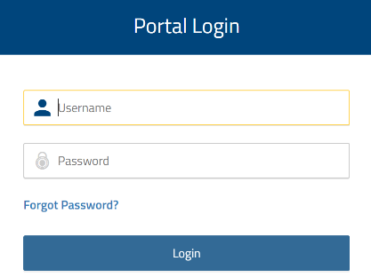

Step Three:

Students should click on the Google Classroom app.
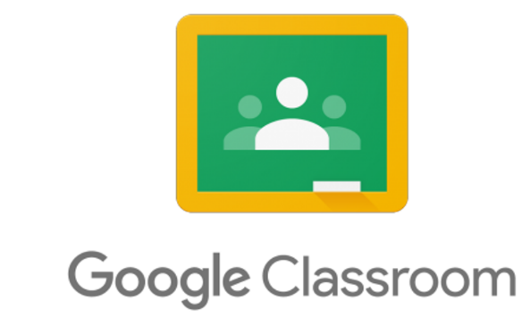

Step Four:
Let’s get to work! When they sign into Google Classroom, they should see several “classrooms’. They simply click on ‘JOIN’ for each class.

Please Complete and return this page only. Save page 1, 2 and 3 in your notebook

Student printed Name: ___________________________________________
Student Signature: ______________________________________________
PERIOD #_______

I have read the Spanish 1 syllabus and understand what is expected of my child. I also realize that if I have any questions or concerns, I can email Mr. Vivas at roberto.vivas@hcbe.net or call the school at 478-218-7537, 64650.

Parent printed name: ____________________________________________
Parent signature: _______________________________________________

Please fill in the contact information below. Contact during the semester is made mostly through email notification.

Current email address #1 ____________________________________

Current email address #2 ____________________________________

- Check box if no email address available.

Daytime number: _________________ / Evening number: _________________

++++++++++++++++++++++++++++++++++++++++++++++++++++++++++++++++

