ALGEBRA 2B

Mrs. Greer Lones
Rm 217
greer.lones@hcbe.net
Phone: 478-988-6340

ALGEBRA 2 DESCRIPTION AND OUTLINE:
Algebra 2 is the culminating course in a sequence of three high school courses designed to ensure career and college readiness. It is designed to prepare students for fourth course options relevant to their career pursuits. High school course content standards are listed by conceptual categories including Number and Quantity, Algebra, Functions, Geometry, and Statistics and Probability. Conceptual categories portray a coherent view of high school mathematics content; a student’s work with functions, for example, crosses a number of traditional course boundaries.
(PREREQUISITE: ALGEBRA 1 & GEOMETRY)

GRADING:
45% Major Assessments (Tests/Projects/Presentations)
20% Minor Assessments (Quizzes)
15% Daily (Classwork/Warm-Ups/Homework)
20% Final Exam

45% Major Assessments: Students will take 5-6 tests each semester. If the desired mastery of the standards is not met at that time, the student will have the opportunity to retake two tests each semester. Students are strongly encouraged to be present on test days. When students miss an assessment the student is required to take a quiz or test on scheduled day or on day of return if previously announced.

20% Minor Assessments: Quizzes will be used throughout a unit to determine mastery of concepts along the way. This will serve as formative feedback and great study tools for unit tests.

15% Daily Work and Homework: Homework is a vital part of learning mathematics and is a requirement for this class. It will all be collected each Friday. One homework grade for each week will be entered into Infinite Campus. To receive full credit for homework, all problems are expected to be attempted. Answers alone will not be sufficient for credit. Show all work! Missed homework may be completed for full credit during academic detention. I will assign you a time and date for detention.

DISCIPLINE POLICIES:
Be Prepared | - Classwork/Homework  - Materials: Pencil, 3-ring binder, calculator  - You may bring an electronic device on designated days
Expect Excellence | - Follow all instructions  - Challenge yourself  - Do not distract yourself or others by using a cell phone  - Respect class time: Take care of personal errands before class begins (restroom, attendance office, locker, etc.) Restroom passes are only for emergencies and will be limited.  Lost class time = Lost learning opportunities  - Produce work of exceptional quality  - Show all steps when solving a problem  - Show willingness to present work to the class
Always Be on Time | - Be on time to class each day  - Turn in work on time  - Make up work on time
Respect Everyone | - Respect the opinions of others  - Respect your teacher and her decisions  - Do not make disrespectful comments about other students, teachers, or school staff  - Be able to work both individually and cooperatively Remember that cooperative work requires an equal amount of contribution from all members of the group
Show Bear Pride | - Do not bring outside food/drink into class (exception: bottled water)  - Keep the classroom clean and throw away trash  - Always have a positive attitude in class!  - Pay attention to due dates  - Plan for your future  - Take responsibility for your actions  - Read and follow all rules in the Student Handbook

Consequences for Failure to Follow Rules and Procedures:
Step 1: MIR Warning
Step 2: MIR & Parent contact
Step 3: MIR, Parent Contact and teacher detention
Step 4: Office referral

Please Note: The discipline plan is progressive and follows the PBIS structure. Some offenses may automatically move a student to step 4 (for example: severe disrespect, fighting, cheating, etc.)

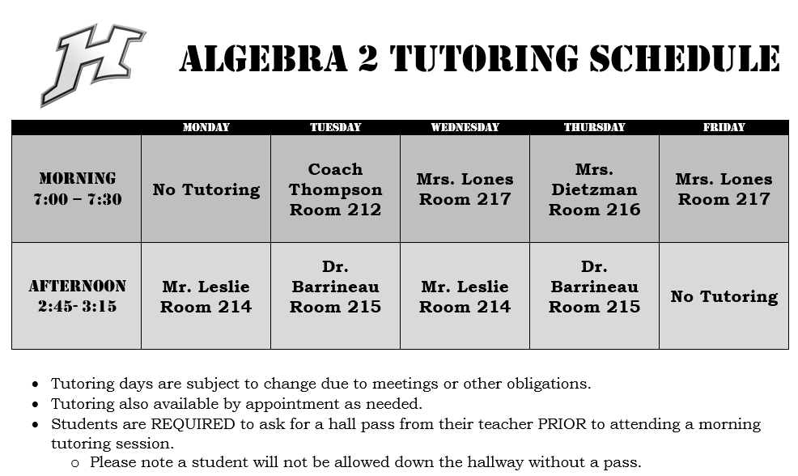
CLASSROOM PROCEDURES:
- Materials – You will need the following things for success in this class:
- PENCIL AND PAPER!! This is a MATH class, and we do our work in PENCIL.
- TI-84 or TI-Nspire calculators are recommended for this class. I will have a single class set of TI-84 for use in class but do not have enough for everyone to check out on a nightly basis. It is HIGHLY recommended that you buy a TI-84 or a TI-Nspire for your own personal use at home on homework. You can use either of the two mentioned on your ACT/SAT and throughout college. DO NOT purchase the TI-Nspire with the keyboard at the bottom.
- Graph paper
- Warm Up – Each day when you enter class, there will be a Warm-Up for you to begin. These are designed to either review the previous day’s work or prepare you for the present day’s lesson. I expect you to handle any “business” before the bell rings. Class begins as soon as you enter the classroom. Therefore, you should begin the Warm-Up immediately upon entering.
- Restroom – Only one person will be allowed to go to the restroom at any given time.
- Absences – When you are absent from class, it is your responsibility to get the work that you missed while you were gone. All homework you miss will be posted on the assignment board. It is best to complete a Quiz/Test after school, but if necessary, you may take it during class; if either are made up during class, you are responsible for all material missed. You will find copies of the handouts in the file cabinet at the front of the classroom. I am always available before school to answer questions about any work that you missed. Remember that you have five class days to make up any missed assignments following an excused absence. Tell me in advance if you will miss my class because of a non-instructional absence (NI), AND ask me for the assignments for the days that you will miss. Upon your return, you are expected to have all assignments completed and take any scheduled tests or quizzes.
- Class Weebly – I post our daily notes on glonesmath.weebly.com along with upcoming quiz and test dates.
- Cheating – Any student caught cheating will be referred to the office under a discipline referral and required to make up the assignment at a teacher assigned time. Refer to the handbook for consequences.
- Re-test Policy – You are allowed to re-take TWO tests per semester. To be eligible to re-take the test, you must come to at least one session of tutoring and correct all missed problems on your test. I will check your corrections before you can retake the test.
- Food - Food will not be allowed in class. If it is open upon arrival, please throw away in the trashcan. If you leave my room to go get food, it will be thrown away upon return.
- Tutoring –Please see the tutoring schedule listed on the previous page. (You do not have to come see only me. The other Algebra 2 teachers also hold tutoring and I will have a schedule posted in my room of the times.) Schedule is subject to change based on school events (i.e. faculty meetings, parent conferences, etc) so please do not wait until the last minute to seek out help.
- Contacting Me – I will contact your parents often. Do not be alarmed. I will call or email them for positive and negative reasons. You and your parents are always welcome and encouraged to contact me. My contact information is on the top of this syllabus. I will respond to all communication within 24 hours. If you do not hear from me, particularly by email, in that time, assume that I did not receive your message, and try again.
- Cell-phones – I will let you know if we will ever use them for class but please don’t have them out unless we are doing a classroom activity.
- Just Some Extra Info – Do not ask to use the phone during class time unless it is an emergency. Make wise use of your time between classes to take care of personal business. Also, do not ask to go to your car to get anything. Phone and car rules are set by the school, so see your handbook for more information.

I reserve the right to modify, add or delete any policies or procedures, as I deem necessary. You will be notified of any changes immediately.

STUDENT NAME: _____________________________________ CLASS PERIOD: ___________

I have read and understand all the objectives, student expectations, classroom rules and procedures, grading policy, disciplinary consequences, textbook, calculators, and tutoring information in the syllabus for Honors Algebra 2.

Parent/ Guardian Contact Number from 7:15-3:15

Name __________________________________________ Work ( ) ___________________, Cell ( ) ___________________

Name __________________________________________ Work ( ) ___________________, Cell ( ) ___________________

Parent/Guardian E-mail Address (if not updated in the Infinite campus contact information) __________________________________________

__________________________________________

______________________________________ ____________________________________
Parent/Guardian Signature Student Signature

