

Reminders

-**Masks** need to be worn at school.

-Please send a **water bottle** every day.

-**Timed test**: multiplication facts 0-12 with 8 division problems (3 minutes)

-October 5: Bullying Awareness day **(wear blue)**

-October 21: National Bullying Prevention day

**(wear orange)**

-October 26-30: Red Ribbon Week

Mon. **Team Jersey Day** Tues. **P.J Day**

Wed. **Hawaiian Day** Thurs. Western Day

Fri. **Book Character Day**

**Dismissing Every Friday at 1:10-** Starting September 25th- December 18th DCS will be having a 70% day for students every Friday. Please be aware of the new dismissal time!

September 21st – 25th

Homework

Monday:

* Multiplicative comparison worksheet
* Study the study guide

Tuesday:

* Multiplicative comparison worksheet
* Study math facts

Wednesday:

* Multiply by 10, 100, and 1,00 worksheet

Thursday:

* Estimating products worksheet

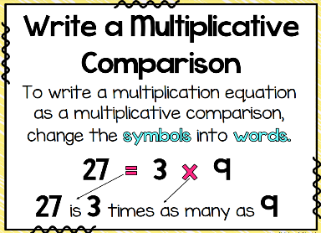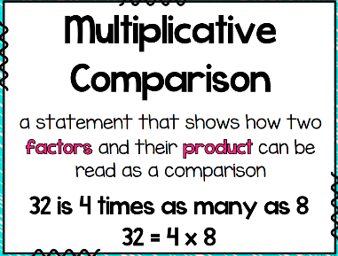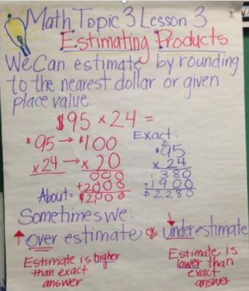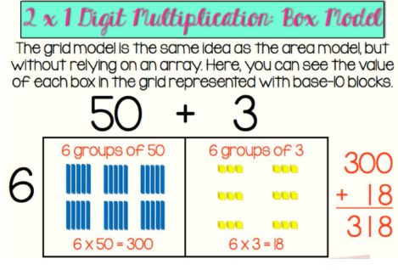[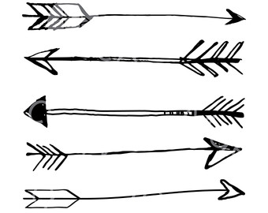](http://www.google.com/url?sa=i&rct=j&q=&esrc=s&source=images&cd=&ved=2ahUKEwjbyMqH2tncAhVGTt8KHRAyARgQjRx6BAgBEAU&url=http://moziru.com/explore/Drawn%20arrow%20transparent%20background/&psig=AOvVaw3O4nvR5-T0PL7ocsxFfq7j&ust=1533688766639822)

What we are learning…

Tests/Projects

-Timed Test 9/23