The Chinn Dynasty Scholarship Fund

Community Foundation of Washington county

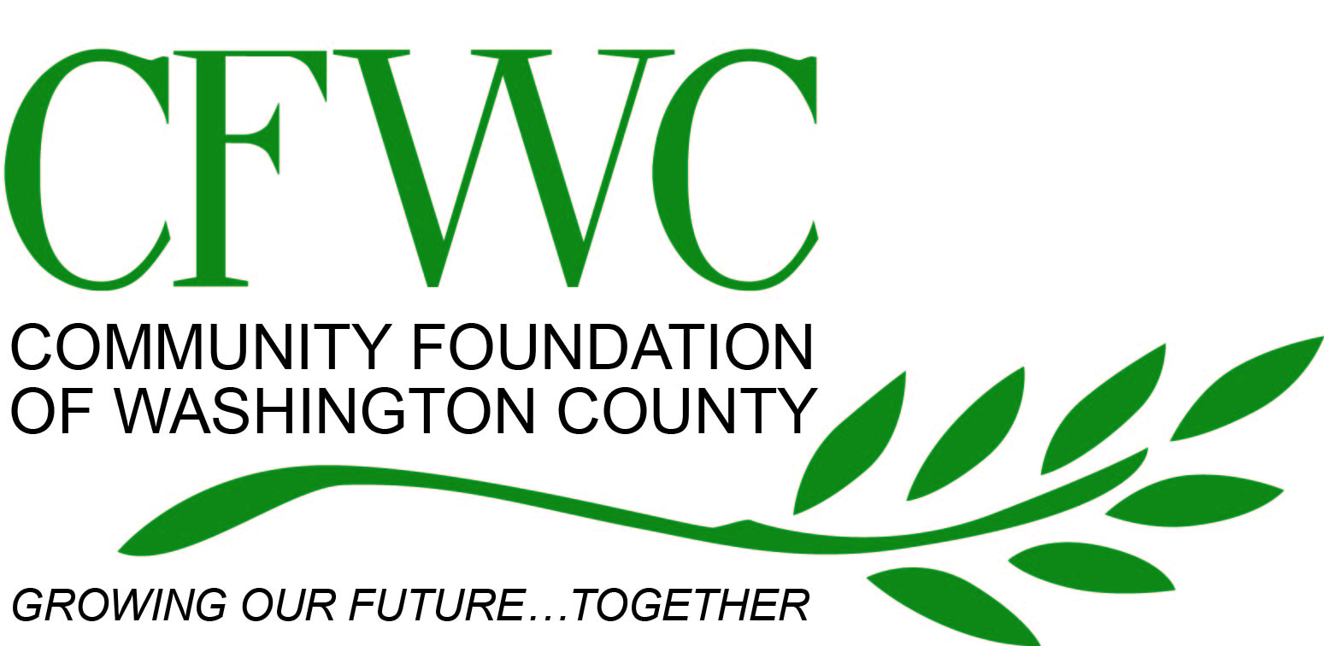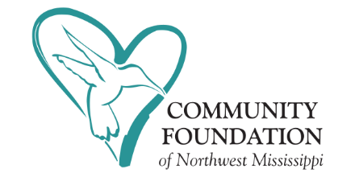

Purpose

The Chinn Dynasty Scholarship was established by Everett and Kiara Chinn to serve and give back to their community. Through their incredible passion for people and their enormous faith in God, Everett and Kiara have committed to work diligently to help all children be successful. Their core belief is that all children can learn and are most unique. Through this scholarship fund, they are leading by example and supporting students to reach their fullest potential and become productive members of society.

Scholarship Information

The Chinn Dynasty Scholarship Fund will make available a scholarship to a qualified candidate who will attend an accredited two-year or four-year college or university in the State of Mississippi or Louisiana.

Criteria
In making a decision, the Scholarship Advisory Committee will use the following criteria:
- Scholastic Achievements
- Extracurricular Activities
- Acceptance to an accredited college or university
- Essay (2 pages not double spaced) answering, “Why are you the ideal candidate to receive this scholarship award this year?”
- Recommendation Letters

Eligibility

- Applicants must be a US citizen, a high school senior from a high school in Washington County who is graduating with the current graduating class, with acceptance to an accredited two-year or four-year college or university in the State of Mississippi or Louisiana.

- Applicants must provide an official transcript in a sealed envelope from the high school currently attending that includes the first semester of senior year. Applicants must have a B average or higher.
- Must register as a full-time student within the next 6 months following date of graduation at any Mississippi or Louisiana junior college, community college, or university. (Note: Proof of enrollment must be provided before funds are distributed.)
- Attach 2 letters of recommendation from the following list of individuals:
  - Guidance Counselor, Teacher, School/District Administrator
  - Leader of a community organization in which the student participates
  - Any other non-family adult of the student’s choosing (i.e. boss, government official or religious leader)

Notification

Applicants will be notified by mail about the status of their application no later than April 23, 2021. The recipient of the Chinn Dynasty Scholarship will be announced no later than May 1, 2021. Scholarship funds will be distributed directly to the institution of the applicant’s choice no later than August 1, 2021.

Guidelines
Each complete application must be received by the Community Foundation by April 16, 2021.
- Completed application form
- Essay (2 pages not double spaced) answering, “Why are you the ideal candidate to receive this scholarship award this year?”
- Official high school transcripts
- Copy of ACT and/or SAT score
- Resume
- Two signed letters of recommendation. Letters must be sealed by the author.

Questions

Contact the Community Foundation of Washington County at 662.580.4500 or email us at tlane@cfwashco.org.

The Chinn Dynasty Scholarship

Application

Scholarship Application
Full Name: __________ ___________ SSN: ______________
Date of Birth: Country of Birth: ______
Mailing Address: ______
City: _____________________________________ State: ________________ Zip: ____________________
Home Phone: ______ Cell Phone: _
Email Address: _____________________________________
Parent/Legal Guardian: _______
Parent/Legal Guardian’s Address: _________________________________________________________
High School Attended/ Attending: Graduation Date: ________________
H.S. School Address: ________________City: ____________________State: Zip:
Current GPA: ACT Score: or SAT Score: ______

Previous College and/or university attended: Years Attended: ______
College and/or university you plan to attend: ______
College Address: __________________________City: __________________Stae:________Zip:_______
Class Level: ____________________________ College GPA: _____________________________________
Major / Career Goals: ____________________________________________________________________
Briefly describe your family living situation (example: single or two parent home, or guardian including relationship).
_______________________________________________________________________________________
_______________________________________________________________________________________
_______________________________________________________________________________________

List honors / awards / scholastic achievements that you have received in the last four years (include the year received):
_______________________________________________________________________________________
_______________________________________________________________________________________
_______________________________________________________________________________________

List school or community activities that have been most significant to you during the last four years:

Activity: | Position Held: | Date from: | Date to: | Ave. # of Hours:

List any work experience (including summer and part-time) you have had over the past four years:
Job Title Position Held Dates of Employment (mm/yyyy) Average # of Hours/Week

Name and amounts of any scholarships you expect to receive:
(Please do not apply if you are receiving a full scholarship, including books from another source)

Essay
For the following question, attach separate pages with your typed answers (put your name at the top of each additional page). This essay should be 2 pages, typed and not double spaced.
“Why are you the ideal candidate to receive this scholarship award this year?”

I certify that all information on this form is true and complete to the best of my knowledge. I understand that I may be asked to provide proof of information stated on this form.

Signature of Applicant: Date:

Application Checklist
I have included one copy of the following:

- Completed application form
- Essay
- 2 Letters of Recommendation (please list names)

- Official high school transcript – must include 1st semester of Senior Year
- Copy of ACT or SAT score
- Resume

Completed application must be received at the address below by April 16, 2021:
Community Foundation of Washington County
P.O. Box 5910
Greenville, MS 38704

