Just for Fun! Week 8

Warning: There are a few spelling errors in the crossword puzzle. I did not create it!
I found it online.
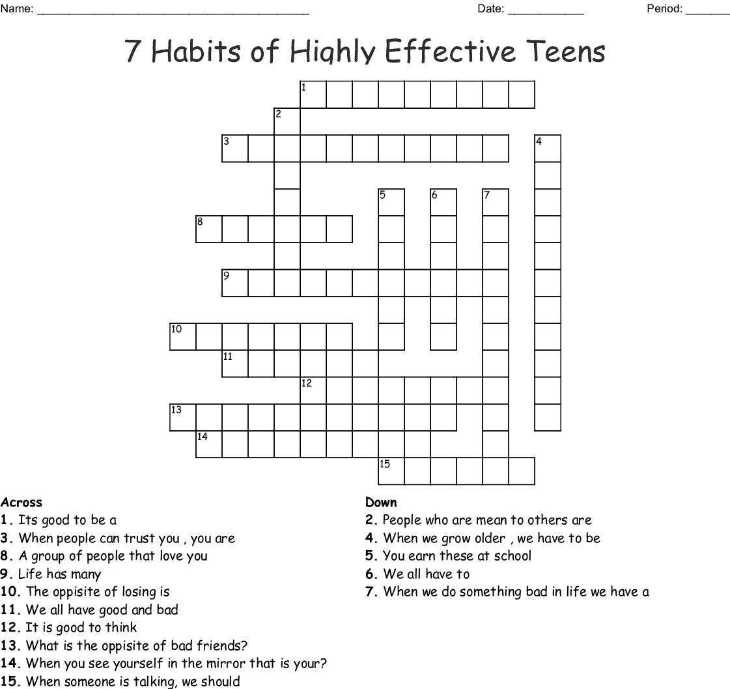

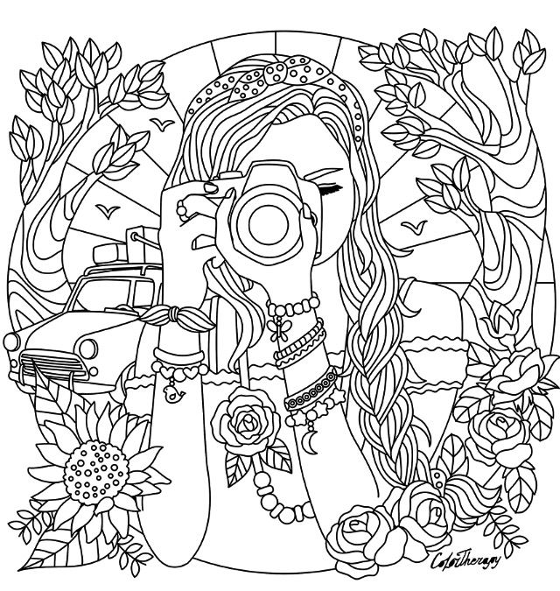

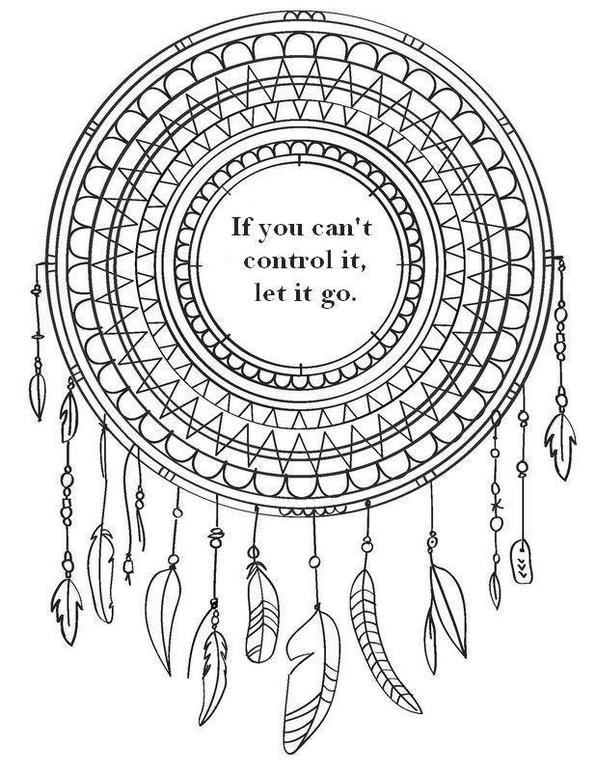
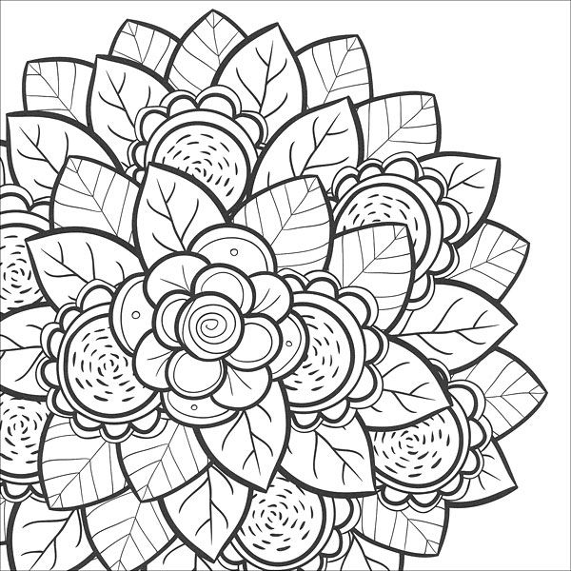

Answer Key to Crossword Puzzle
This crossword contains the following questions and answers:
What is the opposite of bad friends? Good friends
When you see yourself in the mirror that is your? Self-Image
People who are mean to others are Bullies
When people can trust you , you are Trust worthy
You earn these at school Grades
A group of people that love you Family
Life has many Ups and downs
Its good to be a Proactive
It is good to think Positive
We all have to Grow up
When we do something bad in life we have a Consequence
We all have good and bad Habits
The opposite of losing is Winning
When someone is talking, we should Listen
When we grow older , we have to be Responsible

