To install:
- Open the mpsetup zip file
- extract all files (it’s just one)
- run the program!
- Say yes/ok to any prompts that pop up

To REALLY save your work:
You have to copy ALL the mixpad project folders to your Google Drive, plus the mixpad file (it looks like the program icon). It’s a great idea to save all of the music files you plan to use to your drive folders as well.
It will look like the two I have highlighted in the file below.
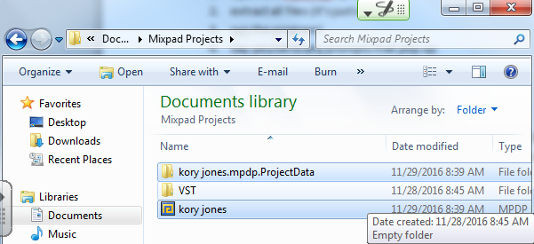
*If you are saving to DRIVE, you have to open the .ProjectData folder and save everything INSIDE*

Your finished project should look something like this:
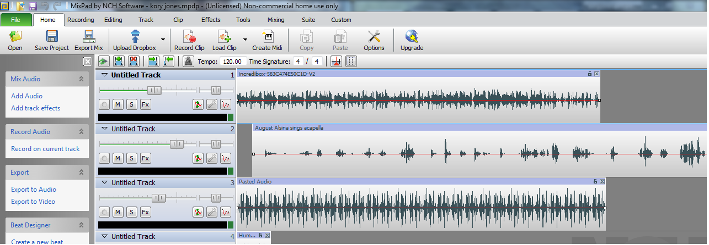
To edit speed, notes, or other effects for your music you should RIGHT click on the track you want to edit:
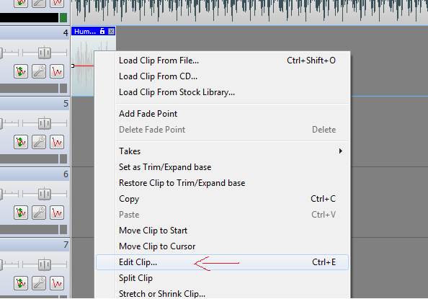
It will open WAVEPAD, which it might make you install first. There are cool effect choices inside the program, so play around. I typed a description next to the buttons to change the speed or notes of your clip.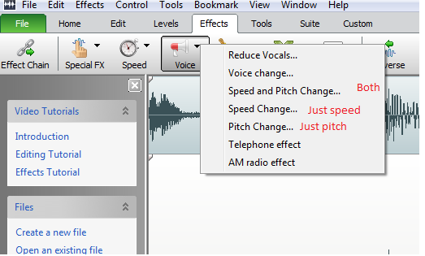
The other effects in MIXPAD can be cool too, so play around with them.

To convert youtube videos:
Be sure you copy the whole LINK from the address bar. If you open the rubric I posted, you can follow the link to the one that works from school.

ANY QUESTIONS? ASK ME!!!!

