**Lockard Elementary School**





News Letter

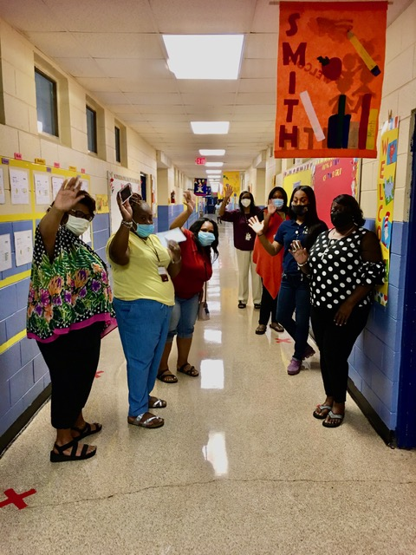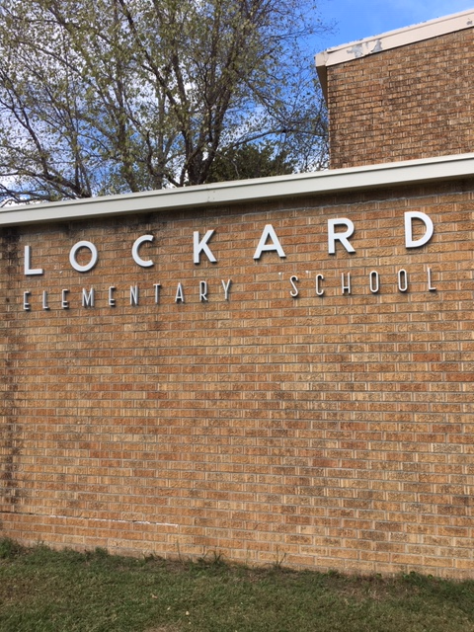

Music Room

The students in music have been learning about various holidays over the month of February. Valentines, Mardi Gras, and National Tortilla Chip Day.

C.Ray, Music Teacher



**Daphne Heflin-Principal**

**Terrell Hayes – Assistant Principal**

Linda Rule – Parent Liaison Parent Center Hours - Monday-Friday 8:00AM-3:00PM





Library Life

Happy March!

What a great month! (I know that I say that every month, but it's true! All months are great for reading and learning.) We have **Dr. Seuss spirit week** and **Read Across America**, Spring break, and **St. Patrick's Day**, and Spring is coming! Woohoo! Check out our **Spring rooms in LLL** (Lockard Little Library)!

This month we will be reading lots of **Dr. Seuss**and learning about **national monuments and landmarks** as well as studying **text features and dictionaries.**

Be sure to go to your library course to check out all of these great resources:

**Lockard Little Library (LLL)** which has new February rooms with winter themes.

You may use **EPIC** every day as well. Click on the word EPIC and use the class code **ayh5887**.

You may use **JLG** every day.  Username and password is **Lockard.**

One other source you may use is **MackinVIA**.  This is available in Clever.

As always, happy, happy reading to all of you.

.0



Mrs. Burkett

March Student of the Month

Shamika Johnson

March Parent of the Month

Jaylen Johnson

**Mason Memo**

**Student Attendance Really Matters**

Recently, I was reading an article about student attendance and I was reminded of a few common sense facts:

*There is a direct relationship between student attendance and student achievement.

*Teacher effectiveness is a strong school-related factor of student success,

*Chronic student absence **reduces even the best teacher's ability** to provide learning opportunities.

*Students who attend school regularly have been shown to achieve at higher levels than students who do not have regular attendance.

*Absenteeism in kindergarten was associated with negative first grade outcomes such as greater absenteeism in subsequent years and lower achievement in reading, math, and general knowledge.

***So, to put it in a nutshell, a student can have the best teacher in the country but if they don’t come to school or log into their virtual classes their achievement and future could be negatively affected.***

National Center for Educational Statistics February 2009

March Teacher of the Month

Cheryl Neal

March Calendar 2021

* 3rd Nine Weeks Assessment 3/1/21-3/5/21
* Spring Break – 3/8/12-3/12/21
* Teacher Work Day – 3/15/21
* Students Return – 3/16/21
* Math Biweekly – 3/18/21
* Report Card Issued – 3/22/21-3/26/21
* ELA BiWeekly – 2/25/21
* Awards Day – 3/26/21

