Mrs. Cook’s Messages
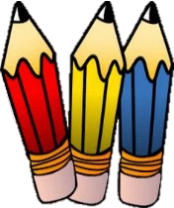
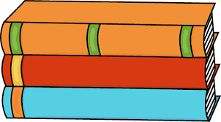
May 3-7, 2021
Grammar (quotation marks) and
Reading Skills (author’s purpose) Tests: Thursday
Vocabulary, Spelling (abbreviations), and Topic 15 Math Tests: Friday
DIBELS TESTING
DIBELS testing will take place at school this week. Please try to have your child at school each day. I will be testing each child for the end of the year DIBELS assessment.
Story:  “Red, White, and Blue”  by John Herman  Phonics/Fluency:  abbreviations  Text-Based Comprehension:  author’s purpose; summarize  Grammar:  quotation marks |  | Selection Vocabulary Words (Students will be tested on these):  - America – the United States of America  - birthday – the day someone was born or something began, usually  celebrated yearly  - flag - a piece of cloth, usually with square corners, with a picture or pattern that stands for some country  - freedom – the condition of not being under someone else’s control  - nickname – names used instead of real names  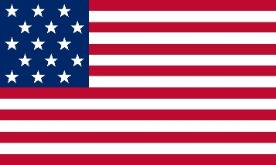  - stars – shapes that have five or more points  - stripes – long, narrow bands of color  Amazing Words  history, symbol, unfurl, allegiance,  independence, patriotic, frayed, indivisible
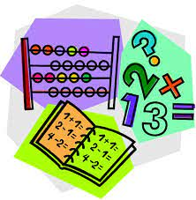  Topic 15: Measuring Length  Lesson 7: Adding and Subtracting  in Measurement  Lesson 8: Comparing Lengths  Lesson 9: Problem Solving (Use Objects)  Topic 15 Test will be on Friday! |  |  | Social Studies/Science  Students will understand that people need to use resources carefully, so that they do not run out. We will discuss ways to conserve resources. We  will also learn that some living things  are in danger of becoming extinct  and need to be protected.
Spelling Words:
- Mr.  - Mrs.  - St. | - Jan.  - Feb.  - Aug. |  |  | - Dr.  - Ms.  - Rd. | - Oct.  - Nov.  - Dec.

