Unit 7 QUIZ

1. “If you neighbor’s house was on fire, and he didn’t have a water hose, wouldn’t it make sense to let him use your hose to fight the fire so the fire could be put out before it spread to your house?”

This question was raised by FDR to justify:

a. Neutrality Acts

b. Kellogg-Briand Act

c. Lend-Lease Act

d. Munich Pact

2. The economic impact of WW2 in the U.S. included all of the following EXCEPT:

a. Low unemployment

b. The forced rationing of many foods and other items

c. A continuation of the troubles of the Great Depression

d. Many new workers taking jobs previously off-limits to them

3. Which event from WW2 best illustrates the government’s willingness to place national security above individual liberty?

a. The creation of propaganda

b. The bracero program

c. Schenk vs. the U.S.

d. The internment of Japanese Americans

4. Who were the defendants at the Nuremburg Trials?

a. Nazi Leaders

b. Soviet Occupants of Eastern European countries

c. The developers of the atomic bomb

d. Japanese war criminals

5. The Neutrality Acts were in part a reaction to which of the following beliefs?

a. Alliances had drawn the US into WW1

b. The U.S. could not win another war

c. The US had to prepare to help the British

d. US participation in the next war was inevitable

6.



7.



8.



9.

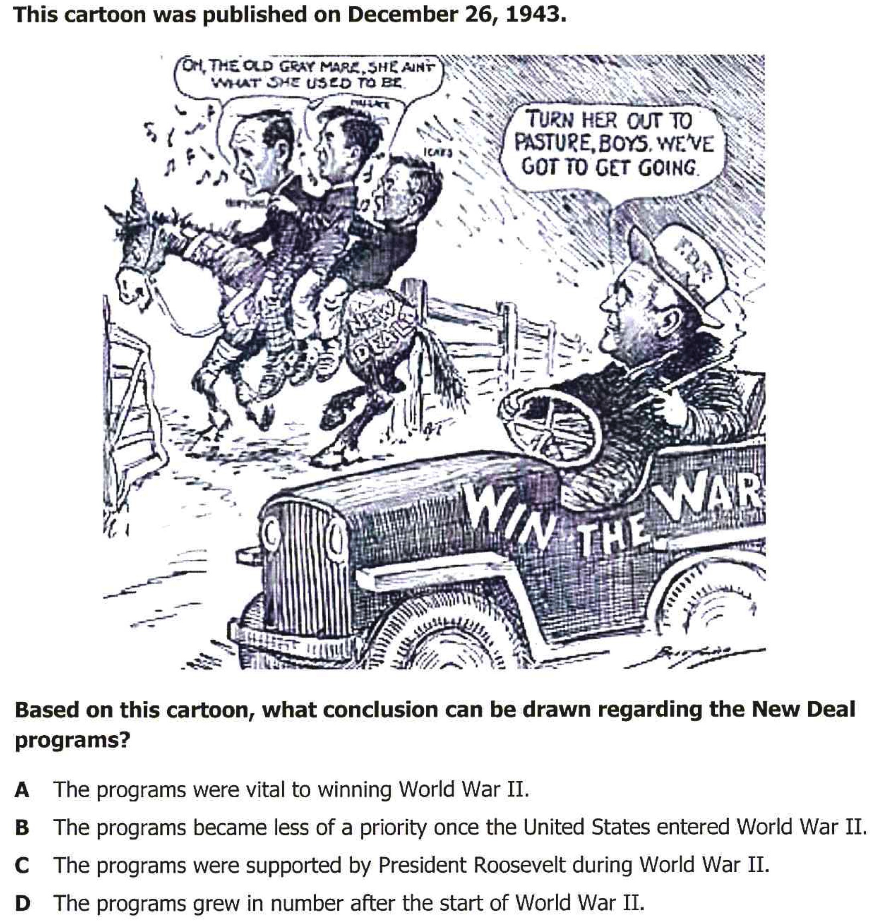

10.

