BODY STRESS
Mark the places on the body where you feel stress. Answer the following:
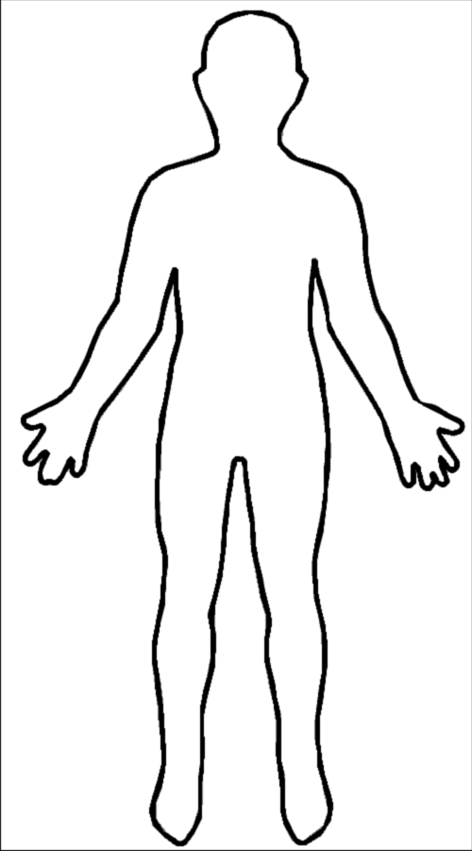
Physically, I feel stress:
______________________________
______________________________
______________________________
______________________________
Things that cause me stress:
______________________________
______________________________
______________________________
______________________________
A lot of stress makes me:
______________________________
______________________________
______________________________
______________________________
What I do to relax:
_______________________________
_______________________________
_______________________________
_______________________________

