 **Eagle Update August 18, 2020**

**WELCOME TO THE 2020-2021 VIRTUAL ORIENTATION**

***We are happy to provide you with uploaded documents to review***

***and the opportunity to sign documents digitally!***

**There are 3 focus areas for today’s orientation:**

1. **Register for PikMyKid no later than Tuesday, Aug. 18.**

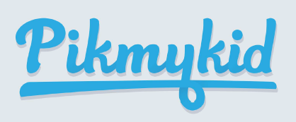

We hope you have all downloaded the PikMyKid App, Registered in the system, and practiced a little. On Wednesday, August 19, we will begin using PikMyKid. There are several Resource Documents in the Parent Portal available in both English and Spanish to help guide you. See next page for information on how to access Resource Documents.

**To get started, complete the following two steps today:**

* **Download the app**

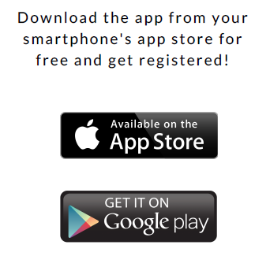 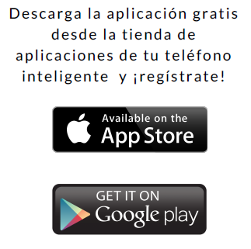

* **Register**

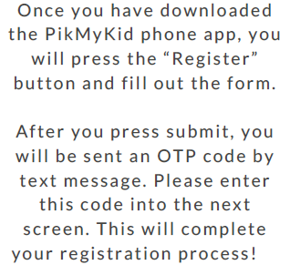 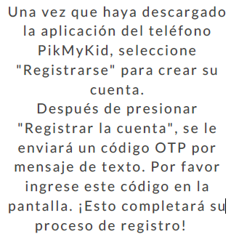

1. **Review documents on the Parent Portal**
   * Log in to the Parent Portal and select Resource Documents on left side of screen
   * Review the PikMyKid documents in English or Spanish: 1) Parent App User Guide and 2) Check-in and Questionnaire
   * If you missed any of the Virtual Parent Meetings or want to review the information, the presentations for all grade levels both On Campus or Distance Learning are available in documents.
   * Review the Google Classroom Directions document (Grades K-8)
   * Review the Return to School Plan document
   * Curbside Meal Pick Up Document for Distance Learners

***This is a screenshot of Resource Documents in the Family Portal. You must log in to the Family Portal in order to access the documents.***

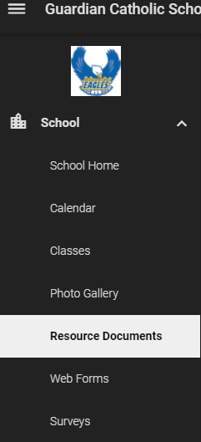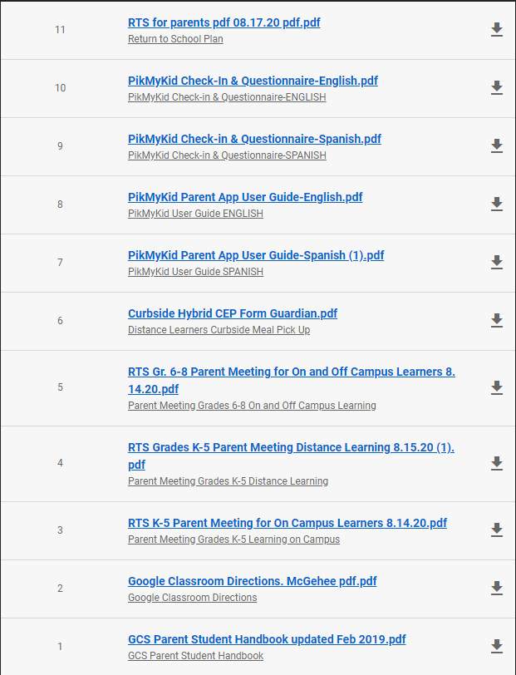

1. **Sign Forms digitally in the Parent Portal – all signatures must be complete by 3pm Tuesday, Aug. 18**
   * Log in to the Parent Portal and select Web Forms on left side of screen
   * Use the **Custodial Parent Form** to update any changes needed in demographic data. It is very important that we have correct phone numbers, addresses, etc.
   * Review and Sign the **Waiver of Liability Relating to COVID-19**.
   * Review and Sign the **Parent Agreement for On Campus Learning** **OR**
   * Review and Sign the **Parent Agreement for Distance Learning**

***This is a screenshot of Web Forms in the Family Portal. You must log in to the Family Portal in order to access and sign the documents.***

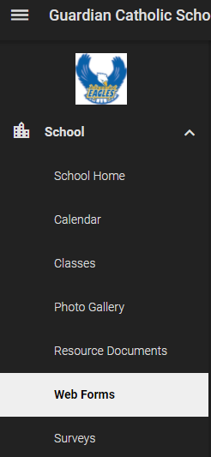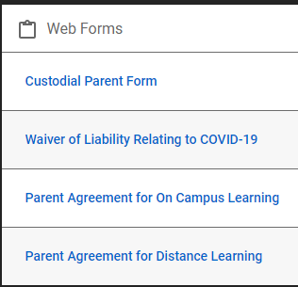

* **August 17, 6 pm PK3 - PK4 Virtual Parent Meeting -** Join the meeting by clicking on the following link: <https://meetings.ringcentral.com/j/4531648027> The link will prompt you to download the Ring Central Meetings app if you don’t already have it downloaded on your device. Please log in at least 10 minutes prior to the start of the meeting.