Quaver Music Login Student Instructions
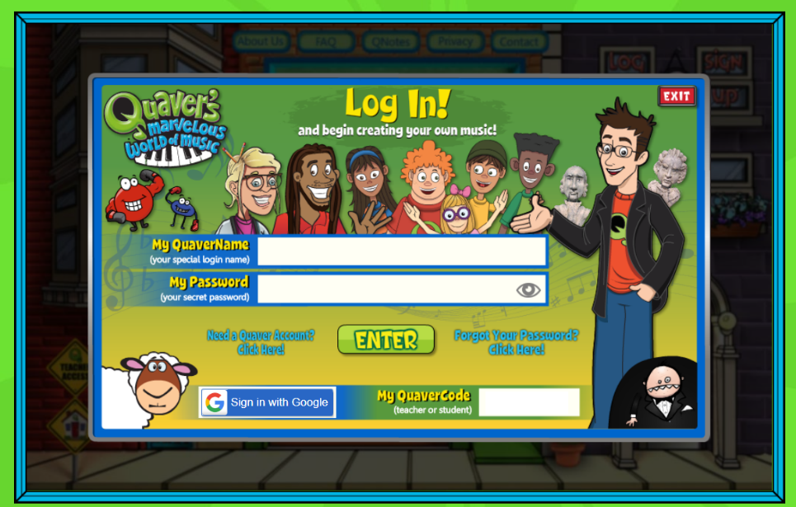
- Go to https://www.quavermusic.com/Login.aspx

2

- Click on “Need a Quaver account?” or Sign Up if you are directed to the main page.
- The username will be the students first and last name separated by a period. (Ex. chris.bowler)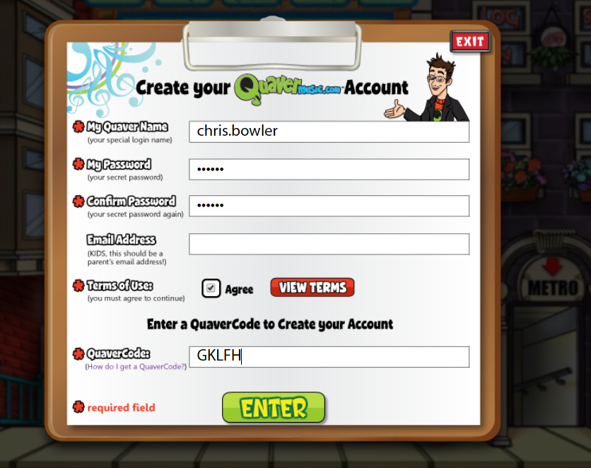
music
music
STEP 5
STEP 4
STEP 3

- Your password will be music. Enter password again on confirm password, then click on agree to terms of use.
- Enter Quaver Code for Grade level:
      - 1st Grade: KSG37
      - 2nd Grade: VG8H5
      - 3rd Grade: NKMDM
      - 4th Grade: EP46G
      - 5th Grade: LMC4G
      - Kindergarten: 4A486
- Click enter. You should see a “Boom Chicka Boom” screen pop up. Click OK.
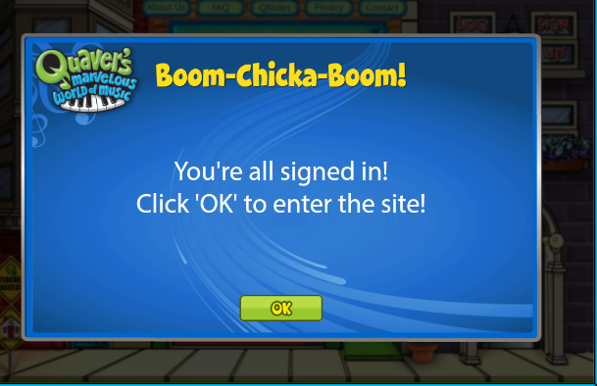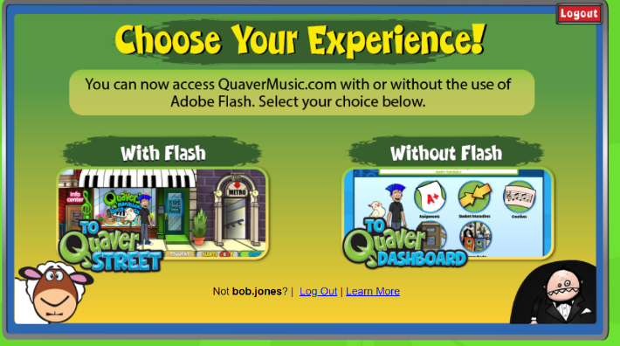
STEP 6
- You should now see a screen that says “Choose Your Experience” with or without flash. If your device does not support flash you will not be able to access Quaver Street and it will go straight to the Dashboard. All of the learning materials and assignments will still be available on The Quaver Dashboard. Quaverstreet has a few games and activities (arcade, Avatar, Metro, etc.) that are not available on the Dashboard. They are converting away from flash but this area is still using it.
- Students can now access all of Quaver’s wonderful enrichment materials.

