Which number line shows skip counting by ten?  A)  140 240 340 440 540  B) 455 460 465 470 475  C)  331 341 351 361 371  D)  201 202 203 204 205 | 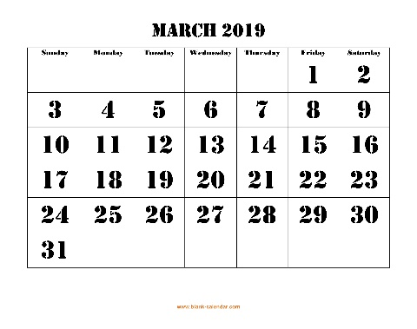  Warren gets paid $100 every Saturday. How much money will he make in the month of March? | Solve using any strategy.  562 – 318 = ?
There were 27 birds in the tree. Some more birds join them. Now there are 52 birds in the tree. How many birds joined them in the tree?  Choose two equations that could help you solve this problem.  A) 27 + _____ = 52  B) 27 + 52 = ____  C) 52 – 27 = _____  D) 27 – 27 = _____  E) 64 + 19 + _____ | What is the value of the group of coins?  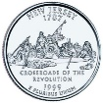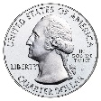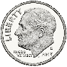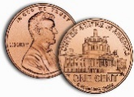  ________________ | Solve using any strategy.  478 + 259 = ?
Chloe had $18.74. She took her little sister to the movies. Now Chloe has $3.51. How much money did she spend at the movies? | Which equation shows the correct number sentence with two equal addends for the group of objects.  A) 6 + 4 = 10  B) 5 + 5 = 10  C) 7 + 3 = 10  D) 8 + 8 = 16 | Max bought an eraser for 74 cents and a pencil for 59 cents. How much more did she spend on the eraser?

