School Messenger – Homework Hotline

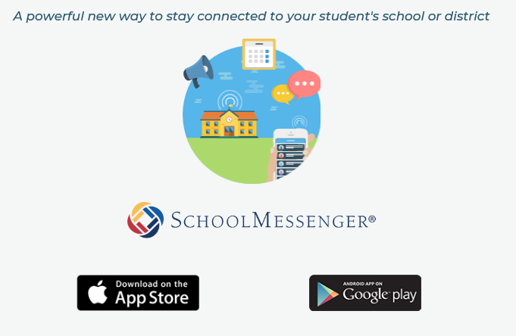
App for Phone
App for Computer
https://go.schoolmessenger.com/#/home

1) Download app for phone and/or computer

2) Follow steps – You will need to verify by using an email – Must be the email listed at school in Infinite Campus.

3) Once you have downloaded and verified the account you will need to enter the team or class code for the messages you would like to receive.

4) The teacher/team leader will then be able to send you homework/test and other announcements.

***If you downloaded the App last year it will work this year. You will need to enter the codes for the teachers this year and it will work. ***

