Autaugaville
Baseball Shirt Order Form
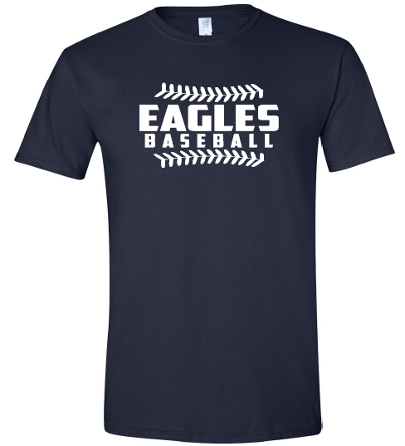
Eagles Baseball Shirt
$15 per shirt
Kids | Youth  Small | Youth Medium | Youth Large
Quantity

 | Small | Medium | Large | X-Large | 2X-Large  + $2.50 | 3X-Large  + $2.50
Quantity

Name: _____________________________________________________________

Total # of Shirts: ___________________________

