

Rules and Procedures

Since I will travel to homeroom classes, STEM will follow each homeroom teacher’s rules and procedures.

Music Expectations

We will be following the Quaver Five as always

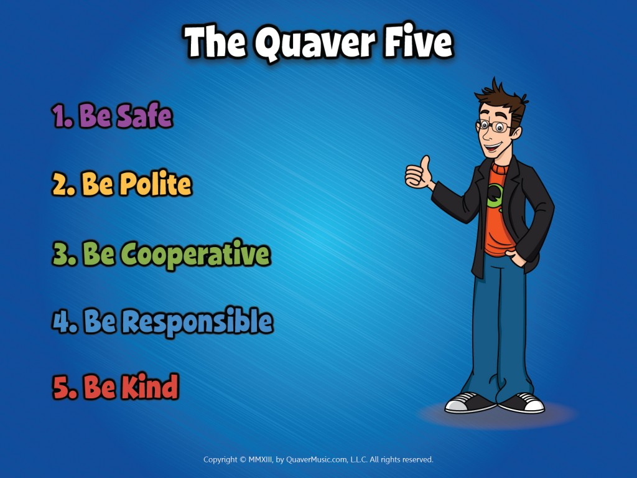

Overview of Music

In Music we will be discussing the Theory of Music and students will be able to create their own music by using cutting edge technology and by using Quavermusic.com

Mr. Seth Phillips [sphillips@dd4.k12.sc.us](mailto:sphillips@dd4.k12.sc.us)

Related Arts Remind: Text to 81010

In the Message Section, Enter: @wmesra

Grading

Music activities will be graded based on Related Arts’ grading scale.

E – Excellent (100 – 80)

S – Satisfactory (79 – 60)

U – Unsatisfactory (50 or below)

Additional Resources

Students will be given a login to Quavermusic.com and be expected to login during music class in order to complete assignments relating to what is discussed in music.

If your child already has an account from last year they will be allowed to use that account again this year.