AP European History Assignment Part ONE MEDIEVAL EUROPE:
FROM THE FALL OF ROME TO THE RENAISSANCE

A BACKGROUND READING LINKING CLASSICAL TO MODERN TIMES
(Reprinted with permission from George Roswell, Rancho Buena Vista High School, Vista, CA. May 2010) (Edited by Theresa Tempesta of Massaponax HS, Fredericksburg, VA, May 2014)
Fall of Rome
From approximately 200 B.C. to 476 A.D., the "civilized" areas of Europe and the Near East were dominated, ruled, and imprinted with a lasting influence from the Roman Empire. At its greatest
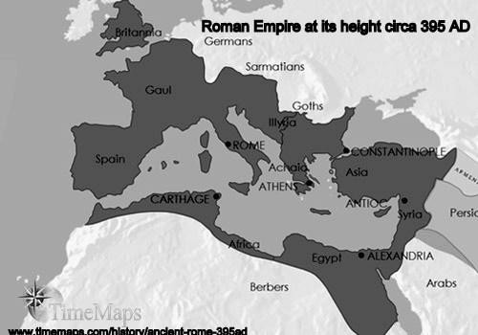
extent, the Roman Empire stretched east to include Greece, Turkey, Syria, Mesopotamia and Persia; it stretched south to encompass Africa north of the Sahara from Egypt to the Atlantic; and, it stretched north and west in Europe with its frontiers on the Danube and the Rhine and included Great Britain south of Scotland and Hadrian's Wall.
This great empire crumbled for a variety of reasons including: internal political corruption; economic and social difficulties arising from ruling such a vast territory; the high cost of warfare to maintain the empire; labor
surplus problems largely caused by slavery; overindulgence by the citizenry; and immorality, indolence, and reduced production causing heavy public welfare expenses. Religious and ethnic strife caused division of the people of Rome from within while Germanic tribes invaded the Empire from the North and East. The fall of Rome actually occurred gradually over a period of many years, but is usually set at 476 A.D., the year a German chieftain, Odoacer, seized the city and proclaimed himself emperor.

Eastern Roman Empire (Byzantine Empire)
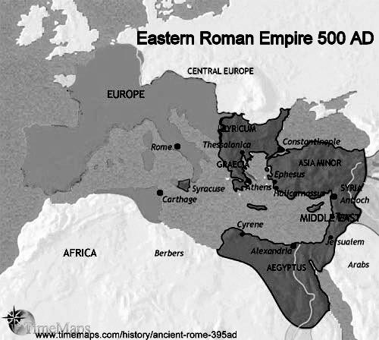
Although the Western Roman Empire and the government in Rome itself fell, the Empire lived on in the East (Greece, Turkey, Syria, Mesopotamia and Persia). The
Emperor Diocletian (reigned, 284-305) divided and reformed the Empire during his reign to increase administrative efficiency.
The Emperor Constantine (reigned, 324-337) had erected a new capital on the site of the Greek city of Byzantium, which controlled the passage from the Black Sea to the Mediterranean, calling it Constantinople. Theodosius I (r. 378-
395) was the last emperor to actually rule both portions of the

Empire. The Eastern, or Byzantine, Empire contained more diverse nationalities than the West. The dominant language of the Byzantine Empire was Greek rather than Latin and it featured a much stronger influence from Hellenistic, Semitic, and Persian cultures. The Byzantine Empire contained most of the Roman Empire's rich commercial centers including Alexandria, Athens, and Damascus, as well as Constantinople. While Rome and the western Empire fell, the Byzantine Empire survived at Constantinople (the modern city of Istanbul) until 1453 when it was conquered by the Ottoman Turks. Only then did the city cease to be the cultural and economic center of Byzantine rule in the East.

Rise of Germanic Tribes
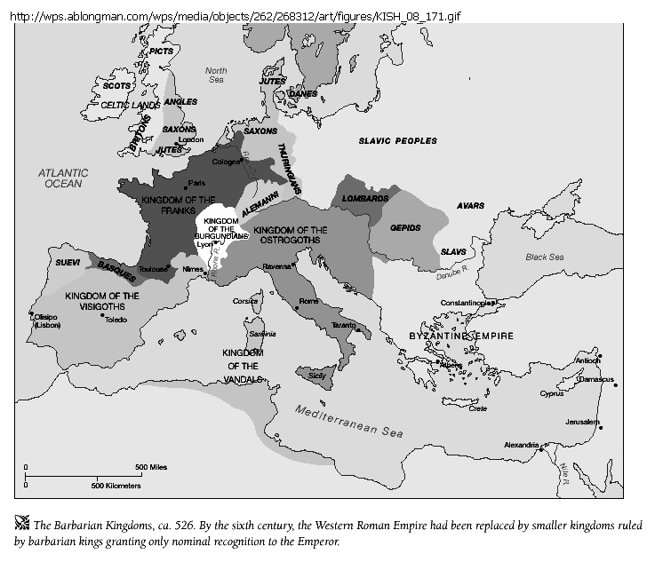
During the centuries of Roman rule, the entire civilized European world was united under a single government. (The Romans called everyone who was not a Roman a barbarian.) When Rome fell, that union also vanished: For centuries after the fall of Rome-roughly 476-1350 AD, which are commonly known as the “Middle Ages”-there was no unity and there were no nations as we know them today. As the many nomadic Germanic tribes from northern Europe moved across the continent during this period, sometimes called the "Dark Ages" (the early part of the Middle Ages- roughly 476-900 AD), what political organization did exist in Europe was based on the tribal organization of these
peoples. Only a few of these tribes were of much lasting importance. The Angles and Saxons established their rule and culture in Great Britain (hence the name "Angleland") and the Franks (as in "France") dominated northern and western Europe. The Vandals are remembered for their especially destructive behavior, and the word Gothic (from the Goths) was later used to describe these tribes collectively.

Charlemagne
Charlemagne (French
for Charles the Great) was King of the Franks from 768-814 and was able to unite most of Western Europe into the Frankish Kingdom which lasted from 800-860. On Christmas Day, 800 A.D., after restoring Pope Leo III (reigned, 795-816) in Rome from which he had been driven by invaders, Charlemagne (reigned, 768-814) was crowned by the Pope as "Emperor of the Romans". From that point until it was dissolved in 1806 by Napoleon, this Frankish Kingdom was known as the Holy

Roman Empire. Voltaire would later note that it was neither holy, nor Roman, and only a confederation of German tribal states rather than an Empire. This was the first serious attempt (many others would follow) to re-establish the rule and grandeur of Europe along the lines of the fallen Roman Empire, which remained a mythical ideal to someday be re-established. It also established an entangling relationship between Church and State that would dominate Europe for centuries.
At this time in history-the Middle Ages--without modern communication methods and with travel more difficult and hazardous than ever, it was difficult even for good rulers to maintain strict control over wide-spread lands. Thus, governing rested mainly in the hands of the local nobility. When Charlemagne died, his empire passed to his son, Louis I, "the Pious" (reigned, 814-840), who in turn divided the empire among his three sons in the Treaty of Verdun in 843 A.D. These sections roughly became the main divisions of Western Europe we find today: France, Germany and the middle kingdom of northern Italy. However, Charlemagne's grandsons, the rulers of these three kingdoms were less than competent. Between their poor rule and the continuing invasions of Europe by Muslims, Slavs, Magyars and Vikings (or Norsemen), Charlemagne's empire was lost except in name and tradition.

Rise of Feudalism
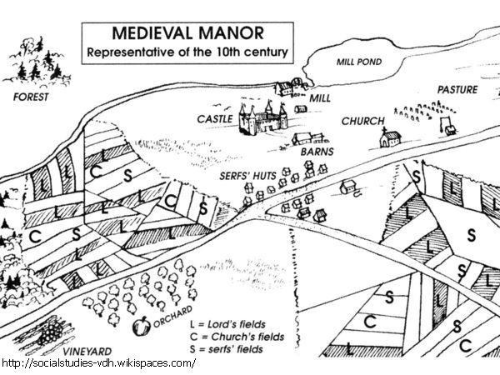
After the breakup of Charlemagne's empire towards the end of the 9th Century, European political organization was characterized by weak kings and strong nobles or lords who ruled their estates rather independently. This kind of political organization is known as feudalism. Feudalism was also a social and economic organization based on a series of reciprocal relationships. The king in theory owned the land which he granted to lords who in return would give service, usually in the form of military aid, to the king. The receiver of the land became a vassal, and this grant of land was known as a fief. Sometimes these fiefs were larger than a lord could himself administer. So he, in turn, granted use of part of the land to lesser lords who pledged their service in return. This system continued on until, at the lowest level, the lord administered only a small feudal estate.
Each of these lords was part of the nobility and therefore above the level of true labor. The actual farming and other necessary labor on the land were performed by serfs who were bound to the land and actually transferred from one landlord to another with its title. They produced the necessities of the estate. In return, they received protection by the nobles and a share of the produce of the land. The serf was not a slave in the true legal sense, for a class of slaves, usually non-Christian prisoners,
did exist. A small class of free men also existed having won their freedom for themselves and their descendants for service to some past lord. They usually performed the special skills of craftsmen, artisans, and merchants and were the beginning of a middle class.

During the Middle Ages, warfare was almost constant between lords who fought for power, land, or wealth. Probably hardest hit by this near-constant warfare were the serfs whose homes and fields were often the scenes of battles and suffered the damages. Indeed, the very slave-like status of the serf was due to his need for protection from this warfare. Feudal manors provided both political and social organization, as mentioned above. They also were individual economic units, nearly self- sufficient due to medieval warfare, the difficulties of travel, and the resultant lack of trade. The feudal estate featured a manor-home, usually a fortified castle surrounded by protective walls, belonging to the lord, surrounded by fields, herds and villages where serfs lived and worked. The serfs by their labor provided everything needed on the estate.

The “Dark Ages”
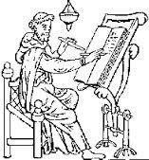
An important economic characteristic of the period was the decline in travel, communication and trade. Under the Roman Empire, there had been a great amount of trade between the widespread areas of the Empire. Legions patrolled the roads and the roads linked the provinces. After the fall of Rome, with no government to supply protection or to keep the roads and bridges repaired, travel became difficult and dangerous. This danger, coupled with ignorance and lack of desire to change the situation by the powerful lords, whose manors required little trade because they were self sufficient, led to the decline in travel and trade.
One reason for the early Middle Ages being designated as the Dark Ages is that education and learning also declined. The ancient discoveries and creations of the Greeks and Romans in mathematics, science, philosophy, art, and more were lost to tribal invasions except within the fortified monasteries in the remotest parts of the former Roman Empire. Education lost its value; instead people were busy with their roles in life and just trying to survive. There was no government to sponsor education. Because of the lack of trade and travel, contact with the scholars of the ancient world was
lost. However, while civilization in Europe declined, learning and discovery was progressing in Asia and the Middle East. Europeans were about to rediscover the wealth and more advanced civilizations of Asia.

The Role of the Roman Catholic Church
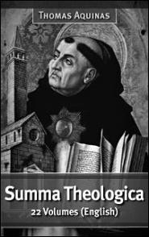
The Roman Catholic Church was the only center of knowledge during this period and learning was mostly religion-centered. True scholarship lived on in the monasteries where devout monks had withdrawn from the corruption and violence of the outside medieval world. There they preserved the ancient writings of the advanced civilizations of Greece and Rome. This treasure trove of knowledge from the Classical Age awaited its discovery by people in the future who cared more for these achievements. The dominant philosophy of the late Middle Ages was best articulated by St. Thomas Aquinas (1224- 1274) and known as scholasticism. Although Aquinas' scholasticism attempted to reconcile all new knowledge with accepted Christian dogma, it ran into many problems. Learning emerged from the Dark Ages and the long conflict between science and religion was about to begin. Under scholasticism, if reason and religious dogma clashed, reason must always give way

because religious knowledge was considered to be without error. In fact, nearly everything in feudal Europe seemed to be religiously centered. Religion and the after-life became the focal point of thought and living. The influence of religion can also clearly be seen in the art, architecture, literature, and music of the time. Perhaps because life was so hard on earth, the peasants endured it concentrating on and longing for their reward in the afterlife.
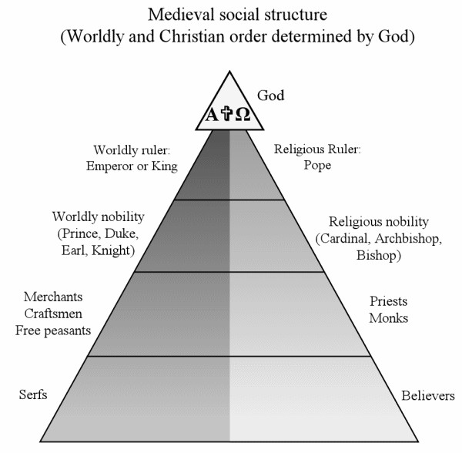
The Roman Catholic Church remained the only stable and unifying institution left over from the old Roman days and therefore came to dominate the lifestyle of the feudal era. The Church claimed superiority over all earthly political figures (as heaven was supreme over earth). As Pope Leo III had crowned Charlemagne, later popes claimed to be superior to kings and all other feudal rulers of the temporal world. The Church's official name of Roman Catholic, (meaning universal) with its headquarters in Rome, was reminiscent of the old Roman Empire. The dream of a new Roman Empire in the image of the Church
was envisioned by Pope Gregory VII (1073-1080) as "Christendom". The Church reached the height of its power and influence under Pope Innocent III (reign, 1198-1216). The Church's hierarchy paralleled that of ancient Rome: The Pope occupied the position of the emperor. The bishops presided over bishoprics, as the governors had once presided over the Roman provinces. Local parish priests ministered to each local community. Geographically or politically important bishops became archbishops and, in time, the College of Cardinals, appointed by the Pope, occupied a legislative position equivalent to that once held by the Roman Senate. The Cardinals had the further responsibility to elect
each new pope. The Church had its own law, canon law, and its own court system which was a rival to that of the new emerging monarchies.
The Church was the constant link the people and God. Church doctrine held that one could only get to heaven by doing good works and observing the sacraments. The seven sacraments (baptism, confirmation, communion, penance, holy matrimony, holy orders, and extreme unction or last rites) kept an individual constantly connected with God and the Church from birth to death. Individuals could be punished by excommunication, the process of being cut off from the Church when a person could not receive the sacraments. Whole geographic areas could be punished through interdiction which prohibited the performance of any of the sacraments in that district. Interdiction was a powerful weapon against immoral, rebellious or independent feudal rulers. On the other hand, the Church actually provided the only real opportunity in the Middle Ages for an exceptional individual to excel and rise above the social status of his birth. The Church was far more organized than any

political state in Europe, but such extensive organization and the access to great wealth also provided the opportunity for corruption. This would be one of the major causes of the loss of prestige that would come at the end of the Middle Ages.

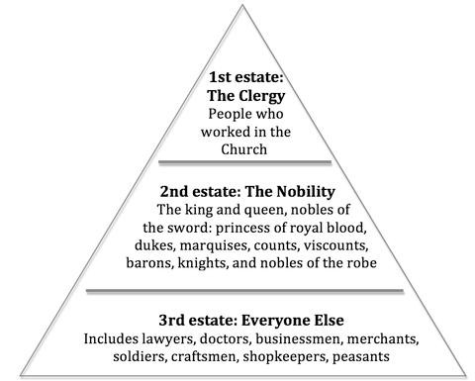
Social Structure in the Middle Ages (especially Late Middle Ages)
The social structure of Europe during the Middle Ages was strictly divided into three classes or "estates". The First Estate, composed of the ordained officers of the Church, from pope to parish priest and wandering monk, constituted a separate class claiming authority from God. The nobility, by virtue of its land ownership and its right to bear arms, made the nobles' primary function as warriors. They comprised the Second Estate. Everyone else, mostly peasants, was grouped into a Third Estate with no base for power. Problems with this social structure were inevitable. A new money economy emerged and many commoners of the Third Estate became richer and more powerful than the old nobility of the Second Estate whose members' wealth was based solely on land ownership.

Feudal Government
The system of feudalism decentralized the power of the state and made for a weak national government. Feudal lords were the real power in their local provinces. Since the soldiers in a feudal army were as likely as not recruited and paid by the lord, kings were very dependent upon their loyalty and weakened because of this feudal system. A centralized government would mean a loss of local power of the feudal lords. The Church also favored this system of weak national monarchies.
Both the old nobility and the high- ranking Church officials had much power to lose if strong national governments developed. In order for the modern nation-state with its central government to emerge, new monarchs would have to challenge this entrenched power system.

Ending the “Dark Ages”
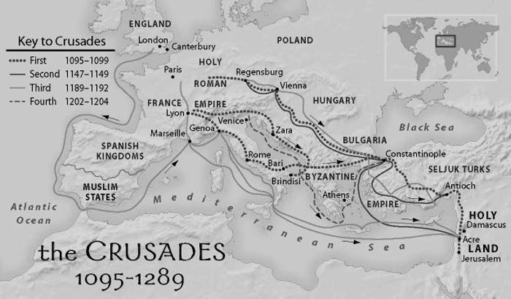
Feudal Europe was a self-perpetuating society for almost a millennium. The lack of learning and education and the lack of travel and trade tended to keep society as it were. Even if new ideas, products, and methods were discovered, they were not widely introduced. More than any other factor, it was a series of religious wars known as the Crusades that were responsible for bringing Europe out of the Dark Ages into the high Middle Ages (roughly 900-1400) and eventually the

Modern Age (1350-Present). These wars were fought by northern European Christian lords and kings who were responding to a call from Pope Urban II (reigned, 1088- 1099) to drive the Muslims from the Holy Land in Palestine after the Turks began to restrict religious pilgrimages and persecute Christians in the Middle East. In addition, the Muslim Empire had expanded into southern Europe. The threat from invading tribes had lessened along with the opportunity to gain new lands. Also, the Pope promised salvation to all who fought in these religious wars. Many of these lords went off to the Middle East to fight for God and glory. The Crusades went on over a period of time beginning in 1095 and lasting for over 300 years. They were militarily unsuccessful, and many of the soldiers seemed more interested in looting and fortune hunting. Also, the native Muslims proved a formidable foe. However, the Crusades were a turning point in the history and development of Europe.
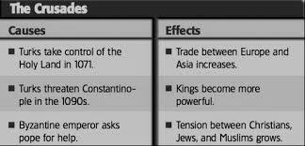
The Crusades brought tremendous economic, social, and political changes to Europe. First, trade was gradually re- established. During the Crusades, soldiers brought back many of the products of the East including spices and textiles. As Europeans became more and more accustomed to having these luxuries, they began to expand their trade. With increasing trade, there came
a need for new products to sell and people to carry on these transactions. Therefore, a whole new class in society was created: the merchants and craftsmen of the middle class. Cities also began to grow as centers of population and trade. Venice, Genoa, and Pisa in Italy became great port cities as the trade between the Middle East and western Europe passed through them. Italy thus became the gateway to Europe in the late Middle Ages. Neither the independently wealthy cities nor the growing, newly wealthy, but non-noble, middle class fit into the political or social structure of feudalism. Land had been the only real source of wealth in the Middle Ages. However, the expanding use of money for trade made land ownership less important, as land does not bring wealth unless it produces a surplus for sale. Thus, the feudal system was breaking down and would eventually be replaced. The only question was what way of life would arise to take the place of this long-entrenched system. Feudalism had dominated Europe politically, socially and economically since the return of order after the fall of Rome.

Impact of Trade in the High Middle Ages
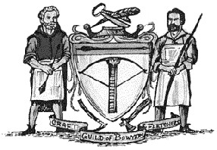
The new traders and merchants developed a system of their own to bring order to the new state of economics. To maintain the quality and prices of goods and services, the "guild system" was developed. By this system, merchants and craftsmen maintained control over their own professions. A townsman was forbidden to practice a trade or enter a business without the approval of the guild membership that consisted of those regarded as master craftsmen. To practice a trade,

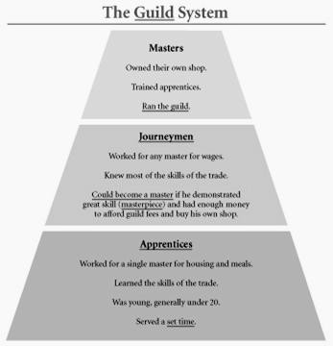
one began as an apprentice usually as a young boy assigned to work under the tutelage of a master craftsman. Apprentices frequently lived with the master and performed many other menial tasks other than those related directly to learning the craft. After years of service and learning, an apprentice could rise to the rank of journeyman.
Journeymen were free to work for other master craftsmen for wages. Only after additional years of work and meeting difficult criteria established by the guild could a journeyman be admitted to the guild as a master craftsman. A master had the right to open his own shop or merchant business. Through this system the guilds could control wages and prices, monopolize trade, set quality standards, and limit the number of people in a business.
Once established, the guilds became as rigid in their own way as the old class structure. These
merchants and craftsmen formed the basis for a new class of town dwellers, the bourgeoisie, burgesses, or burghers. They would form the basis of the growing "middle class" (in the middle between the nobility and peasants) that really had no place in the old system of estates. The political and social systems were failing to keep up with the economic changes.
Several factors began to strengthen the role of those kings willing and desiring to increase their power in this new society. These new, stronger monarchs led to the rise of the centralized, modern nation-states as we know them today. First, many landowners had been killed off during the Crusades leaving more land in the hands of fewer people. Second, cities and towns attached their development and prosperity to the kings, rather than to the lords. They sought protection from the powers of unjust lords by securing promised rights to govern themselves, which they purchased with wealth gained through trade. In return, they were able to pay more in taxes to the king. As a result, the king now had more money to spend in controlling the lords who previously had been largely independent of his authority. Merchants also supported stronger kings in hopes of gaining protection in their travels as well as uniform laws, tariffs, uniform weights and measures, and other trade concessions which would make trade easier and more profitable. Kings had the money, the interest, and stood to profit the most by paying for new modern armies equipped with the first firearms and ocean-going navies armed with cannon needed to protect commerce. The old nobility lacked the wealth to keep up with such changes. Thus, political, social, and economic changes were stimulated by the trade created by the Crusades.

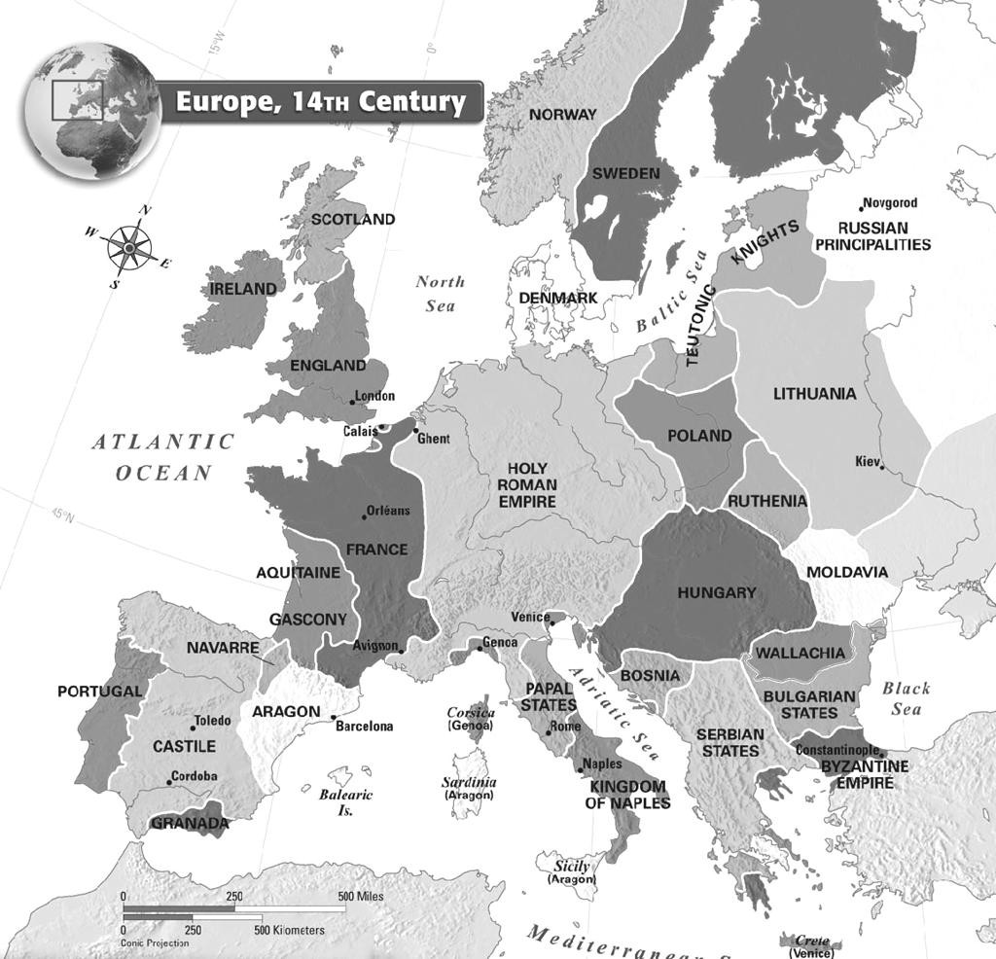

All of these things -- the increasing wealth, wider travel, and a greater knowledge of the outside world--led to a new philosophy and outlook on life.
Whereas during the Middle Ages, the Church provided the main source of inspiration, now there was a new interest in and concentration on man himself and the world in which he lived. This new age that came about in the late 14th and early 15th, centuries was called the Renaissance, the rebirth of the human spirit. We find this changing outlook on life reflected in the art, the architecture, the literature, the music, a new interest in learning and scientific discovery, the rediscovered curiosity about the world bringing exploration and discovery, and in new political ideas. This new philosophy which was
human-centered and emphasized human reason was called humanism and dominated the period of the Renaissance.

This new age brought many lasting changes to Europe. Most of the changes, however, did not come quickly or easily. For many centuries, much of the history of Europe would feature a clash between the old traditions of the Middle Ages and the new ways of the so-called modern world.

DISCUSSION QUESTIONS: Answer each of the following questions in complete sentences on your own paper. Be sure to answer ALL PARTS of the question. They are not completely in order.
- About how long did the Roman Empire last? When was it at its height? Why did it fall?
- What is the Eastern Roman Empire?
- Why did trade and travel decline after the fall of Rome? How did that impact governance of Europe?
- Who was the first "Holy Roman Emperor" and how did he get the title?
- What is the difference between the Roman Empire and the Holy Roman Empire? Explain.
- What were the connections between "The Holy Roman Empire" and "The Church"?
- How did Charlemagne’s division of the Holy Roman Empire between his three sons impact his legacy?
- Define feudalism and describe the characteristics of its organization.
- Why were strong kings rare and central government generally missing under the feudal system?
- What were the benefits supposedly derived from the feudal system? Who benefited the most?
- What was the importance of "the Church" and the Christian religion in the lives Europeans in the Middle Ages?
- How did the ritual and sacraments of the Church establish a constant, ongoing relationship with its individual members?
- How did the Church use the powers of excommunication and interdiction in maintaining its power?
- How were the education, learning and knowledge of Europe preserved during the lowest point of the Middle Ages, the so-called “Dark Ages”?
- Why was feudal society self-perpetuating for nearly a thousand years between the 5th century and 15th century?
- What was the dominant philosophy of the Middle Ages called? Who was its most outstanding spokesman? What were its basic beliefs, and how did that philosophy view life and learning?
- Who belonged to each of the three estates of medieval European society and what was the primary duty of a member of each estate? How was this different from the social classes in modern society?
- Describe the guilds. Who made up their membership and what was their influence on the business practices of the late Middle Ages.
- How did the guilds improve the lot of freemen? How did they help business and trade? How did they restrict its growth?
- Who were the bourgeoisie, burgesses, or burghers? Why did they not fit in the traditional class structure of the Middle Ages?
- Why was the social structure of Europe challenged by the growing number of free townspeople and the changing economy?
- How did the Crusades help to begin the change from Medieval society into the Modern Age?
- Why are the Crusades sometimes called "successful failures"?
- Why and in what ways did kings and central governments grow stronger at the end of the Middle Ages?
- What obstacles stood in the way of the creation of strong central governments?
- Why was the re-establishment of trade so important to the transformation of Europe?
- Why was there such a mystique among Europeans about the old Roman Empire?

Choose two of the following assignments to complete in addition to the questions.
- IDENTIFICATIONS / VOCABULARY-You may do this on flashcards or paper.
  - Define each of the bolded terms in the reading in your own words. This includes people, places, things, ideas. ANYTHING BOLD!
  - Please make sure the definitions are in the context of the reading (mainly how do they apply to the middle ages in Europe).
    - For example cardinals are lovely red birds and the state bird of Virginia but that is NOT the definition I want for this assignment.
  - In addition, be very specific in your definitions, include details.
    - For example cardinals are leaders in the Catholic Church-but that’s true of ANY time period— what is important about them in the middle ages.
  - Feel free to consult outside sources beyond the reading BUT . . .
  - definitions plagiarized from other source will not be counted-you must put them in your own words.
- CHRONOLOGY
  - Create an annotated timeline of the major events and eras mentioned in the reading. Annotated means you should put the event on the timeline and write a short description of the event. Feel free to use outside resources to look for specific dates and time periods.
OR
  - Create an illustrated timeline of the major events and eras mentioned in the reading. Illustrated means you should put the event on the timeline and draw a specific contextual image that describes the event- anyone looking at your image should be able to understand the event. Feel free to use outside resources to look for specific dates and time periods.
OR
  - Create a cartoon strip of important events in the reading. There should be a frame of at least two events from each of the sections of the reading (The bolded titles indicate new sections). The images should be contextual and chronological. Someone should be able to understand the events of the reading and how they flowed by looking at your cartoon.
- PEOPLE & PROFILES
  - Describe the importance of each bolded person in the reading within the context of the reading. Be sure to mention accomplishments or impacts. Create contextual images to accompany information. You may do this on paper or flashcards.
- GEOGRAPHY-Use the maps in your reading and other resources to complete this.
  - Draw in, color and label the map on the last page with the following:
- Countries/Regions: Greece, Turkey, Syria, Mesopotamia, Persia, Egypt, Great Britain, Scotland, France, Germany, Italy, Palestine,
- Cities: Rome, Alexandria, Athens, Constantinople, Damascus, Venice, Genoa, Pisa,
- Bodies of Water: Atlantic Ocean, Danube, Rhine, Black Sea, Mediterranean,
- Other features: Hadrian’s Wall, Holy Land
  - Identify the following empires on the map by drawing border lines, lightly shading area, or some other visual. Create a key.
- Roman Empire, Byzantine Empire, Holy Roman Empire

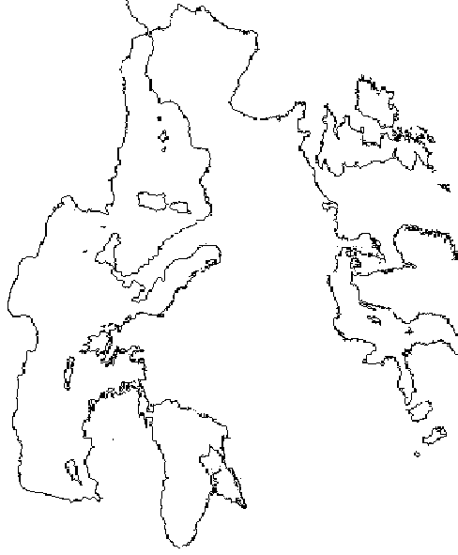
Z

