

Weekly news from

Mrs. Newburn’s Class

**Upcoming Events / Reminders…**

* October 2nd is our day at the book fair. We will go right after breakfast (@ 9:45)
* Conferences are Thursday, October 10th! See ya then!
* Tuition is due by **Tuesday, October 15th.**
* There is **NO SCHOOL** on Monday, October 14th (Columbus Day) and Tuesday, October 15th (Teacher In-Service).
* The Halloween Party will be on Halloween this year (Thursday, October 31st). The head mom will be contacting you shortly with more information!

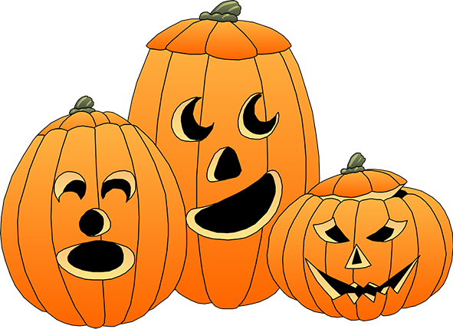

**Skills we are working on…**

* The letters “Aa, Tt, & Ff”, their sounds and how to make them in sign language
* Writing names/recognizing letters in names
* Fine motor skills (writing, coloring, and cutting)

**Things to work on at home…**

**Things to work on at home…**

* Days of the week
* The more practice with fine motor skills, the better! Practice writing, coloring, and cutting!
* Help your child write the first letter of their name