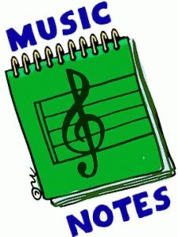
Week of:
May 11 - may 15
5/11: This week see if you can keep the beat with our song of the week, “Happy”
5/12: Watch “I Got the Rhythm”
5/13: Let’s dance to “Just Dance Kids ABC”
5/14: Let’s practice our rhythm reading by playing the game “Poison Rhythm Rest 1”
5/15: Let’s Dance and Sing to our fun song Friday tune, “Life of the Party”

