Mrs. Cook’s Messages
April 12-16, 2021
Grammar (contractions) and
Reading Skills (main idea and details),
Vocabulary, Spelling (aw, au, augh, al) tests on Friday.
 |  |  |  |  | If you have a child who will be attending Kindergarten next year,
 |  |  |  |  | Please go ahead and register online. Go to the school’s website
 |  |  |  |  | www.pinelevelelem.com to find information on how to register your
 |  |  |  |  | child for kindergarten.
Story:  “The Signmaker’s Assistant”  by Tedd Arnold  Phonics/Fluency:  vowel patterns  aw, au, augh, al  Text-Based Comprehension:  main idea and details, inferring  Grammar:  contractions |  |  |  | Selection Vocabulary Words (Students will be tested on these):  - afternoon – the part of day between morning and evening  - blame – to hold someone responsible for something bad or wrong  - ideas – thoughts or plans  - important – something that has a lot of meaning or worth  - signmaker – a person who makes marks or words on a sign that give information or tell you what to do or what not to do  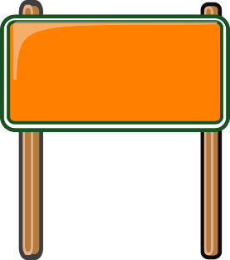  - townspeople – the men, women, or children who live in a village or town  Amazing Words  apologize, judgment, scold, protest,  citizen, hoard, interrupt, troublemaker
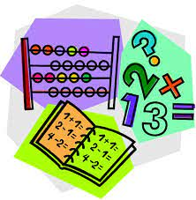  Topic 16: Time, Graphs, and Data  Lesson 4: Graphing Lengths  Lesson 5: Pictographs  Lesson 6: Problem Solving –  Use a Graph |  |  |  |  |  | 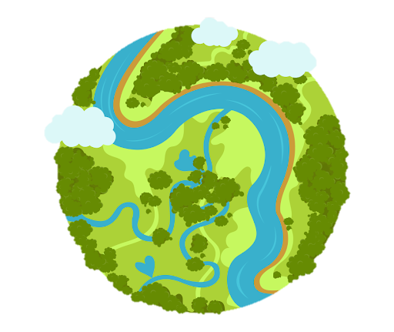  Social Studies/Science  We are learning about the different habitats on Earth that plants and animals call home. We can associate living things with their environment by looking at their structures.
Spelling Words:
- talk  - because  - August |  |  | - caught  - draw  - walk |  |  |  | - chalk  - auto  - taught | - thaw  - fault  - launch

