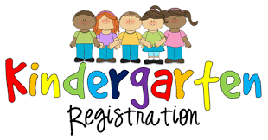

Dear Parents,
We are so excited to have your child with us during the 2020-2021 school year. We are going to allow registration online this year. However, our preference is definitely to get to meet your family personally. Due to unprecedented times, we are going to go ahead and give you the opportunity to complete these forms and fax or email these documents to us. Before doing so, we want to make sure to clarify some important points.
- The registration will only be accepted if all documents are complete and attached.
- It has to be a parent or legal guardian to fill out the paperwork and we must have a copy of the picture ID for the Parents/Legal Guardian.
- Our building will not be open until July so packet drop offs will not be accepted.
- Make sure to refer to the Kindergarten Checklist so you will know all of the documents that need to be included in your completed packet.
- If you have a custody or guardianship issue, please include a copy of the most recent court order.
- Note: A biological parent can’t be blocked from pick-up unless there is court papers attached.
- Many of you have students that will be turning five soon and will be getting immunizations in the summer. Yes. You can still register. Please provide your most up to date immunization form and appointment slip for upcoming shots.
- All forms in the Registration Folder are required.
Again, please make sure the packet is totally complete before sending the registration packet. We Will Not Keep Partial Packets.
If you have questions regarding address verification, you can call us at 334-361-3890.
All COMPLETE registration packets, can be sent to April.Gayler@acboe.net or Fax to 334-361-3891.
If you have any questions, we are here for you!
WE ARE SUPER EXCITED ABOUT MEETING YOU AND YOUR CHILD! WE CAN’T WAIT FOR UPCOMING SCHOOL YEAR!

Sincerely,

Jodi Womble
Principal
Prattville Kindergarten School

