Smart Snacks
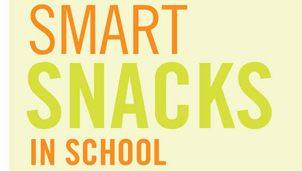
Childhood obesity is a national epidemic. Nearly 1 in 3 children (ages 2-19) in the United States is overweight or obese, putting them at risk for serious health problems. As parents, caregivers, brothers and sisters, leaders in schools, communities and healthcare, we can work together to create a nation where the healthy choice is the easy choice. Learn the facts, our approach to solving this epidemic and how you can help be a part of the change.

The USDA took a major step forward in releasing the Smart Snacks in School nutrition standards for all foods and beverages sold to students during the school day in vending machines, school stores, snack carts and a la carte lines, as well as through fundraising. These standards are now in effect and apply all around your school campus.

Smart Snacks Resources
Use the Smart Snacks Product Calculator to take the guesswork out of this project and help identify if your current products meet the nutrition standards
https://www.healthiergeneration.org/take_action/schools/snacks_and_beverages/smart_snacks/alliance_product_calculator/

Browse the Smart Food Planner to help you identify products that meet the Smart Snacks standards. You can search by company to see if your vendor is in our database and identify compliant products that they have.
https://foodplanner.healthiergeneration.org/

