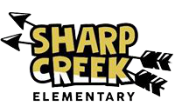

Right to Know Professional Qualifications of Teachers and Paraprofessionals

Date: July 1, 2020

Dear Parents,

In compliance with the requirements of the Every Students Succeeds Act, the Sharp Creek Elementary would like to inform you that you may request information about the professional qualifications of your student’s teacher(s) and/ or paraprofessional(s). The following information may be requested:
- Whether the student’s teacher—
  - has met State qualification and licensing criteria for the grade levels and subject areas in which the teacher provides instruction;
  - is teaching under emergency or other provisional status through which State qualification or licensing criteria have been waived; and
  - is teaching in the field of discipline of the certification of the teacher.

- Whether the child is provided services by paraprofessionals and, if so, their qualifications.

If you wish to request information concerning your child’s teacher’s and/ or paraprofessional’s qualifications, please contact the Title I Lead, Amanda Driver, at 770 214-8848.

Sincerely,

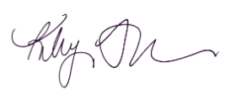

Kiley Thompson
Principal, Sharp Creek Elementary

