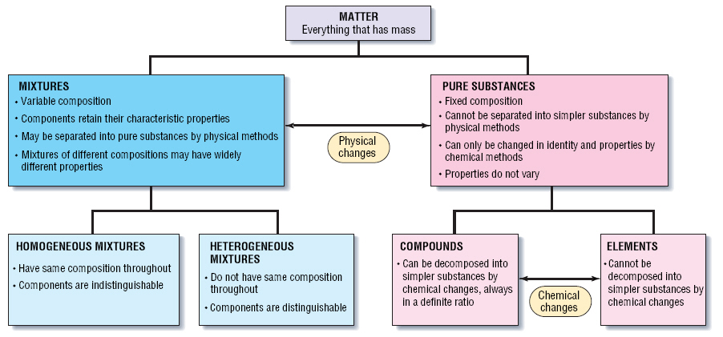

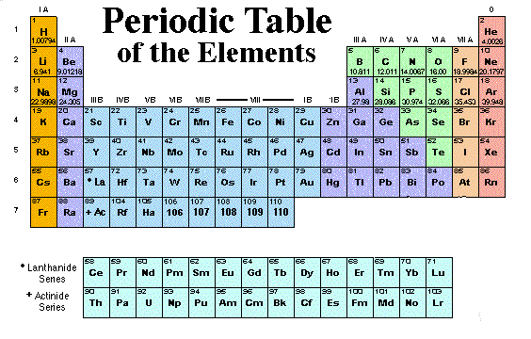

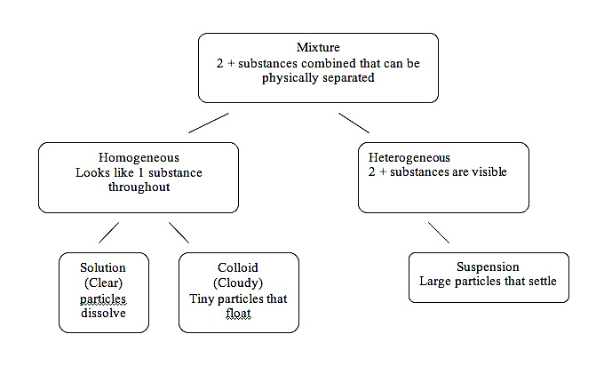

**YOUR NOTES:**

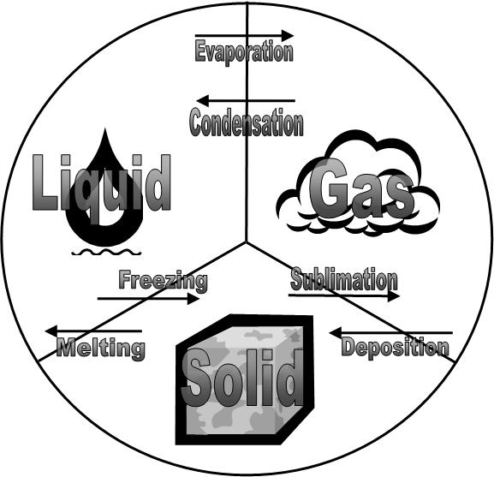

***STATE STANDARDS: S8P1 AND 2:Examine the nature of matter – atoms, molecules, elements, compounds, 3 states of matter, physical and chemical changes, Periodic Table of Elements, and the Law of Conservation of matter.***

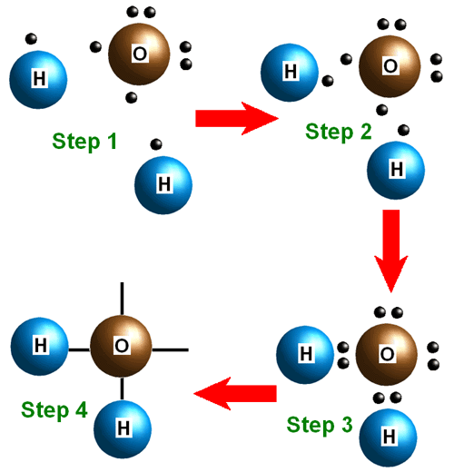

|  |  |
| --- | --- |
| **Physical Change vs Chemical Change** | |
| Aluminum foil cut in 1/2 | Milk goes sour |
| Clay is molded into a new shape | Jewelry tarnishes |
| Butter melts on warm surface | Iron rusts |
| Water evaporates from the surface of ocean | Bread is toasted or baking a cake |
| Water freezes into ice | Gasoline is ignited |
| Rubbing alcohol evaporates on your hand | Hydrogen peroxide bubbles in a cut |
| Paper is folded into a plane | Food scraps decompose in a compost |
| Ice melts into water | Your body digests food |
| You chop a tree into logs | A match is lit |
| You break a match | You fry an egg |
| You butter bread | You take antacid to settle your stomach |
| A PHYSICAL CHANGE alters the physical properties of a substance without changing the identity of the substance. Change occurs in mass, volume, phase, or shape. Most changes can be reversed. | You burn a log on the fire |
| A CHEMICAL CHANGE occurs when a substance is changed into a new substance. It loses its original identity. It is almost impossible to reverse. Combustion is a type of chemical change. |
|  |  |