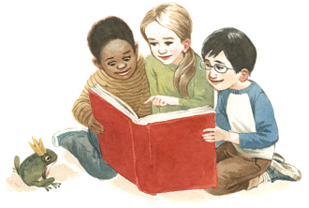

Notes from the RES Librarian

April 16, 2020

Hello, Everyone!

As we enter into a time of distance learning, I hope that you and your children are continuing
the progress that began at school this year. With that in mind, I will be posting literacy ideas,
book reviews, free resources that I hope will help you and your family find the joy in reading and learning.
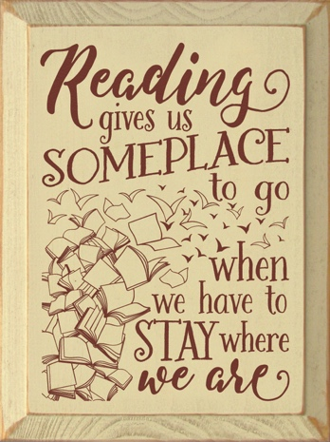
I would love to provide support to assist your children during this time. If you have questions about books or literacy resources please don’t hesitate to contact me by email. Also, if you have suggestions or questions about this newsletter, please let me know.
Thank you,
D. Goss, Library/Media Specialist, Riverside Elementary School
dgoss@westernline.org

Check out the Washington County Library System website with a list of resources for students. https://www.washington.lib.ms.us/children.htm

For grades PreK – 1:
Piggy and Elephant: These books by author Mo Willems are delightful. Piggy and his friend Gerald the Elephant have many funny adventures that kids enjoy reading for themselves. The text is simple enough for beginning readers to follow while the storyline is interesting enough to get and keep their attention. The illustrations are precious and turn the story from your basic phonics reader to a real story with characters and a plot. Your little ones are sure to be charmed.
AR: 0.5 – 1.9

For grades 3 – 6:
I Survived: At our house we love this series! Each book is the story of a real disaster told through the eyes of a fictional character who survives. The characters are young people from diverse cultures and socioeconomic backgrounds. The stories are well researched with vivid details that make the reader care about the characters and what happens to them. Each chapter ends with an element of suspense that makes the reader want to keep going. At the end of the book there is a section that gives true historical details with photographs and other primary documents. These books are a great way to introduce historical events to your children in a way that makes them care about what happened and why.
AR: 3.5 up to 5.5

