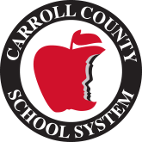
Mount Zion Elementary School
2021-2022
Fifth Grade Supply List

2- 2” 3 Ring Binders
3​ ​Prong Folders- 2 Green, 2 Orange
2- Blue Spiral Bound Notebooks
5- Packs of Wide Ruled Notebook Paper
2- Packs of Wooden or Mechanical Pencils
Ear Buds/Headphones
Scissors
Skinny Expo Markers
Markers
Colored Pencils
Glue sticks (no liquid please)

Other Needs:
Kleneex, Paper Towels, Clorox Wipes, Hand Sanitizer, Teacher Expo Markers. Highlighters

