Name ____________________________________
Food Web
1. For the food web, label each organism: (Some may have more than one label)
P = producer | 1 = Primary Consumer | 2= Secondary Consumer | 3 = Tertiary Consumer | | 4 Quartenary Consumer

2. Now label each animal as either a : H = herbivore C = carnivore O = omnivore
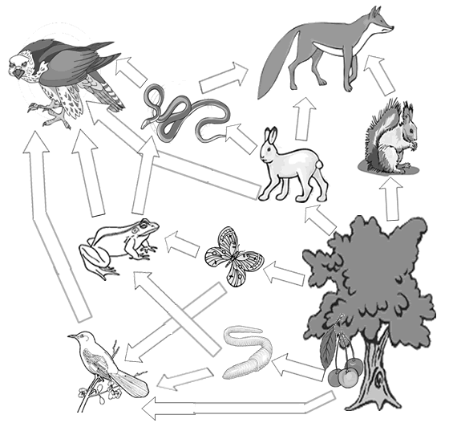
3. Create your own food web on the back Create your own include at least 8 organisms. EX.: MOUSE, CORN, BLUEBIRD, KING SNAKE, HAWK, CAT, CRICKET

