***What is a  
 School-Parent Compact?***

A school-parent compact is an agreement that explains how parents, teachers and students will work together to make sure all students reach grade-level standards. This agreement was jointly developed by stakeholders and is reviewed/revised annually based on feedback from all stakeholders. Compacts will be discussed during parent-teacher conferences.

***Opportunities to Volunteer***

Due to Covid-19 restrictions, these opportunities are not currently available. We welcome and encourage parental engagement at NMS. All volunteers working with students are required to have a background check and volunteer training.

There are many ways for parents to give of their time and talents.

* Serve as a chaperone for field trips
* Serve on the NMS P.E. Team
* Serve on School Council
* Attend and or assist with Book Fairs, student performances and sporting events
* Organize Staff Appreciation

For the above and other opportunities of parent engagement, please contact **YOUR** Parent and Family Engagement Coordinator, Kyna Williams at 478-929-7845 ext. 2771 or email at kyna.williams@hcbe.net.

***Access to Staff***

* Our school has an open door policy
* All teachers and staff are available through e-mail (see school webpage for contact information) or can be reached at 478-929-7845
* Parents are encouraged to schedule conferences as needed with your child’s teacher or through the Counseling office
* Our Parent and Family Engagement Coordinator, Kyna Williams, is available Monday thru Friday from 8:00 am-4:00 pm

***Communication about Student Learning***

* Infinite Campus provides up to date information on your student’s schedule, grades and attendance
* Progress reports are issued every nine weeks (Sept, Nov, Feb & Apr)
* Report cards are issued every 18 weeks (Jan and May)
* Parent-Teacher conferences
* Parent contact as needed via e-mail or phone call
* Failure notices sent home via student or postal service

***Building Partnerships***

* “Walk a Day in My Shoes” Open House
* NMS Literacy Events
* Cram Session Video Tutorial

***Northside***

***Middle School***

[***www.nms.hcbe.net***](http://www.nms.hcbe.net)

***478-929-7845***

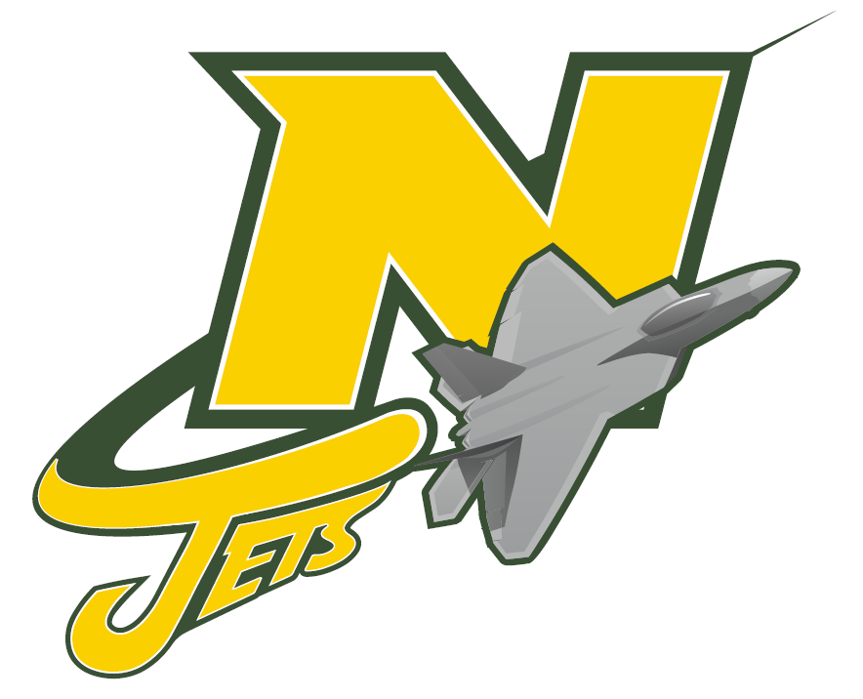

***6th Grade***

***School-Parent***

***Compact***

***Revised 8/7/2020***

Revised: 8/ /2020

***Teachers, Parents, and Students—Together for Success***

***Due to Covid-19 restrictions, where applicable these resources or events will be provided virtually.***

***Students Will…***

* Students will attend and participate in Literacy and Math Events with parents.
* Students will read daily and strive to reach the goals set to increase their Lexile scores.
* Students will utilize school resources provided on websites, newsletters, and videos related to Literacy and Math.

***Families Will…***

* Parents will make every effort to attend Literacy and Math Evenings to learn strategies that will help support their learners with reading fluency, comprehension, Math content and critical thinking.
* Parents will set goals for their students at home to help improve their Lexile score.
* Parents will utilize the school resources available, such as websites, newsletters and videos related to Literacy and Math to assist their student.

***NMS Will…***

* Invite parents to attend Literacy and Math Events to learn strategies that will help support their learners with reading fluency, comprehension, Math content and critical thinking.
* Provide parents with their student’s Lexile score and help families set goals for improvement.
* Provide families with resources such as websites, newsletters, and videos related to Literacy and Math.

***Our Goals for Student Achievement***

**Houston County District Goals**

* Increase the value of the overall College and Career Ready Performance Index (CCRPI) score by 3% focusing on literacy, high quality standards based instruction and Multi-Tier System of Supports.
* Increase the percentage of parents who feel their child’s school provides various opportunities for engagement.

**Northside Middle School Goals**

We will increase our 2019 CCRPI score by 3%.

We will also continue to grow in our implementation of professional learning communities (PLCs) so that the percentage of students’ achievement grows by 3% between 2019 and 2021 as measured by the Georgia Milestone Assessment and the Measure of Academic Progress (MAP).

Northside Middle will increase by 3% the number of students demonstrating reading comprehension at eh midpoint of the College and Career ready “stretch” Lexile Band on the GMAS.

**6th Grade Supports These Goals by Focusing On:**

* Literacy
  + Reading fluency and comprehension
  + Greek and Latin roots
* Math
  + Operations with rational numbers
  + Geometry concepts