Monday, April 13th
Contour lines - Draw an object of your choice in contour. Recommended: Draw your shoe, a shampoo bottle, or a piece of fruit.
A contour is an outline or the edge of an object. Contour drawings help train your eye to look closely at an object. You draw what you see, not what you think is there.

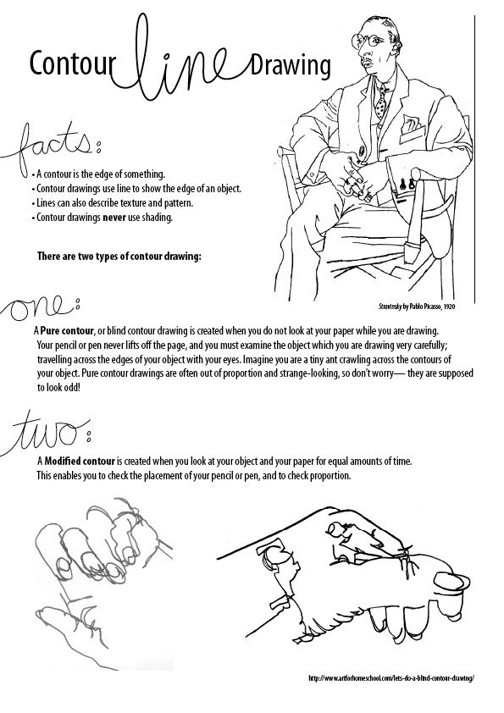
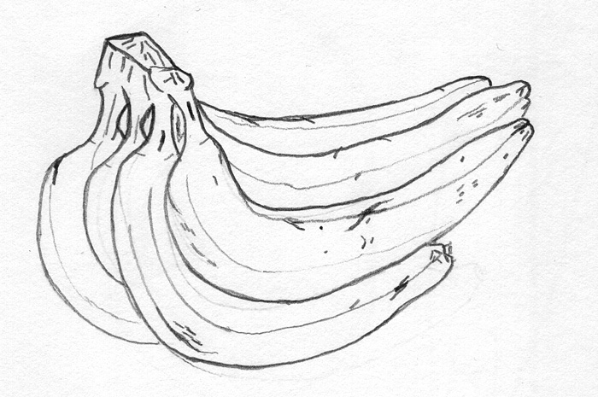

Tuesday, April 14th

Try this blind contour drawing of your hand. A blind contour drawing means you cannot look at your paper while your are drawing. Your pencil should follow where your eye moves around the edge of the object. Do not pick up your pencil or look at your paper until you have completed the drawing.
https://youtu.be/FKHVqbM_xLU
Check out the blind contour drawings of Austin Kleon.
https://austinkleon.com/2020/02/20/blind-contour-drawings/
Read the above definition of a BLIND contour drawing. Draw your hand without looking at the paper.
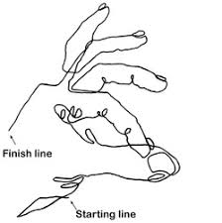

Wednesday, April 15th
Abstract art - what is it?
Watch this video from Pixar's "Inside Out"
Draw an abstract work of art and write a few sentences about it.
I love this one!
https://youtu.be/uRWR2phhRLc

The Abstract Art movement took place in the United States. In its purest form, Abstract Art has no subject. It is just lines, shapes, and colors. The Abstract Art movement is called Abstract Expressionism because, although the art has no subject, it is still trying to convey some kind of emotion.

When was the Abstract Art movement?

The Abstract Expressionism movement began in the 1940s in New York City after World War II. However, the first real Abstract Art was painted earlier by some Expressionists, especially Kandinsky in the early 1900s.

What are the characteristics of Abstract Art?

The main characteristic of abstract art is that it has no recognizable subject. Some Abstract Artists had theories on the emotions that were caused by certain colors and shapes. They planned out their seemingly random paintings to the last detail. Other Abstract Artists painted with emotion and randomness hoping to capture their emotion and subconscious thoughts on the canvas.

Examples of Abstract Art

Composition II in Red, Blue, and Yellow (Piet Mondrian)

Mondrian painted with precision and geometric shapes. In this painting he creates a sense of balance using straight black lines, white spaces, and primary colors. He painted many other pictures using the same style.

Jackson Pollock created his own unique style of painting. He would splash and dribble paint onto the canvas straight from the can. This style of art was later called Action Painting. In this painting yellow and brown paint is drizzled to create an interesting nest of colors and textures. The painting sold in 2006 for an amazing $140 million.
Famous Abstract Artists
- Willem de Kooning - Kooning was a Dutch artist who became a part of the New York City Abstract Expressionist movement. His most famous painting is Woman III which sold for over $137 million.
- Franz Kline - Kline was an American painter mostly known for his black and white paintings. He was considered an Action Painter.
- Wassily Kandinsky - Kandinsky is considered the father of abstract painting. In an effort to capture sound and emotion in art, he painted some of the first major abstract works.
- Piet Mondrian - Mondrian developed an Abstract painting style that involved straight lines and colored rectangles. He called this type of painting "The Style".
- Jackson Pollock - Pollock created his paintings without using brush strokes in what would later be called Action Painting. He became famous for his large paintings made with dribbles and splashes of paint.
- Mark Rothko - Rothko's paintings are known for their large vibrant blocks of color.
Interesting Facts about Abstract Art
- Before World War II, Paris had been the center for most new modern art trends. After World War II, New York City emerged as a major center for artists.
- A movement similar to Abstract Art was launched in the early 1900s in Italy called Futurism. One of Futurism's major artists was Giacomo Balla.
- One of the most extreme styles of Abstract Art was called Suprematism. Russian Artist Kasimir Malevich painted in this style. One of his paintings was a white square painted on to a white background.
- Famous Abstract artist William de Kooning arrived in America as a stowaway on a boat. He worked as a house painter for a while.
Draw an abstract drawing and write a few sentences about it.

Thursday, April 16th
Wassily Kandinsky was an abstract artist with a condition called synthesia. Synthesia means the person can hear color and see music. Play music of your choice and draw what you feel through the music. Loud harsh sounds might look like sharp lines. Soft music might be curvy. Add shapes and color to represent the music.

About Kandinsky:
In 1909 Kandinsky began to think that painting didn't need a particular subject, but that shapes and colors alone could be art. Over the next several years he would start to paint what would become known as Abstract Art. Kandinsky was one of the founding fathers of Abstract Art.

Colors and Shapes
Kandinsky felt that he could express feelings and music through colors and shapes in his paintings. For example, he thought that yellow had the crisp sound of a brass trumpet and that certain colors placed together could harmonize like chords on a piano. The shapes he was most interested in were the circle, triangle, and the square. He thought the triangle would cause aggressive feelings, the square calm feelings, and the circle spiritual feelings.
In 1911 he wrote an essay called Concerning the Spiritual in Art. He described three types of paintings including "impressions", "improvisations", and "compositions". Many of his paintings were named using these titles and a number. Some examples of this include the paintings Composition X and Impression V.

Legacy
If Kandinsky wasn't the first abstract artist, he certainly was one of the founding fathers of the art form. His art and essays on art have had influence over many artists during the last century.

Interesting Facts about Wassily Kandinsky
- Many of his paintings used names as if they were songs or musical works like Composition and Improvisation.
- The Blue Rider was also the name of a group of expressionist artists including Kandinsky, Paul Klee, Franz Marc, and others. They had their own exhibitions and wrote an almanac that included essays on art theory.
- He once said that "Everything starts with a dot".
- About abstract art he said that "the more frightening the world becomes…the more art becomes abstract".
- He named the paintings he considered the most accomplished "Composition". He only named ten of his paintings this way. Image below is by Kandinsky.
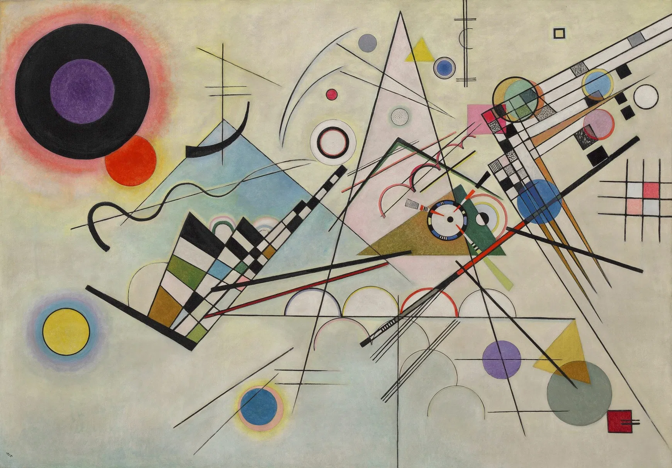
Friday, April 17th
Pop Art
Pop Art is art made from commercial items and cultural icons such as product labels, advertisements, and movie stars. In a way, Pop Art was a reaction to the seriousness of Abstract Expressionist Art. Pop Art is meant to be fun.

When was the Pop Art movement?
Pop Art began in the 1950s, but became very popular in the 1960s. It started in the United Kingdom, but became a true art movement in New York City with artists like Andy Warhol and Jasper Johns.

What are the characteristics of Pop Art?
Pop Art uses images and icons that are popular in the modern world. This includes famous celebrities like movie stars and rock stars, commercial items like soup cans and soft drinks, comic books, and any other items that are popular in the commercial world. There are a number of ways that artists use these items to create art such as repeating the item over and over again, changing the color or texture of the item, and putting different items together to make a picture.

Eight Elvises uses a picture of Elvis Presley pulling a pistol out and aiming it at the viewer like a gunslinger from the Wild West. The picture of Elvis is repeated eight times. The repeating pictures get closer together as they move to the right and overlap each other giving the picture a feeling of infinity. This painting sold for over $100 million in 2009.

This painting is made to look like a scene from a comic book. The girl is drowning and she yells out "I don't care! I'd rather sink, than call Brad for help!" The artist even painted the picture with the dots that are often seen in the color areas on comic books.
Jasper Johns painted a number of pictures of the American Flag. In this picture he paints three flags on top of each other. Each flag appears closer to the viewer, but gets smaller as well.

What could be considered pop art in today's culture?
Describe your art and what materials you could use to represent 2020.

