Mrs. Cook’s Messages
January 25-29, 2021
Grammar (adjectives) and Skills Test (draw conclusions): Thursday
Vocabulary, Spelling Test (consonant + le), and Topic 10 in Math
HFW | warm | ago | father
 | family | mother
We will be DIBELS testing at school this week. Please make every effort you can for your child to attend school, unless he/she is sick. Thanks and I greatly appreciate all your understanding during virtual learning.

Story:  “A Froggy Fable”  by John Lechner  Phonics/Fluency:  consonant + le  Text-Based Comprehension:  draw conclusions, background knowledge  Grammar: adjectives  and our senses | Selection Vocabulary Words (Students will be tested on these):  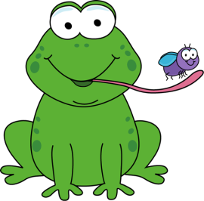  - clearing – piece of land that has no trees  - crashed – fell with a loud smashing noise  - perfect – as good as is possible  - pond – water with land all around it; a small lake  - spilling – scattering everywhere  - splashing – making water scatter and fall in drops  - traveled – went from one place to another  Amazing Words  preserve, valuable, concentration, homeland, represent, tough, patient, frown  High-Frequency Words:  warm, ago, father, family, mother
Math: Topic 10  10-1 – Building 1,000  10-2 – Counting 100s, 10s, and 1s  10-3 Reading and Writing numbers to 1,000  10-4 Changing numbers by 100s and 10s  10-5 – Patterns with numbers on 100 charts |  |  | 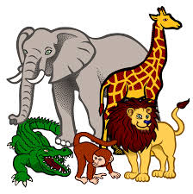  Social Studies/Science  We will continue our study of animals this  week, discussing how many animals use  plants for shelter. We will also go over the  life cycles of animals. In addition to this, we will learn about plants, their structures, and environments. We will explore the life cycles of plants as well.
Spelling Words:
- ankle  - title  - apple |  | - cable  - purple  - able |  | - bugle  - bundle  - bubble | - giggle  - sparkle  - tickle

