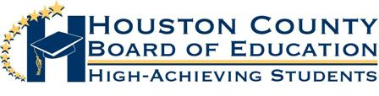
Superintendent of Schools
Dr. Mark Scott

Board Members
Helen Hughes, Vice Chairman Mr. Fred Wilson, Chairman Dave Crockett
Lori Johnson Hoke Morrow
Dr. Rick Unruh Bryan Upshaw

20-002 SNP BREAD AWARD
THIS BID IS AWARDED TO FLOWERS BAKERY CO.

