[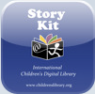](http://itunes.apple.com/WebObjects/MZStore.woa/wa/viewSoftware?id=329374595&mt=8)**Story Kit** -Create an electronic story book by

writing text, and either drawing on

the screen or using your own photos.

Record sound effects too! (Free)

[](http://itunes.apple.com/us/app/lifecards-postcards/id304401787?mt=8)[**Lifecards - Postcards**](http://itunes.apple.com/us/app/lifecards-postcards/id304401787?mt=8)  
Translating the meaning of a graphic into writing and vice versa is another example of "understanding." With the Lifecards app, students can import a graph, chart, historic photograph, symbols, diagram, or even political cartoons onto one side of a postcard and then use a letter-writing format to explain the graphic on the other side. The limited space for writing will demand that communication immediately address the content's main idea and force students to determine what information is the most significant. Teachers can also choose to provide the writing instead and ask students to create a visual representation of the letter's contents. Students can use photographs taken with a mobile device or graphics saved in the iPhoto library. I am sure the creators of Lifecards had different intentions for their app but their beautifully designed, one-ended app proves to have many possible uses. (1.99)

[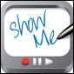](http://itunes.apple.com/us/app/showme-interactive-whiteboard/id445066279?mt=8)[**ShowMe Interactive Whiteboard**](http://itunes.apple.com/us/app/showme-interactive-whiteboard/id445066279?mt=8)  
ShowMe is an interactive whiteboard that can record a screencast on the iPad. It will import photos or graphics from iPhoto, has simple drawing tools, an eraser, and voice recording. Having a tool that incorporates graphics with voice recordings provides a wonderful opportunity for students to translate material they have read. Consider asking students to narrate a map of a character's journey, create a timeline, sketch diagrams, animate a recording of the water cycle, or explain the results from a class poll. Teachers will need to create an account in order for users to save work to showme.com. Uploading content to this site will provide an embed code, and enable the ability to email the file or post it to Twitter or Facebook. (free)

**The Hudson Alpha iCell a**pp provides 3D models of cells from plants, animals and bacteria. These 3D models are well detailed, can be zoomed in on and will provide you information about each part when you click on it.

 (Free)

**Speed Anatomy Lite (Quiz)**

How fast can you point to your liver or gall bladder? Do you know the difference between, the sacrum and the manubrium? Speed Anatomy is an addictive game that tests your speed and challenges your knowledge of human anatomy! (free) 

**Science House:** A growing library of over 80 hands-on Science lessons that are great for home and the classroom. These short videos demonstrate inexpensive and easy to recreate experiments that are designed to inspire and excite kids of all ages. 

**(Free)**

i **Biology ExamHD**

This is an Educational Quiz for All Students ***  
300 questions to test BioSkills..  
Test your skill before your final exam.   
Description of the Game :  
** Each Correct answer carries 10 marks.  
** you get 3 lifes to find the correct answer.  
** Some of the questions are from Reproductory System of Human Beings.  
** If you give 3 wrong answer simultaneously then you will be out of the quiz.  
** If your marks is over 75 then you will be pass otherwise you will be failed.  
** Result will be declared after the exam.  
** you will notified with the correct answer after selecting the wrong answer.. (free)

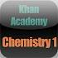 **Khan Academy: Chemistry 1** Ximarc Studios Inc is proud to bring you Khan Academy Chemistry 1 (videos 1-20). Khan Academy Chemistry allows students to learn Chemistry through various videos which are downloaded directly on your iPhone or iPod touch and in the future to your iPad. Students can watch the video anywhere, anytime, all the time and NEVER be concerned about having access to the internet while you are going through a Khan Academy lesson.

 **Chemistry Formula Practice Lite:** Chemistry Formulas Practice stimulates students’ mastery of the fundamental skill of naming compounds and writing formulas. The practice categories include ionic and molecular compounds, acids, bases, polyatomic ions, hydrocarbons, and organic functional groups. Students may choose their pace as they work from formula to name or name to formula.

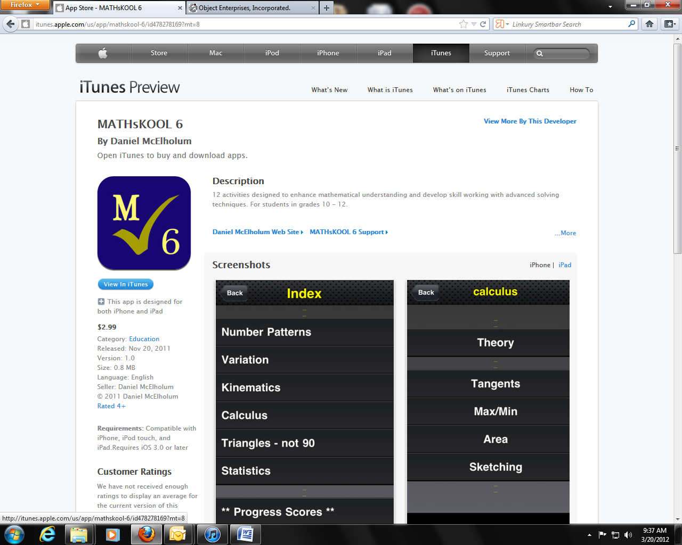

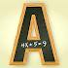

**Alge-Bingo** This game is great for Pre-Algebra and Algebra I students who are just learning how to solve equations as well as for Algebra II and even Precalculus students needing to review their equation solving skills. It can also be used an Algebra tutorial for anyone preparing for a standardized test such as the S.A.T. or A.C.T. (.99)

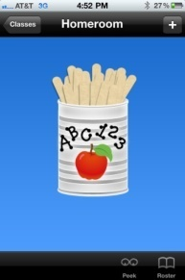 **Stick Pick** by Buzz Garwood (sixth grade teacher

in the Corona-Norco Unified School District)

"Stick Pick is an iPhone / iPod Touch / iPad “teacher tool”

application that allows you to randomly

(or intentionally) draw astudent’s name

from an on-screen can of popsicle sticks -- but that’s

just the beginning. You determine the mode and

level of difficulty for each learner, and then, every time

that student’s stick is drawn, you’ll be shown

over a dozen Bloom’sstyle question stems -- uniquely

tied to your learner’s individual ability level!" $2.99

**iTunes U** –Everything you need to create and share complete courses – all in one place. If you’re an educator at a university, college, or K-12 school, now you have an easy way to design and distribute complete courses featuring audio, video, books, and other content. And students and lifelong learners can experience your courses for free through a powerful new app for iPad, iPhone, and iPod touch.  
Demo: - American Revolution – Yale University

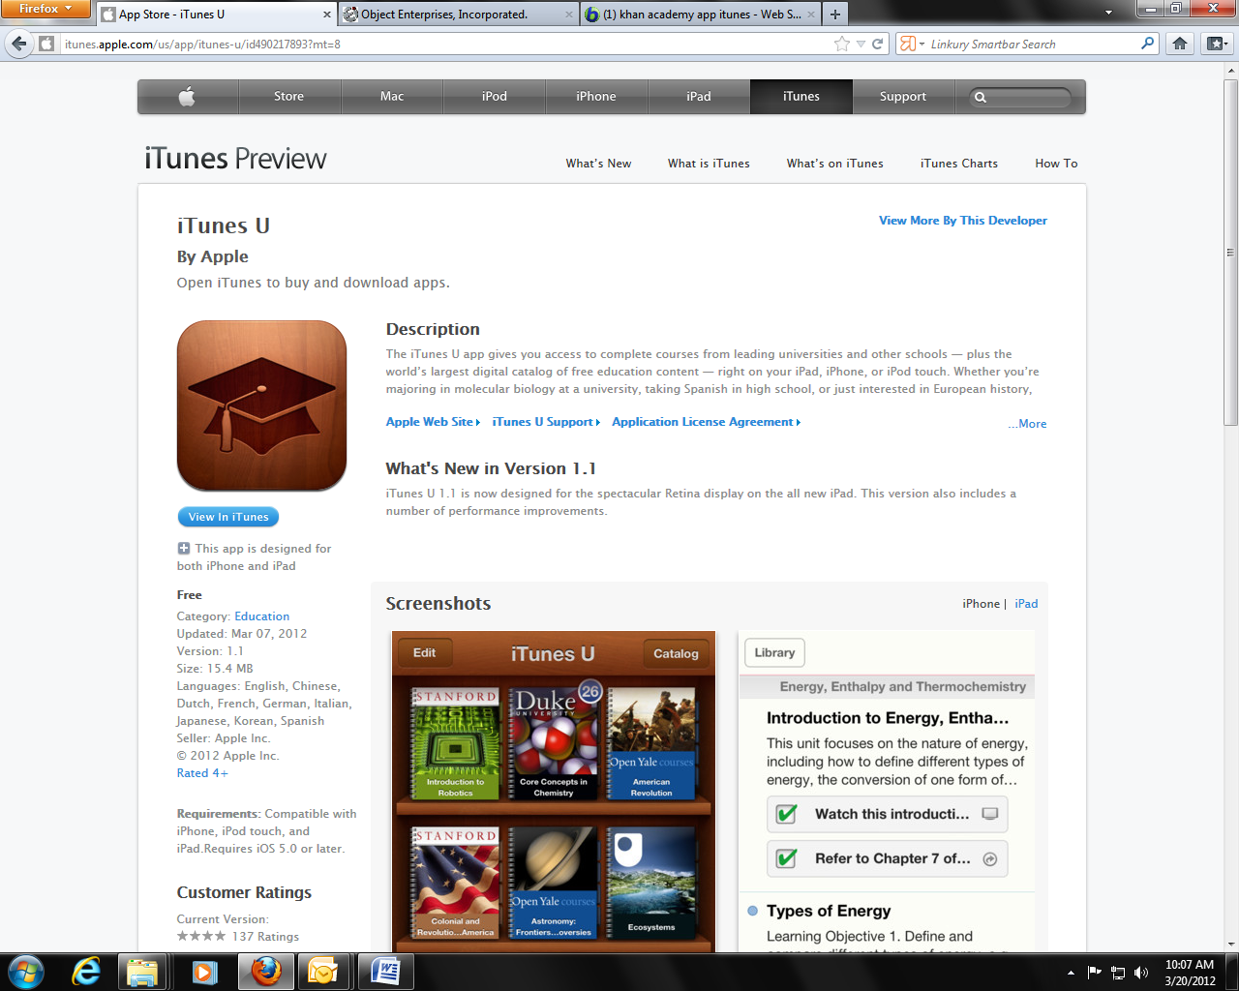(Free)

**Khan Academy** allows you to learn almost anything for free.   
Our iPad app is the best way to view Khan Academy’s complete library of over 2,700 videos.



 **Socrative** ( you will need to download teacher version and students will use student version on either student Ipad or Smartphone) (**Free)**

Socrative brings smart clickers, student response and ease of use to a whole new level. Be engaged for the entire class with educational exercises and games. See all your classmates’ ideas in real time and interact with the responses. Provide your instructor feedback on the lessons and how well you understand the material. Ask your own poll questions for the entire class or build a premade activity for your whole class. Have Fun!

--WORKS ON ANY DEVICE WITH A WEB BROWSER: Tablets, Smartphones & laptops (expect some types of blackberries)MOST POPULAR ACTIVITIES:  
✔ Short Answer Questions  
✔ Space Race  
✔ Exit Tickets

✔ Quick Quiz  
✔ Multiple Choice

**Story LinesDo** you remember playing the game 'Telephone' when you were

[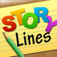](http://www.appolicious.com/games/apps/822996-storylines-root-one-inc)The idea behind the game is very simple. The first player must come up with a sentence or phrase, and write it down. The next player must then illustrate that phrase to the best of his or her ability. The third player will then try to describe what is happening in the picture without seeing the original phrase, and so on, until everyone has a chance to contribute. Drawing skill is not a prerequisite for this game, and in fact, the more difficult it is to decipher the drawings, the sillier the results become. (**Free)**.r

**eClicker**

Use 'Hinge' questions to assess

understanding. Instead of having the usual

multiple choice questions with

one right answer and the others

as incorrect, use each answer to

refer to a particular level of

understanding.

For example, answer 1 may be

a 'B' grade answer, answer 2

may be a 'C' grade. Use a tool

like **eClicker** (free)to aggregate the

scores and feedback to students. Teacher **eClicker Host** version $9.99

Use the iPad as an expensive mini whiteboard.

**Shopping APPs Websites:**

App Shopper: <http://appshopper.com/education/lets-name-things>

App Annie: <http://www.appannie.com/top/ipad/united-states/education/>

**App Websites:**

Christian Co.TIS Website: <http://www.christian.kyschools.us/webpages/tpelletier/ipads.cfm>

Murray State: <http://kate.murraystate.edu/mobile_apps/>

Teachers With Apps : <http://teacherswithapps.com>

Teaching Appz: <http://www.teachingappz.co.uk/>

Education Apps: <http://www.topeducationalapps.com/>

Apps By Subject (all grades):  
<http://www.apple.com/education/apps/>

Bloom's Taxonomy of Apps:  
<http://issuu.com/ktenkely/docs/lg_alpha?mode=window&backgroundColor=%23222222>

<http://www.ipadcurriculum.com/>  
Apps for 9-12 Grade (all subjects):  
[http://cre8tiveduservices.pbworks.com/w/page/34819551/Scott-County-High-School-iPod-Training%29...just](https://pod51004.outlook.com/owa/redir.aspx?C=4rPbs77W1kmCrTYrCgmXp2NHJP2TaM4I-Ax8tcPUWHQPUY59SrtpPuhNn36axZpDRWno_K6YFJ8.&URL=http%3a%2f%2fcre8tiveduservices.pbworks.com%2fw%2fpage%2f34819551%2fScott-County-High-School-iPod-Training%2529...just)

High School Apps:

<http://palmbeachschooltalk.com/groups/ipadpilot/wiki/70925/>