Unit 7: Wave Properties, Electromagnetic Radiation, and Informational Technology
Student Notes

BIG IDEA: Waves have different properties and interactions that affect the world around us.

ENDURING UNDERSTANDING: Students will apply their understanding of waves as a vibration that carry energy, not matter, over distance to describe their properties, apply knowledge of wave properties to wave interactions, and have an understanding that waves can be used for communication purposes.

Wave properties

- Wave Characteristics
- Waves
  - This is disturbance in matter as energy passes through it.
    - The energy displaces the matter it travels through
    - Meaning the matter moves away from the energy( up and down; back and forth) but always goes back to its original position after the energy has passed.
    - This up and down movement is what causes the “wave” action.
- Types of Waves(Transverse and Longitudinal Waves)
  - Transverse Waves:
    - These waves are generated as energy moves the matter up and down which is perpendicular to the direction of flow for the energy, which is horizontal
    - Parts of a transverse wave:
      - Crest-This is the position of maximum positive displacement.(The Highest Point)
      - Trough-This the position of maximum negative displacement.(The lowest point)
      - Amplitude-This is the total measurement of displacement from the equilibrium position( A flat line)
      - Wavelength- This is the total length of one complete wave cycle.(one crest to another crest, or one trough to another trough)
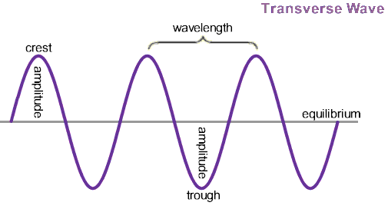

  - Longitudinal Waves:
    - These waves are generated as energy moves the matter back and forth(side to side), which is parallel to the direction of flow for the energy, which is horizontal.( Ex. Slinky waves, sound waves, and P-type Earthquake waves.)
    - Parts of a longitudinal wave:
      - Compression- This is the point of maximum density displacement
      - Rarefaction- This is the point of minimum density displacement
      - Amplitude-This is the total measure of displacement(density of compression)
      - Wavelength-This is one complete wave cycle.(From compression to compression)
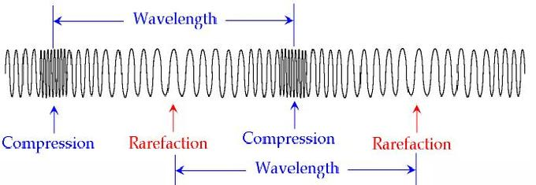
Note Interaction: A wave is traveling in a rope. The diagram below represents a snapshot of the rope at a particular instant in time.
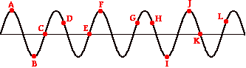
Determine the number of wavelengths which is equal to the horizontal distance between points …
a. C and E on the rope-1 Wavelength
b. C and K on the rope-_______
c. A and J on the rope-_______
d. B and F on the rope-_______
e. D and H on the rope-_______
f. E and I on the rope-_________

  - Frequency(f)(Wave Period and Frequency)
    - This term refers to the number of wavelengths per unit if measured time.
      - Mathematically expressed as: f/t
        - f=frequency(the number of waves.)
        - t=time(seconds usually)
        - Units: 1/s or Hertz or (Hz)
          - They are called Hertz in honor of the German Physicist, Heinrich Hertz(1880)
  - Speed(v)(Wave speed)
    - This term refers to the relationship between a waves’ wavelength and its frequency
    - Mathematically expressed as: S=(ʎ)(f)
      - ʎ=wavelength(measured in meters)
      - f=frequency(number of waves/unit of time)
      - Units: any distance and time(m/sec)

  - Period(T)
    - This is the time required for one complete wave to pass a specific point.
    - Mathematically expressed as: T=1/f
    - Expressed in seconds.

Note Interaction: Practice problems
1. A wave with a frequency of 14 Hz has a wavelength of 3 meters. At what speed will this wave travel?

2. The speed of a wave is 65 m/sec. If the wavelength of the wave is 0.8 meters, what is the frequency
of the wave?

3. A wave with a frequency of 500 Hz is traveling at a speed of 200 m/s. What is the wavelength?

II. Sound waves
- Sound
  - This is a form of energy produced and transmitted by vibrating matter.
  - Sound waves travel as longitudinal waves.
  - Sound travels more quickly through solids than liquids or gases mediums.
    - A medium(media pl.) is the substance which sound travel through.
- Sound Waves
  - All sound is carried through matter as sound waves.
  - Sound waves are alternating areas of high and low pressure in the air.
  - Sound waves move out in all directions from the origin… a vibrating object.
  - Sound waves move faster in warmer weather. Slower in colder weather.
- Sonar
  - An instrument that uses reflected sound waves to find underwater objects.(for example, a submarine or battleship uses sonar to find other underwater objects.)
  - Some animals, such as bats, whales, and porpoises, use sonar or echolocation to find their prey.
    - These sounds have such a high pitch or frequency that the human ear cannot hear them.
  - The sound waves bounce off an object and are then bounced (reflected) back to the “collector”
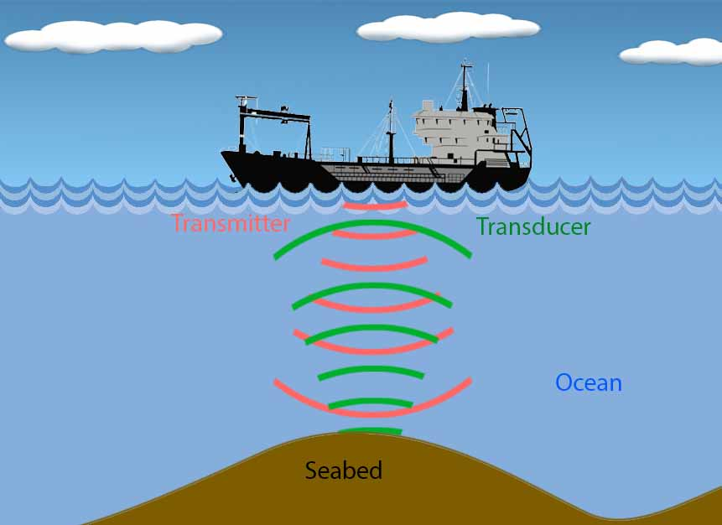

- Volume
  - Volume(loudness) is a measure of how loud or soft a sound is.(we measure the height of a wave)
  - Volume depends on the amplitude (height from equilibrium) of the sound wave.
  - Volume is measured in Decibels.
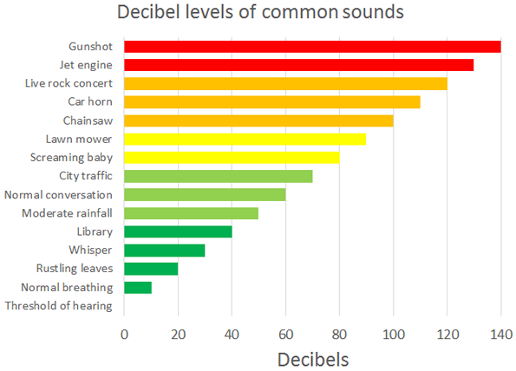
- Pitch
  - Pitch(intensity) is a measurement of how high or low (length of wave) a sound is.
  - Pitch depends on the frequency of a sound wave.
    - As wavelength increases, pitch(intensity) decreases. Less waves will pass a point in a given time.
  - Measured in Hertz.
- Sound and Instruments
  - Instruments can be played at different pitches by changing the lengths of different parts of the instrument.
  - Another way to make different pitches is to change the thickness of the material that vibrates.
    - (Remember….sound is a vibration. It is the back and forth movement of molecules of matter.)
  - Sound waves move through 3 parts of the ear: outer ear, middle ear, and inner ear.
    - The outer eat (Pinna) collects sounds waves.
    - The middle ear amplifies the sound waves and converts it into mechanical energy using bones.
    - The inner ear (cochlea) converts the mechanical energy(vibrations) into liquid waves inside the cochlea. The liquid waves are used to bend hairs and convert wave energy to electrical energy using nerves.
    - The auditory nerves send the electrical energy to the brain to be processed...and you get the sensation of sound.
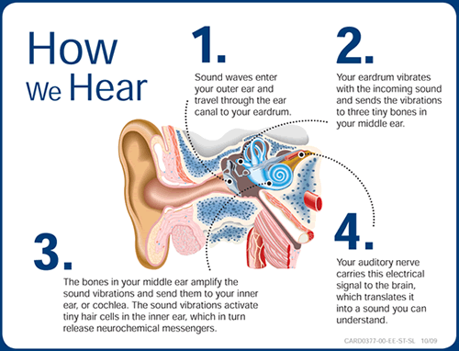
III. Optics
- Optics
  - This field of physics is the scientific study of the wave behavior of light.
  - Sound and light both transfer energy in the form of waves.
    - The way that sound and light interact with objects and substances (medium) that they come into contact with is wave behavior.
- Reflection (Light Absorption, Reflection, and Transmission)
  - This is when a wave hits a smooth surfaced medium, cannot pass through, and bounces off changing direction.
    - Sound waves reflecting off of smooth surfaces are called echos.
  - Reflection of sound waves is used in sonar technology and by animals as echolocation.
  - Light waves hitting mirrors, polished metal, or any reflective surface are called reflections.
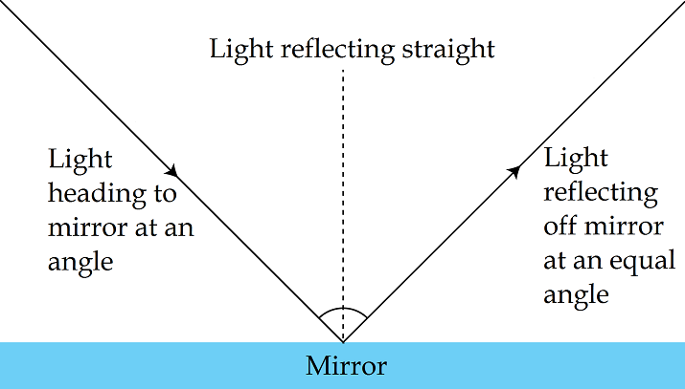
- Refraction(Refraction of light)
  - This is when a wave is traveling and changes from one medium to another, which causes the wave to slow down or speeds up.
    - When the wave changes speed, it will slightly change direction too. (Example: Sound traveling through areas of different temperature. Light waves changing from air to water, glass, clear plastics cause a change in speed and cause magnification.)
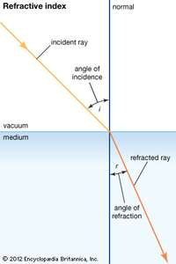
IV. Optics and Objects
- Diffraction(Wave diffraction)
  - This is when a wave hits a medium that it cannot pass through and it bends around the barrier.
  - It also happens when a wave travels through an opening and then spreads out on the other side.
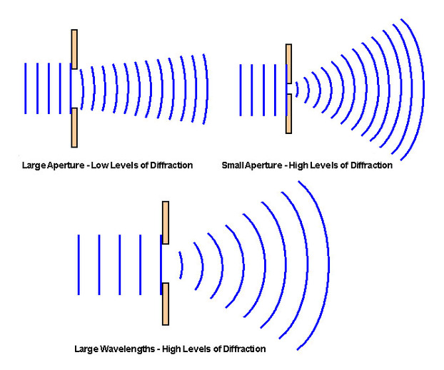
- Interference(Wave Interference)
  - This is when waves are overlapping.
  - There are two types of Interference:
    - Constructive Interference
      - The crest(s) of one wave overlap the crest(s) of another wave thus blending to make a bigger wave-add amplitudes into one.
    - Destructive Interference
      - The crest(s) of one wave and the trough(s) of another wave overlap thus blending to make a smaller wave-subtract amplitudes.
        - If the two waves have identical amplitudes, then they will cancel each other out causing the energy to go the resting position (no wave).
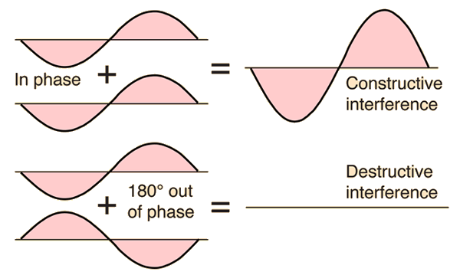

V. Electromagnetic Spectrum: Long Waves(Electromagnetic Radiation)
- Electromagnetic Spectrum(“Spectrum” means “possessing a variety”)
  - These are energy waves produced by stars, such as our sun.
  - Electromagnetic waves are associated with vibrating charged particles called electrons.
    - The vibrating of the electron creates an electric force “field” surrounding the electron.
    - The vibrating electric force creates a vibrating magnetic field with poles(positive and negative)
    - When the two forces are combined, we get an electromagnetic force “field”
  - Electromagnetic waves are transverse waves traveling at 300,000,000 m/sec.(3 x 10^8 m/sec)
    - This distance is called the speed of light(c). (You have probably heard of Albert Einstein and then his equation E=mc^2, c is the speed of light.)
  - There are several different wavelengths within the Electromagnetic Spectrum.
    - Longest waves have the least energy within them.
    - Shortest waves have the most energy within them.
  - Electromagnetic radiation-a kind of radiation including visible light, radio waves, gamma rays, and X-rays, in which electric and magnetic fields vary simultaneously
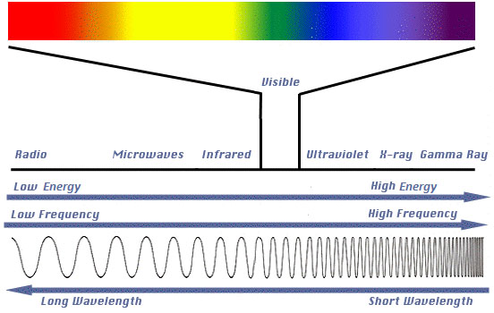

Note Interaction: Based on the picture above, answer the following question.
- List the following colors from lowest frequency to highest frequency.
Violet, Blue, Green, Red, Yellow, Orange, Indigo

Lowest wavelength-______,______,______,______,_____,_____,______-highest wavelength

- The longest waves:
  - Radio Waves
    - Radio waves are the broad range of electromagnetic waves with the longest wavelength and lowest frequencies.(wavelengths of radio waves may be longer than a soccer field.)
    - With their low frequencies, radio waves the least energy of electromagnetic waves, but they are still extremely useful.
      - They are used for radio and television broadcasts, microwave ovens, cell phone transmissions, and radar.
    - AM and FM Radio
      - In radio broadcasts, sounds are encoded in radio wave sthat are sent out through the atmosphere from a radio tower.
      - A receiver detects the radio waves and changes them back to sounds.(You’ve probably listened to both AM and FM radio stations. How sounds are encoded in radio waves differs between AM and FM broadcasts.)
      - AM stands for Amplitude Modulation.
        - In AM broadcasts, sound signals are encoded by changing the amplitude of radio waves.
        - AM broadcasts use longer-wavelengths radio waves than FM broadcasts.
        - With their longer wavelengths, AM radio waves reflect off a layer of the upper atmosphere called the ionosphere. THis allows AM radio waves to reach radio receivers that are very far away from the radio tower.
      - FM stands for Frequency Modulation
        - In FM broadcasts, sound signals are encoded by changing the frequency of radio waves.
        - Frequency modulation allows FM waves to encode more information than does amplitude modulation, so FM broadcasts usually sound clearer than AM broadcasts.
        - With their shorter wavelengths than AM, FM waves do not reflect off the ionosphere. Instead, they pass right through it and out into space. As a result, FM waves cannot reach very distant receiver.

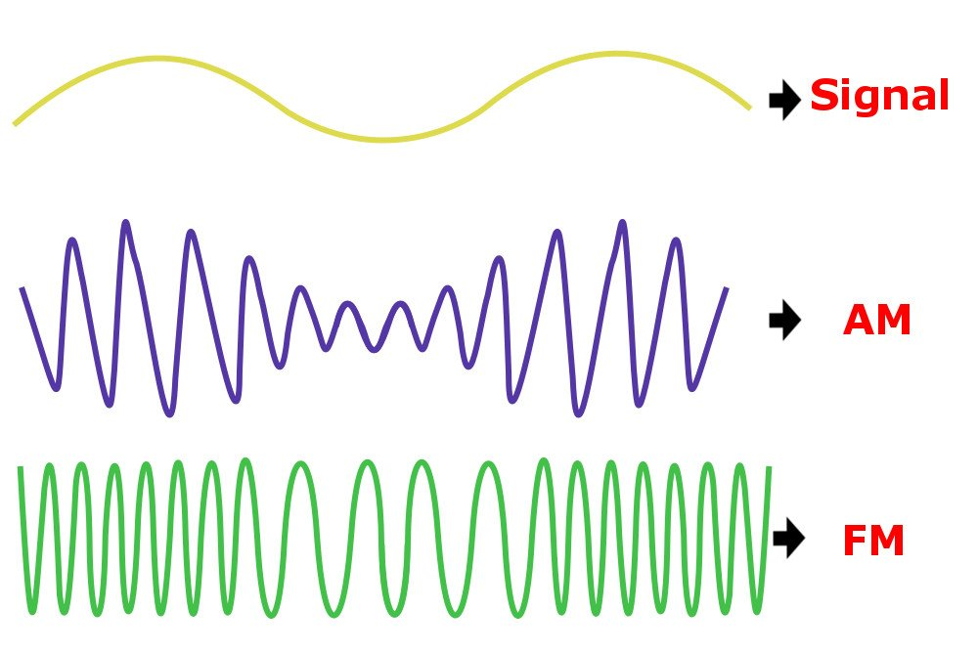
    - Television
      - Television broadcasts also use radio waves.
      - Sounds are encoded with frequency modulation, and pictures are encoded with amplitude modulation.
      - The encoded radio waves are broadcast from a TV tower.
      - When the waves are received by television sets, they are decoded and changed back to sounds and pictures.
  - Microwaves
      - The shortest wavelength, highest frequency radio waves are called microwaves.
      - The microwaves have more energy than other radio waves.(That’s why they are useful for heating food in microwave ovens.)
      - Microwaves have other important uses as well, including cell phone transmissions and radar.
        - Radar-is a device for determining the presence and location of an object by measuring the time for the echo(reflection) of a radio wave to return from it and the direction from which it returns.
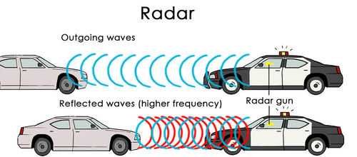
VI. Electromagnetic Spectrum: Light Waves
- Light Waves
  - These are mid-wavelength electromagnetic waves are commonly called light.
  - This range of electromagnetic waves has shorter wavelengths and higher frequencies than radio waves, but not as short and high as X rays and gamma rays.
  - Light includes: visible light, infrared light, and ultraviolet.
- Visible Light (A.K.A White Light)
  - The only light that people can see is called visible light.
    - Absorption- These are the colors of white light we cannot see when we look at a substance.(you see this text is black, because the ink absorbs all the colors of white light, but the paper appears white, because no colors are being absorbed….so you can seem them all combined...white.
    - Reflection- These are the colors(lightwaves) being bounced off the pigments and collected by your eyes. This appears blue because the blue light wave bounced off the pigments and collected by your eye. This appears black because nothing is bouncing back to your eyes. All the colors were absorbed by the pigment.
  - It refers to a very narrow range of wavelengths in the electromagnetic spectrum that falls between infrared light and ultraviolet light.
    - Within the visible range, we see light of different wavelengths as different colors of light.
      - From red light, which has the longest wavelength and therefore least energy, to violet light, which has the shortest wavelength and most energy.
      - The colors composing white light are: red, orange, yellow, green, blue, indigo, and violet. An easy way to remember is ROY G BIV, like a name.
      - When all the wavelengths are combined, as they are in sunlight, visible light appears white.
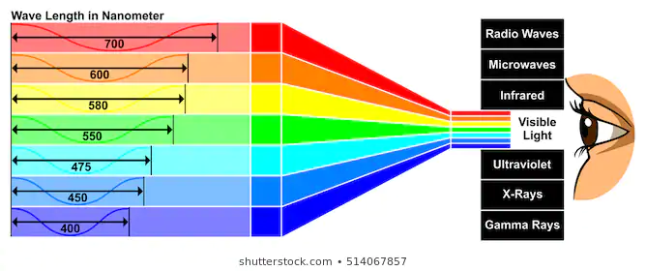
- Infrared Light
  - The spectrum part of visible light with the longest wavelengths and least energy is called infrared light.
  - The term infrared means “below red.” Infrared light is the range of light waves that have longer wavelengths than red light in the visible spectrum. You can’t see infrared light waves, but you can feel them as heat on your skin. The sun gives off infrared light, as do fires and living things.
  - Night vision goggles, which are sued by law enforcement and the military, also detect infrared light waves. The goggles convert the invisible waves to visible images.
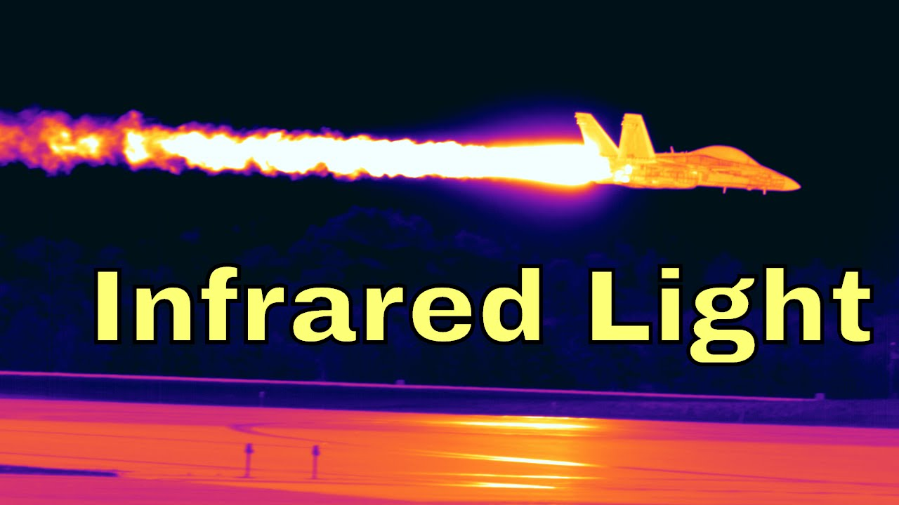
- Ultraviolet Light
  - Light with wavelengths shorter and having more energy than visible light is called ultraviolet light.
  - The term ultraviolet means “above violet”
    - Ultraviolet light is the range of light waves that have shorter wavelengths than violet light in the visible spectrum. Humans can’t see ultraviolet light, but it is very useful nonetheless. It has higher-frequency waves than visible light, so it has more energy.
  - It can be used to kill bacteria in food (often called Pasteurization) and to sterilize Laboratory Equipment.
    - Louis Pasteur developed the process used for cow milk sterilization.
  - The human skin also makes vitamin D when it is exposed to ultraviolet light.
    - Vitamin D is needed for strong bones and teeth.
    - Too much exposure to ultraviolet light can cause sunburn and skin cancer.
      - You can protect your skin from ultraviolet light by wearing clothing that covers you skin and by applying sunscreen with UV protection to any exposed areas.
      - The SPF, or Sun-Protection Factor, of sunscreen gives a rough idea of how long it protects the skin from sunburn. A sunscreen with higher SPF protects the skin longer. You should use sunscreen with an SPF of at least 15 even on cloudy days, because ultraviolet light can travel through clouds. Sunscreen should be applied liberally and often.
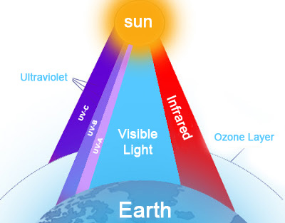

Note Interaction: Compare and contrast light waves and sound waves. Include attributes of each wave that explains how they absorb, reflect, and transmit energy.

Light Sound

VII. Electromagnetic Spectrum: Short Waves
- X Rays and Gamma Rays
  - The shortest-wavelength, highest-frequency electromagnetic waves.
  - These rays have so much energy that they can pass through many materials.
    - This makes them potentially very harmful, but it also makes them useful for certain purposes.
  - X Rays
    - These are high-energy electromagnetic waves.
    - They have enough energy to pass through soft tissues such as skin, but not enough to pass through bones and teeth, which are very dense. (the bright areas on the X ray film show where X rays were absorbed by the teeth. X rays are used not only for dental and medical purposes but also to screen luggage at airports.)
    - Too much X ray exposure may cause cancer.( if you’ve had dental X rays, you may have noticed that a heavy apron was placed over your body to protect the body from the stray X rays. The apron is made out of lead, which X rays cannot pass through.)
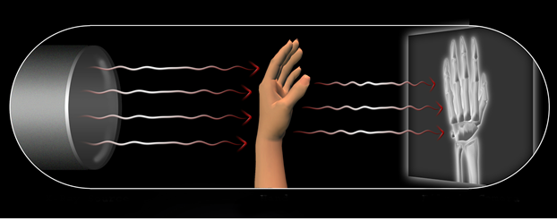
- Gamma Rays
  - The most energetic of all electromagnetic waves.
  - They can pass through most materials, including bones and teeth.
  - Nonetheless, even these waves are useful. (for example, they can be used to treat cancer. A medical device sends gamma rays the site of the cancer, and the rays destroy the cancerous cells.)

Note Interaction: EM SPECTRUM Guided Reading
1. Define electromagnetic spectrum.

2. Define electromagnetic radiation.

3. What are the various types of electromagnetic radiation?

4. Which type of electromagnetic wave has the longest wavelength?

5. Which type of electromagnetic wave has the shortest wavelength?

6. What is the use of radio waves?

7. What is the wavelength range and frequency range of radio waves?

8. How are microwaves used?

9. What is the wavelength range of microwaves?

10. What is the use of infrared rays?

11. What are the different colors of visible light?

12. What is the use of ultraviolet light?

13. What is the wavelength range of ultraviolet light?

14. What is the use of X-rays?

15. What is the wavelength range of gamma rays?

16. What is the use of gamma rays?

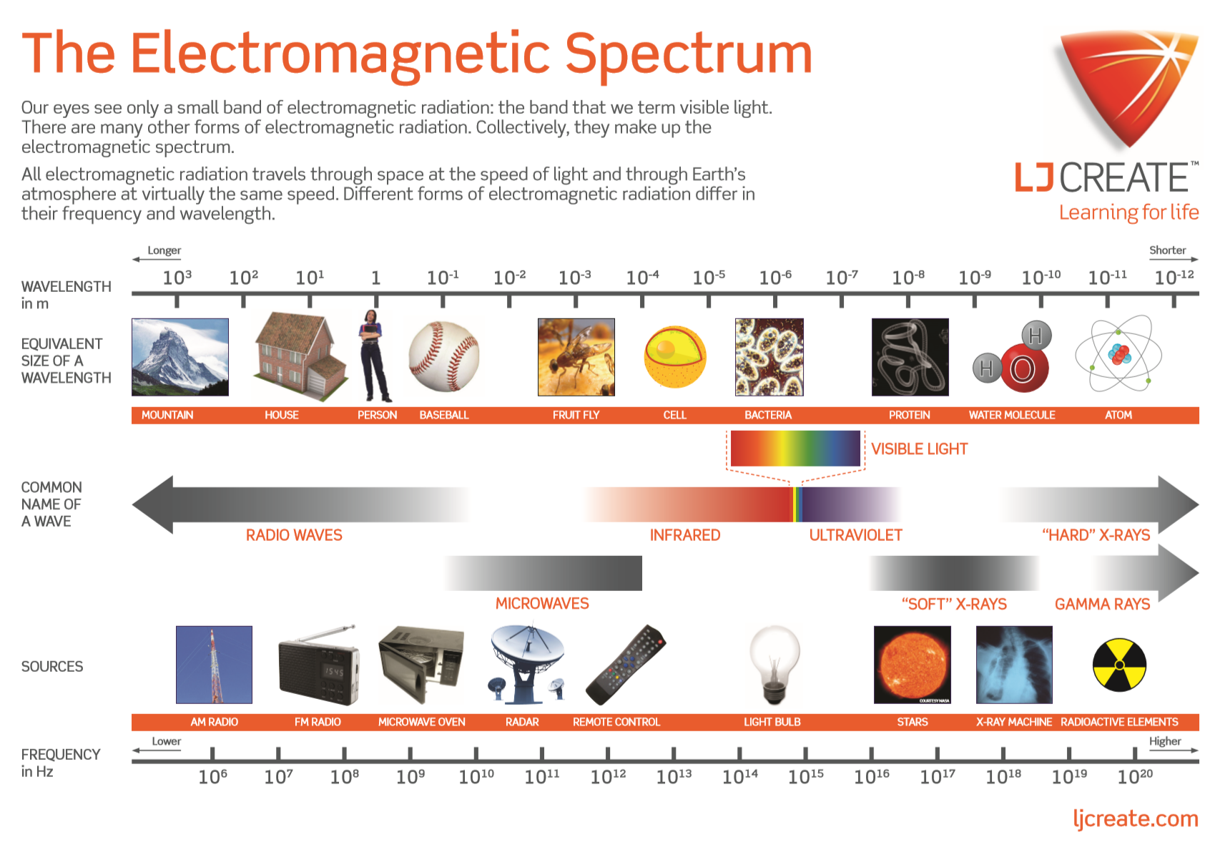
Note Interaction: Based on the diagram above, fill in the following table.

Based on the following frequencies, which type of wave correlates closest to the value provided. Also input if the wave is more helpful than harmful, or more harmful than helpful. Explain your reasoning.

Frequencies | Type of wave | Reasoning
10^8
10^15
10^20
10^11
10^16
10^18

VIII. Communicating with Signals
- Signals and carriers
  - Electronic communication devices send information by using signals.
  - A signal is anything, such as a movement, a sound, or a set of numbers and letters, that can be used to send information.
  - Signals may use light waves, sound waves, or electricity to transmit information from one place to another.
  - Often, one signal is sent using another signal called a carrier.
  - Two kinds of signals are analog signals and digital signals.
B. Analog signals
- An analog signal is a signal whose properties change without a break or jump between values.
- Analog signals are denoted by sine waves. 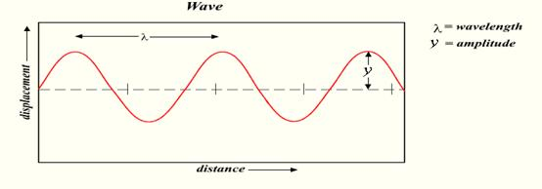
- Analog systems preserve wave forms, so media, such as music, can sound more like the original.
- The changes in an analog signal are based on changes in the original information.
- Analog signals can become distorted if sent over long distances.
  - Analog devices for playback (such as records and speakers) can cause distortions as they wear out.
  - For example, when you talk on the phone, the sound of your voice is changed into changing electric current in the form of a wave. This wave is an analog signal that is similar to the original sound wave. But remember that sound waves do not travel down your phone line!
  - Landline telephones, record players, radios, and regular TV sets use analog signals.

Note Interaction: What is an analog signal? Give an example of a device that uses analog signals.

C. Digital Signals (https://www.youtube.com/watch?v=XCu6L4kQF3k)
- A digital signal is a signal that is represented as a sequence of separate values. They are denoted by square waves.
- Digital signals have discrete values, such as 0 and 1.
- Digital systems collect information by sampling the waveform of the source and converting the information into a binary code.
- Digitizing information has several advantages.
  - Digital files of binary code are easy to transmit.
  - Digital files can be sent long distances without distortion.
  - Digital files are easy to store and protect from degradation.
  - Digital media is less expensive to produce, store, and deliver.
  - Digital signals are more reliable than analog signals.
e. Computers, CDs, DVDs, and other digital electronic devices use digital signals.
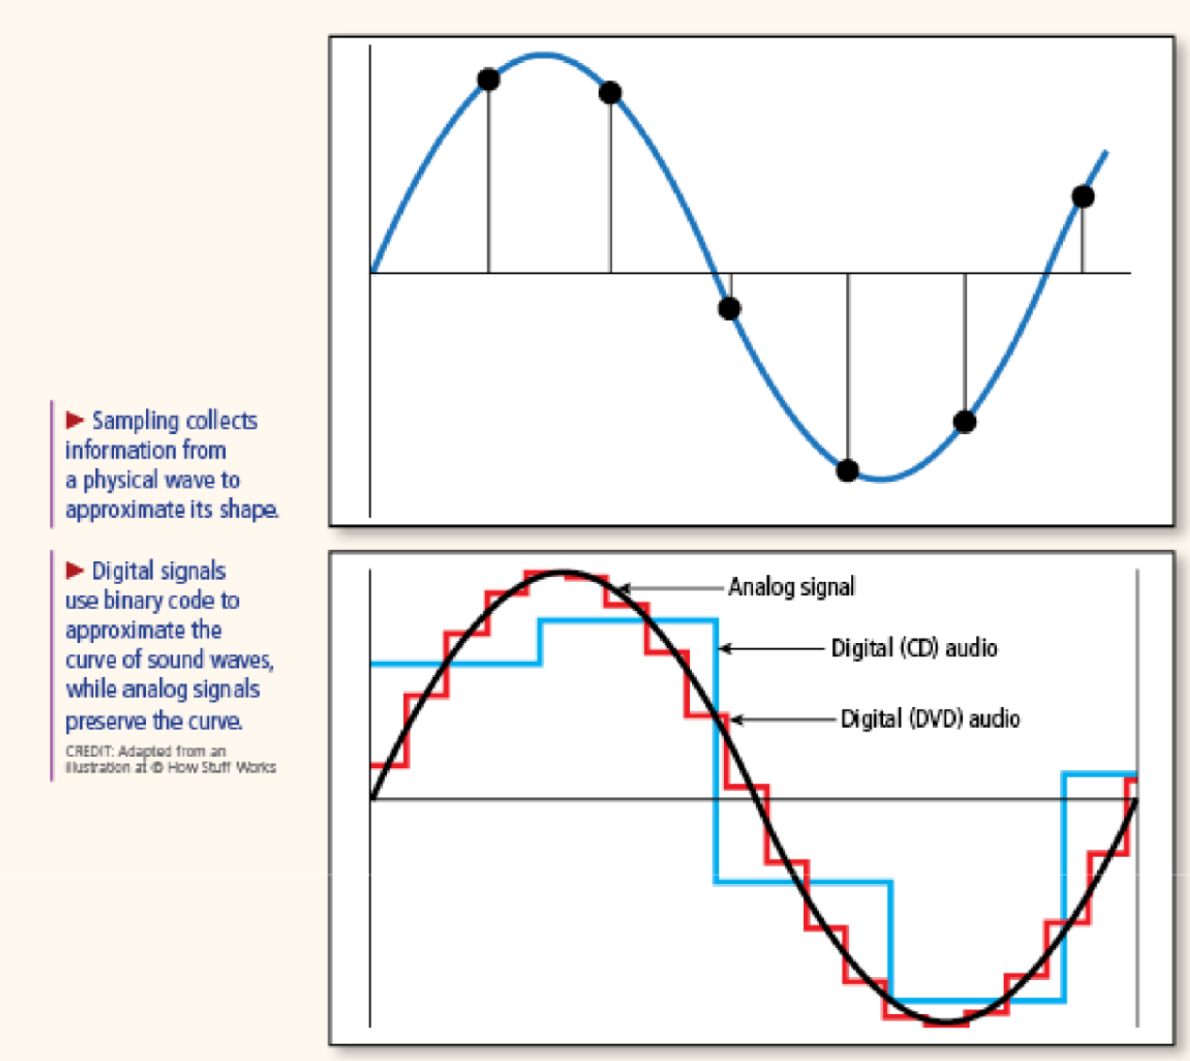

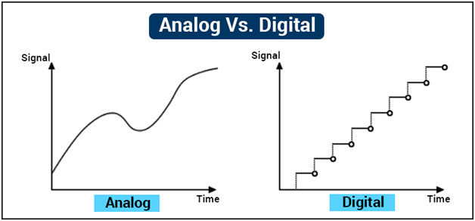

Note Interaction: Show what you have learned about digital and analog signals by completing the Venn diagram below. Sort the words and phrases from the word bank into the correct places. Afterward, add any additional words or phrases that will help you differentiate the two signal types.

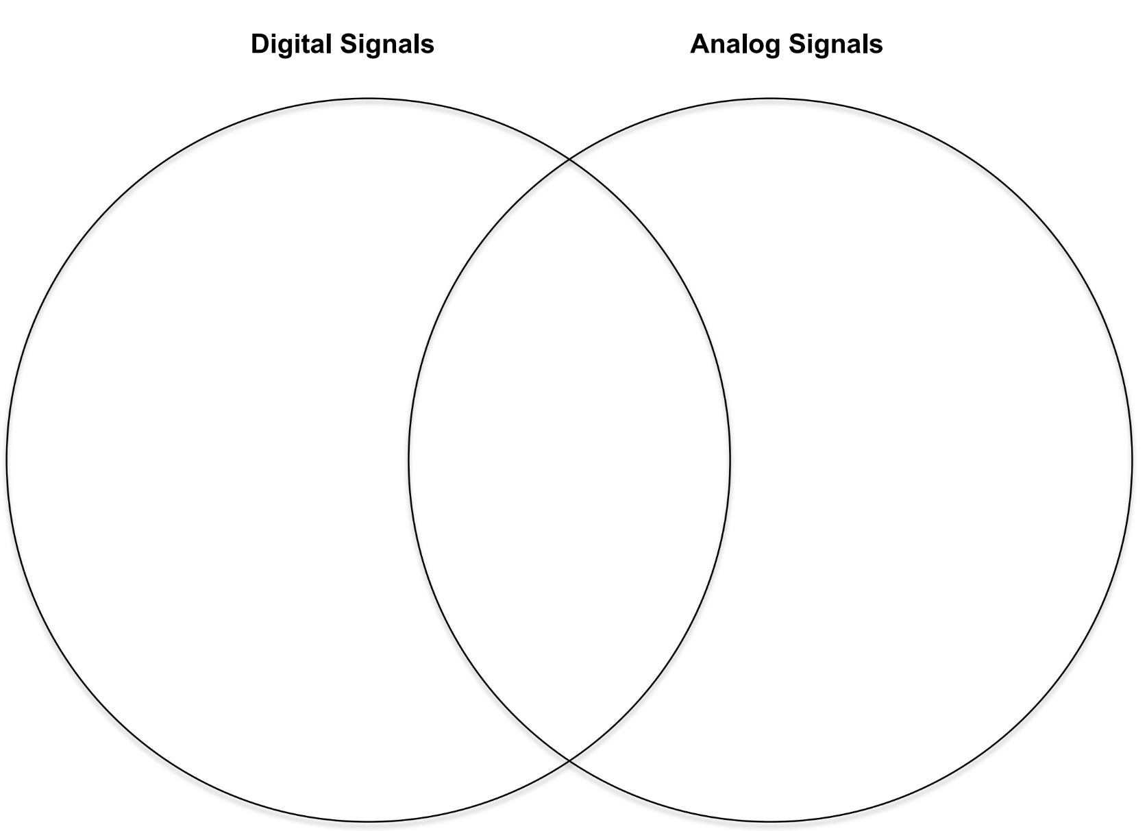

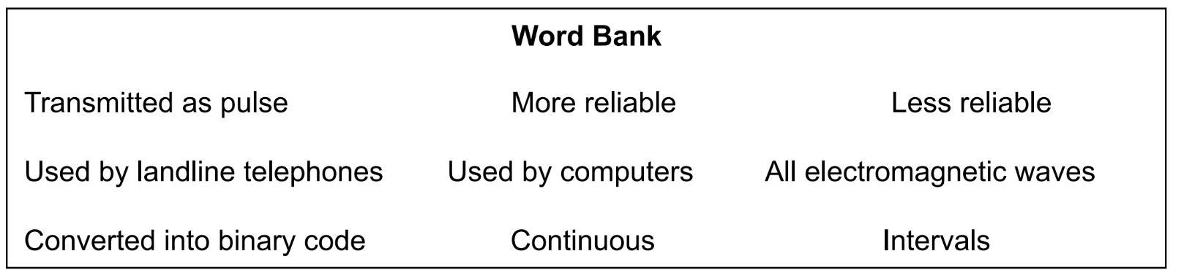

IX. Communication Systems and Information Transfer
- Modern society relies heavily on electronic information transfer systems for real-time communications.
- Telephones, cell phones, Internet devices, broadcast radio, and broadcast television are parts of familiar information transfer systems.
- Information transfer systems must contain components that encode information, generate signals, transmit signals, and decode information.
- Encoding information involves capturing or translating information into a type of code that can be transmitted by electrical signals or waves.
- Modern technologies encode information in analog signals—typically variations, or modulations, in frequency or amplitude of electromagnetic waves—or in digital code, which is a binary system that uses 0s and 1s as a type of alphabet.
- In a telephone, a transmitter changes sound waves to electric current. The current is sent across a phone line. The receiving telephone converts the signal back into a sound wave.
- Radios and televisions use electromagnetic waves. These waves travel through the atmosphere. In a radio, the signals are converted to sound waves.
- In a television, electron beams convert the signals into images on the screen.

Note Interaction
Which of the following objects changes sound waves into an electric current in order to transmit information?
- telephone
- radio
- television
- Telegraph

Explain the reason for your answer.

