Creating  Create an instrument using household items. Play along to your favorite song! | Singing  This Photo by Unknown Author is licensed under CC BY-SA-NC  Sing a song to a friend or family member! OR make a video for Ms. H and send it to her email! | Moving  Do a GoNoodle or Just Dance video on YouTube. | Singing  This Photo by Unknown Author is licensed under CC BY-SA-NC  Find a song on Youtube and sing along! | Listening  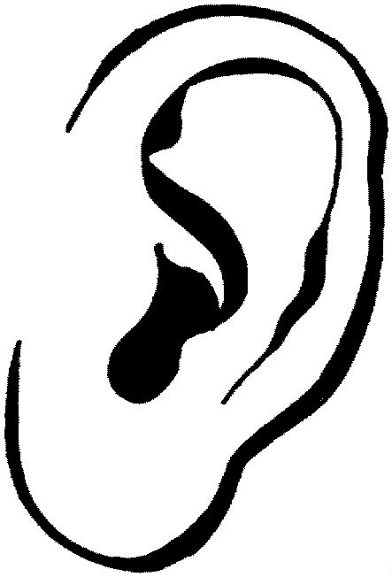  This Photo by Unknown Author is licensed under CC BY-SA-NC  Listen to a song and draw how it makes you feel.
Moving  Make up a dance to your favorite song.  Send Ms. H a video through email | Creating  Design, draw, and name a new instrument. | Listening  This Photo by Unknown Author is licensed under CC BY-SA-NC  Listen to a song by Beethoven.  Close your eyes and take deep breaths. | Singing  This Photo by Unknown Author is licensed under CC BY-SA-NC  Teach your family how to Poison Rhythm or Pass the Beat | Listening  This Photo by Unknown Author is licensed under CC BY-SA-NC  Watch “Carnival of the Animals” from Fantasia 2000.  You can find this on Hulu, Disney +, or YouTube.
Creating  Create a song on Chrome Lab | Listening  This Photo by Unknown Author is licensed under CC BY-SA-NC  Watch “Pomp & Circumstance” from Fantasia 2000.  You can find this on Hulu, Disney +, or YouTube. | FREE SPACE  This Photo by Unknown Author is licensed under CC BY-SA-NC  Go wash your hands! | Singing  This Photo by Unknown Author is licensed under CC BY-SA-NC  Make Rollercoaster “woos” to warm up your voice! | Moving  Family Dance  Party!
Singing  This Photo by Unknown Author is licensed under CC BY-SA-NC  Create a rap OR song using a Dr. Seuss book. Send me a video! | Creating  Write your own rhythm using ta’s (quarter notes) ti-ti’s (two eighth notes) and quarter rests and perform it for someone. | Listening  This Photo by Unknown Author is licensed under CC BY-SA-NC  Listen to “Spring” by Vivaldi and draw a springtime picture. | Listening  This Photo by Unknown Author is licensed under CC BY-SA-NC  Watch “Rhapsody in Blue” from Fantasia 2000.  You can find this on Hulu, Disney +, or YouTube. | Moving  Teach someone a tik tok dance! (Make sure it’s appropriate!)
Listening  This Photo by Unknown Author is licensed under CC BY-SA-NC  Watch “Symphony No. 5”  from Fantasia 2000.  You can find this on Hulu, Disney +, or YouTube. | Creating  Create a song/rhythm using household objects. Think pots, pans, pencils, etc. | Moving  Family Dance  Party! | Listening  This Photo by Unknown Author is licensed under CC BY-SA-NC  Listen to a song and create a drum backing “track” using items around your house | Singing  This Photo by Unknown Author is licensed under CC BY-SA-NC  Sing/play your favorite song you’ve learned in music class.
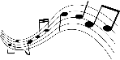HLIS MUSIC BINGO (3-5)
Color in each square as you complete the activities! If you complete a BINGO, get it signed by a parent/guardian and bring it to Ms. H for a fun prize!
Parent/Guardian Signature _______________________________________________________________

