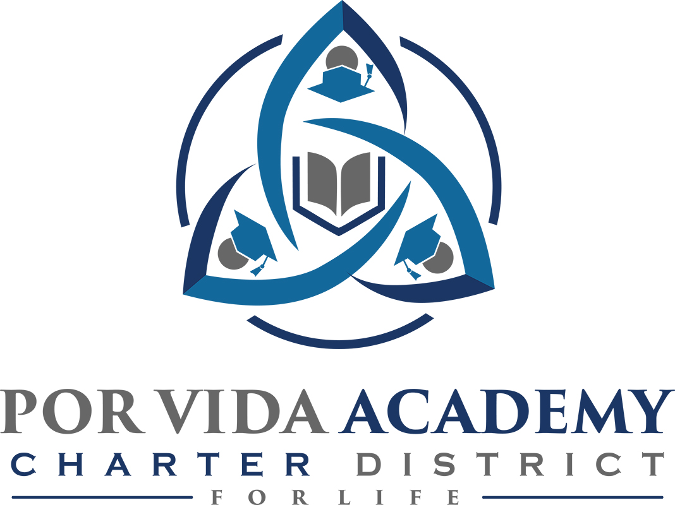

Friday, August 24, 2018 at 12:00pm 1135 Mission Road, SA TX 78210

Agenda of Regular Called Board Meeting

- Call to Order and Establishment of Quorum
  - Roll Call & Recording of Board Members Present - Declaration of Quorum Present
  - Recording of the Executive Director/Superintendent and Staff Members Present.

- Close Session: Personnel discussion of former employees

- Pledge of Allegiance

- Salute to the Texas Flag- “Honor the Texas Flag; I pledge allegiance to thee, Texas, one state under God, one and indivisible.”

- Public Testimony

- Approval of Minutes:

- Superintendent Items:
- FIRST Ratings
- Campus reports
- Guardian plan
- Accountability Ratings
- Local Government Officer

- Financials
  - Budget Approval

- Board Items: None

- Adjournment

