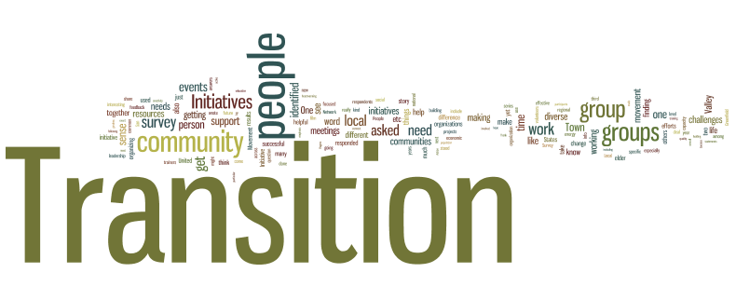

Students in Transition
Parent Handbook
2015-2016

District Mission
RGSD Mission
The Riverview Gardens School District, along with families and the community, nurtures academic excellence in all students, preparing them to be college and career ready in an ever-changing society.

RGSD Vision
The Riverview Gardens School District creates a community of learners equipped to be competitors in a global society and leaders demonstrating social and civic responsibility.

RGSD Value Statements
STUDENT FOCUS
Students are at the forefront of all decisions.
MEETING THE NEEDS OF THE WHOLE STUDENT
A safe learning climate and caring staff are essential to meeting the social, emotional and academic needs of all students.
COLLABORATION
The school, families and community work together, supporting each other.
INTEGRITY
We demonstrate honesty, transparency, ethical behavior and trustworthiness in everything we do every day.

All districts, including Riverview Gardens School District, define homeless students and youth under the McKinney-Vento Homeless Education Assistance Improvements Act of 2001. It describes homelessness as: "Children and unaccompanied youth who lack a fixed, regular, and adequate nighttime residence."
- "Fixed" means stationary, permanent, and not subject to change
- "Regular" means nighttime residence available on a predictable or routine basis
- "Adequate" means the residence is sufficient for both the physical and psychological needs typically met in home environment, including adequate and quiet space for studying

Examples of homelessness
- Sharing the house of others
- Living in motels, hotels, or on camping grounds
- Living in an emergency or transitional shelter
- Living in places not designed for humans to live, such as cars or abandoned buildings
- Migratory children
A student who is in a home for CPS placement or in Foster Care does not qualify for assistance under McKinney Vento.

NOTE: Once a student is qualified as homeless through the SIT office; they remain classified and are eligible for services for the entire school year. However, this does not mean students cannot be removed from the transition list for falsifying any information obtained through the SIT office. It is also required that families MUST complete a new Student Residency Questionnaire at the beginning of each school year and will be subject to the approval process set in place at that time.

Riverview Gardens Policy and Guidelines Governing Homeless Students

Note: This is not the entire policy. Policy can be found on the Riverview Gardens School District’s website (www.rgsd.k12.mo.us).
ADMISSIONS:
As a condition of receiving funds under the McKinney-Vento Homeless Education Assistance Improvements Act, the District shall serve homeless children according to their best interests.
In determining the “best interest” of a child, the District shall:
- To the extent feasible, keep a homeless child in the school of origin except when doing so is contrary to the wishes of the child’s parents or guardian;
- Provide a written explanation to the homeless child’s parents or guardian, including a statement of appeal rights, if the District sends the child to a school other than the school of origin or a school requested by the parents or guardian; and
- In the case of an unaccompanied youth, consider the views of the child and provide the notice required in the event of an enrollment dispute.

ENROLLMENT:
“Enroll” and “enrollment” include attending classes and participating fully in the school activities.

HOMELESS CHILDREN OR YOUTH:
“Homeless child” means a child or youth. “Unaccompanied youth” includes a child not in the physical custody of a parent or guardian.

SCHOOL OF ORIGIN:
“School of origin” means the school that the child attended when permanently housed or the school in which the child last attended.
CONTACT INFORMATION:
The District requires parents or guardian of a homeless child to submit contact information and keep said information updated and current.

ENROLLMENT:
The school selected in accordance with the McKinney-Vento Homeless Education Assistance Improvements Act shall immediately enroll a homeless child eve if the parent/guardian is unable to produce records normally required for enrollment. The school shall immediately contact the last school attended to obtain relevant academic and other records. If immunizations or immunization records are needed, the enrolling school shall immediately refer the child’s parent to the District’s homeless coordinator for assistance.

ENROLLMENT DISPUTES:
If a dispute arises over school selection or enrollment in a school, the child shall be immediately admitted to the school in which enrollment is sought, pending resolution of the dispute. The District shall provide the child’s parents or guardian with a written explanation of the decision regarding school selection or enrollment, including the right to appeal the decision. The District shall refer the child, parent, or guardian to the homeless coordinator, who shall carry out the dispute resolution process as expeditiously as possible.

SCHOOL PLACEMENT:
The District shall not segregate homeless children. The District shall, according to the child’s best interest:
- Continue the child’s education in the school of origin for the duration of the homelessness, if the child’s family becomes homeless between academic years or during the academic year;
- Continue the child’s education in the school of origin for the duration of the academic year, if the child becomes permanently housed during an academic year; or
- Enroll the child in any school that non-homeless students who live in the attendance area in which the child is actually living are eligible to attend.
The District shall make the choice regarding placement without regard to whether the child lives with the homeless parents or has been temporarily placed elsewhere.

COMPARABLE SERVICES:
The District shall provide a homeless child with services that are comparable to services offered to other students in the school in which the child is enrolled, including:
- Transportation services;
- Educational services for which the child meets the eligibility criteria;
- Programs in vocational and technical education;
- Programs for gifted and talented students; and
- School nutrition programs.
COORDINATION:
The District shall coordinate the provision of services to homeless children with:
- Local social services agencies and other agencies or programs providing services to homeless children and their families;
- Other local educational agencies, on inter-district issues such as transportation or transfer of school records; and
- As applicable, state and local housing agencies responsible for developing the comprehensive housing affordability strategy described in the Cranston-Gonzalez National Affordable Housing Act (42 U.S.C. 12705), to minimize educational disruption for homeless children.
The coordination shall be designed to ensure that homeless children have access and reasonable proximity to available education and related support services and to raise the awareness of school personnel and service providers of the effects of short-term stays in a shelter and other challenges associated with homelessness.

BARRIERS TO ENROLLMENT:
The District shall review and revise any policies that may act as barriers to the enrollment of homeless children. The District shall give consideration to issues concerning transportation, immunization, residency, birth certificates, school records and other documentation, and guardianship. The District shall give special attention to ensuring the enrollment and attendance of homeless children who are not currently attending school.
In addition, the District shall adopt policies and practices to ensure that homeless children are not stigmatized or segregated on the basis of their homeless enrollment status.

NOTIFICATION OF RIGHTS
Dear Parent/Guardian,
Your child has been identified and approved for services under the McKinney-Vento Act 42 U.S.C. 11434a(2), which is also known as Title X, Part C, of the No Child Left Behind Act. Provided under the Act, he/she is entitled to the following general rights:
- The right to immediate enrollment in school even if they lack the paperwork normally required for enrollment.
- The right to attend school at their school of origin (if feasible and requested by the parent) or at the school in the attendance area where the family or youth is currently residing.
- The right to receive transportation to the school of origin if requested by the parent.
- The right to services comparable to those received by housed schoolmates including transportation and supplemental educational services.
- Homeless children and youths are identified by school personnel and through coordination activities with other entities and agencies.
- Homeless children and youths enroll in, and have a full and equal opportunity to succeed in, schools of that local educational agency.
- Homeless families, children and youths receive educational services for which they are eligible, including Head Start and Even Start programs and preschool programs administered by the local educational agency, as well as referrals to health-care services, dental services, mental health services and other appropriate services.
- Parents or guardians of homeless children and youths are informed of the educational and related opportunities available to their children and are provided with meaningful ways to participate in the education of their children.
- The parent/guardian of a homeless chld shall be provided contact information for the District’s homeless coordinator and the state coordinator for education of homeless children and youths.
Deidre Townsend Donna Cash
Riverview Gardens School District MO State Homeless Coordinator
1160 St. Cyr Road Dept. of Elementary & Secondary Education
St. Louis, MO 63137 donna.cash@dese.mo.gov
314-869-2505, ext. 1422 573-522-8763
314-388-6093-fax
dtownsend@rgsd.k12.mo.us

Sincerely,

Deidre Townsend
Homeless Coordinator

RIVERVIEW GARDENS
STUDENTS IN TRANSITION PROGRAM GOALS

- Identify and provide immediate enrollment for students experiencing a transitional situation.
- Provide transitional students the same educational experiences as their peers not experiencing transition.
- Provide support and other resources needed by the family to ensure no lapse in the student’s educational process.
- Engage parents / guardians in supporting the educational success of students living in transitional situations.
- Coordinate services and supports for transition students

SIT SUPPORTS
Students enrolled under McKinney-Vento have the right to access any supports offered to traditionally enrolled students. Students have the right to participate in all school activities in which they meet the qualifications. Additional supports are available to students as needed. Such supports are:
- Transportation
- School supplies and backpacks
- School uniforms
- School activity and field trip fees
- Tutoring
- Case management and referral services
- Mental health counseling

Students in Transition Office
The Students in Transition Office is here to assist with your enrollment issues. You can expect to be treated fairly and with respect. Our goal is to assist your student reach and far exceed their academic goals. We will do this by:
- Treating each family member with respect.
- Return phone calls within a 24-hour period.
- Work in partnership with you to ensure your child’s educational rights and needs are met.
- Arrange transportation services, when deemed a needed service, promptly.
- Communicating with you in June regarding your transition status.

Parent Expectations
- Treat SIT staff with respect.
- Communicate any concerns, needs or successes with staff.
- Keep staff and school updated with current contact information.
- Have student prepared to depart at least 15 minutes prior to the quoted pick-up time.
- Take the opportunity to meet the assigned cab driver and learn the contact information for the service provider.
- Accompany your child to the bus.
- Cancel cab service with the cab company, not the driver, by contacting them directly. Three no-shows will result in suspension of transportation services.

Transportation Services
Riverview Gardens School District contracts with outside service providers for transportation. The following applies:
- Parent shall sign and adhere to a “Parent Transportation Agreement” upon approval of transportation services.
- Requests submitted after noon will not have a next day turn-around.
- Parent will contact transportation provider to cancel service if the student will be absent from school.

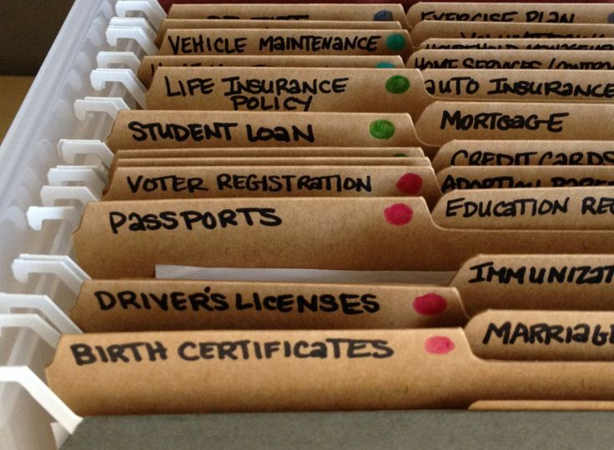
Please retain this handbook for your records.

2015-2016 School Year

