

Reminders

-**Masks** need to be worn at school.

-October 19-23 Homecoming Week

**Mon: pajama day**

**Tues: old folks day**

**Wed: camo day**

**Thurs: “Out of this world day”**

**Fri: Mustang spirit day**

-Oct. 21: National Bullying Prevention day **(wear orange)**

-October 26-30: Red Ribbon Week

**Mon: team jersey day**

**Tues: pajama day**

**Wed: Hawaiian day**

**Thurs: Western day**

**Fri: Book character day**

-Oct. 28: turn in your candy for Halloween bags

-November 3: No traditional school day

(distance learning day)

October 19th – 23rd

Homework

Monday:

* Estimating quotients worksheet
* Study math facts

Tuesday:

* Long division worksheet
* Study math facts

Wednesday:

* Long division worksheet

Thursday:

* Long division worksheet

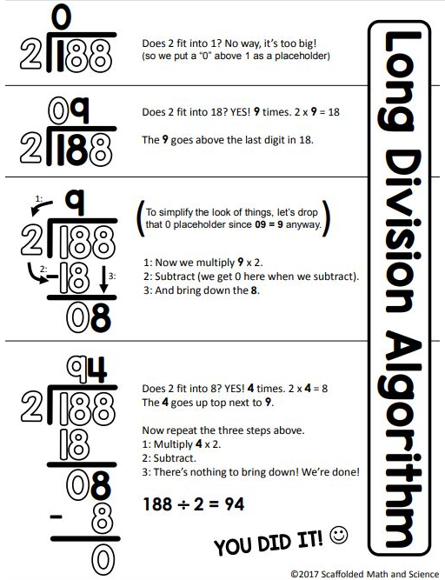

What we are learning…

Tests/Projects

-Timed Test 10/21

- Long division quiz 10/23